UNIT I - SWITCHED RELUCTANCE MOTOR
INTRODUCTION:
Switched reluctance motor (SRM) is electromagnetic and electrodynamics equipment which converts the electrical energy into mechanical energy. The electromagnetic torque is produced on variable reluctance principle. SRM makes use of
❖ Power semiconductor switching circuitry and
❖ Rotor position sensor.

SRM is singly excited and doubly salient electrical motor. This means that it has salient poles on both the rotor and the stator but the only one member carries winding. The rotor has no winding, magnets and cage winding but it is build from a stack of salient pole laminations.
❖ Its construction is simple and robust
❖ It requires less maintenance
❖ Its overall efficiency is better
❖ It is flexible control driving motor as motoring mode generating mode of operations of the machine can be easily achieved,
It is a competitive variable speed dc motor and variable speed 3 – phase cage induction motor.

CONSTRUCTION AND OPERATION OF SRM:
1. Construction of SRM:
Construction details of switched reluctance motor with six stator poles and four rotor poles can be explained by referring to figure 1.1
The stator is made up of silicon steel stampings with inward projected poles. The number of poles. The number of poles of the stator can be either an even number or an odd number. Most of the motors available have even number of stator poles (6 or 8). All these poles carry field coils. The field coils of opposite poles are connected in series such that their mmf‘s are additive and they are called phase windings. Individual coil or a group of coils constitute phase windings. Each of the phase windings are connected to the terminal of the motor. These terminals are suitably connected to the output terminals of a power semiconductor switching circuitry, whose input is a d.c. supply.
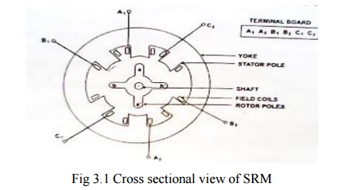
The rotor is also made up of silicon steel stampingswith outward projected poles. Number of poles of rotor is different from the number of poles of the stator. In most of the avaliable motors the number of poles of the rotor is 4 or 6 depending upon the number of stator poles 6 or 8.

The rotor shaft carries a position sensor. The turning ON and turning OFFoperation of the various devices of the power semiconductor circuitry are influenced by the signals obtained from the rotor position sensor.
2. Block Diagram Of SRM:
Fig. 1.2 shows the block diagram of SRM. Dc supply is given to the power semiconductor switching circuitry which is connected to various phase windings of SRM. Rotor position sensor which is mounted on the shaft of SRM, provides signals to the controller about the position of the rotor with reference to reference axis. Controller collects this information and also the reference speed signal and suitably turns ON and OFF the concerned power semiconductor device to the dc supply. The current signal is also fed back to the controller to limit the current within permissible limits.
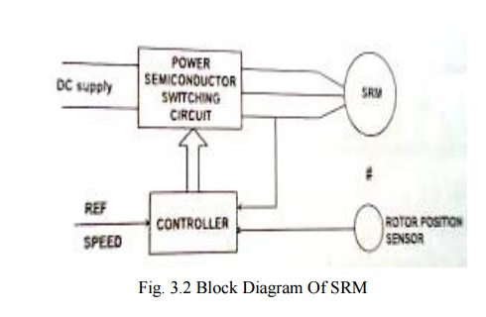

3. Principle of operation:
Fig. 1.3 represents the physical location of the axis stator poles and rotor poles of a 6/4 SRM.
To start with stator pole axis AA‘ and rotor pole axis aa‘ are in alignment as shown in fig. 1.3(a). They are in the minimum reluctance position so far as phase windings is concerned. Then dL_{a}/dθ=0. At this position inductance of B windings is neither maximum nor minimum. There exists dL_{b}/dθ and dL_{c}/dθ.
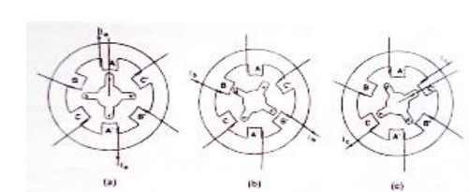

Now if B phase is energized then the rotor develops a torque because of variable reluctance and existences of variation in inductance. The torque developed is equal to (1/2)i_{B}2(dL_{B}/dθ). This direction is such that BB‘ and bb‘ try to get aligned. If this torque is more than the opposing load torque and frictional torque the rotor starts rotating. When the shaft occupies the position such that BB‘ and bb‘ are in alignment (i.e.,) θ=30°, no torque is developed as in this position dL_{B}/dθ=0. [Vide fig. 1.3(b)]

Now phase winding B is switched off and phase winding C is turned on to DC supply. Then the rotor experiences a torque as (dL_{C}/dθ) exists. The rotor continues to rotate. When the rotor rotates further 30°, the torque developed due to winding C is zero [vide fig. 1.3(c)] Then the phase winding C is switched off and phase winding A is energized. Then rotor experiences a torque and rotates further step 30°. This is a continuous and cyclic process. Thus the rotor starts. It is a self-starting motor.

As the speed increases, the load torque requirement also changes. When the average developed torque is more than the load torque the rotor accelerates. When the torques balance the rotor attains dynamic equilibrium position. Thus the motor attains a steady speed. At this steady state condition power drawn from the mains is equal to the time rate of change of stored energy in magnetic circuit and the mechanical power developed.
When the load torque is increased, the speed of the motor tends to fall, so that the power balance is maintained. If the speed is to be develop at the same value, the develop torque is to be increased by increasing the current. Thus more power is drawn from the mains. Vice-versa takes place when the load is reduced. Thus electrical to mechanical power conversion takes place.

POWER SEMICONDUCTOR SWITCHING CIRCUITS FOR SRM (POWER CONTROLLERS):
The selection of controller (converter) depends upon the application. One of the main aspects of the research in SRM drives has been the converter design. The main objectives of the design of the converter are performance of the drive and cost of the drive.
The power semiconductor switching circuits used are ---
1. Two power semiconductor switching devices per phase and two diodes.
2. (n+1) power semiconductor switching devices (n+1) diodes.
3. Phase winding using bifilar wires.
4. Split-link circuit used with even-phase number.
5. C-dump circuit.

1. Two Power Semiconductor Switching Devices per phase and two diodes

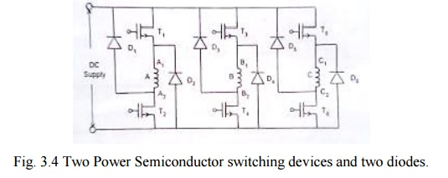

As shown in fig 1.4 phase winding A is connected to the dc supply through power semiconductor devices T₁ and T_{2.} Depending upon the rotor position, when the phase winding A is to be energized the devices T₁ and T₂ are turned ON. When the phase winding is to be disconnected from the supply (this instant is also dependent on the position of the shaft) the devices T₁ and T₂ are turned off .The stored energy in the phase winding A tends to maintain the current in the same direction. This current passes from the winding through D₁ and D₂ to the supply. Thus the stored energy is fed back to the mains.
Similarly phase winding B & C are also switched on to the supply and switched off from the supply in a cyclic manner. This circuit requires 2 power switching devices and 2 diodes for each phase winding. For high speed operation it is required to see that the stored energy can be fed back to the mains within the available period.
Usually the upper devices T₁, T₃ and T₅ are turned on and off from the signals obtained from the rotor position sensor .The duration of conduction or angle of conduction θ can be controlled by using suitable control circuitry .The lower devices T₂, T₄, T₆ are controlled from signals obtained by chopping frequency signal. The current in the phase winding is the result of logical AND ing of the rotor position sensor and chopping frequency .As a result it is possible to vary the effective phase current from a very low value to a high value .For varying the following methods are available.
1. By varying the duty cycle of the chopper.
2. By varying the conduction angle of the devices.
Merits
❖ Control of each phase is completely independent of the other phase.
❖ The converter is able to free wheel during the chopping period at low speeds which helps to reduce the reduce the switching frequency and thus the switching losses of the converter.
❖ The energy from the off going phase is feedback to the source, which results in utilization of energy
Demerits
❖ Higher number of switches required in each phase, which makes the converter expensive and also used for low voltage applications.

2. (n+1) power switching devices and (n+1) diodes
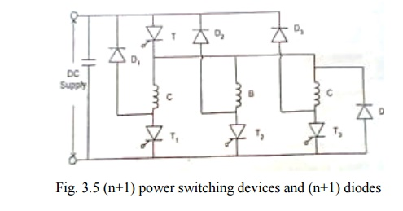
This circuit makes use of less number of power switching devices and diodes as shown in fig 1.5. When the (SCRs) switching devices T and T₁ are turned on phase winding A is energized from the dc supply. When these devices are turned off the stored energy in the phase winding is fed back to the mains through diodes D and D1. When devices T and T₂ are turned on the phase winding B is energized .When they are turned off ,the stored energy in B phase winding C is switched on and off from the mains. The cycle gets repeated.
This circuit makes use of (n+1) power switching devices and (n+1) diodes where n is equal to the number of phases.
Merits
❖ The converter uses low number of switching devices, which reduces the cost of the converter.
❖ The converter is able to freewheel during the chopping, thus reducing the switching frequency and losses.
❖ Voltage rating of all the switching devices and the diodes are V _{dc,} which is relatively low.
❖ The energy for the off going phase is transferred back into the source, which results in useful utilization of the energy and also improves the efficiency.
Demerits
❖ Disability to magnetize a phase while the off going phase is still demagnetizing which results in higher torque ripple during commutation.
❖ At higher speeds of the off going phase cannot be de-energized fast enough because the common switch ―T‖ keeps turnings on intermediately, disabling forced demagnetization.
❖ The common switch conducts for all the phases and thus has higher switching stress.

3. Phase winding using bifilar wires
Each phase winding has two exactly similar phase windings as shown in fig 1.6.For this bifilar wires are used .Each phase consists of two identical windings and are magnetically coupled when one of them are excited.
In stepper motor, the purpose of bifilar winding is for bipolar excitation with a reduced number of switching elements.
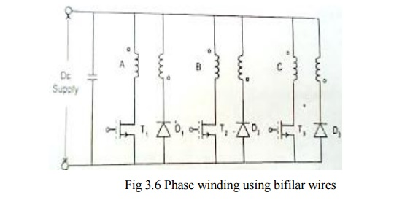
When T₁ is turned on the dc current passes through the phase winding A. when the devices T₁ is turned off the stored energy in the magnetic field is fed back to the dc source through the winding A‘ and D₁ to the supply.
The three devices operate in a sequential way depending upon the signals obtained from the rotor position sensor and the chopping signals for PWM technique obtained from the controller.
Merits
❖ The converter uses lower number of switching devices thus reducing the cost on the converter.
❖ The converter allows fast demagnetization of phases during commutation.
Demerits
❖ Bifilar winding suffers from double number of connections.
❖ A poor utilization of copper.
❖ Freewheeling is not possible during chopping as the phases have -V_{dc}. this causes of higher ripples in current and torque during chopping.
❖ The imperfection in the coupling between the two winding causes voltage spikes during turn off.
❖ The copper loss associated with the auxiliary winding is unacceptable high for many applications.

4. Split – link circuit used with even phase number

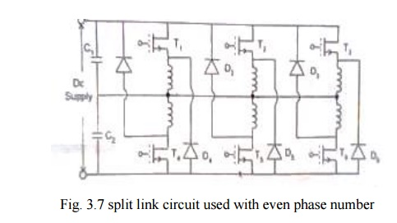
The circuit shown in fig.1.7 is used in a range of highly efficient drives (from 4-80kw).
The main power supply is split into two halves using split capacitors. During conduction, energy is supplied to the phases by one half the power supply. During commutation period, the phases demagnetize into other half of the power supply.
When switch T1 is turned on, phase winding 1 is energized by capacitor c1. When switch T2 is turned off, the stored energy in the phase winding 1 is fed back to the capacitor c2 through diode D4.
When T4 is turned on by capacitor C2 and phase winding 4 is energized. When switch T4 is turned off, stored energy in the winding 4 is feedback to the capacitor C1 through diode D1. The similar operation takes place in the remaining winding also.
Merits
❖ It requires lower number of switching devices.
❖ Faster demagnetization of phases during commutation.
Demerits
❖ During chopping, freewheeling is not possible as the phasor have the voltage Vdc/2. This causes higher switching frequency and more losses.
❖ This is not feasible for low voltage application.
❖ The converter is fewer faults tolerant as fault in any phase will unbalance the other phase that is connected to it.

5. C-Dump circuit
In the C dump circuit shown in fig. 1.8. the device count is reduced to ‗n‘ plus one additional devices to bleed the stored energy from the dump capacitor C back to supply via the step down chopper circuit. The mean capacitor voltage is maintained well above the supply to permit rapid defluxing after commutation.
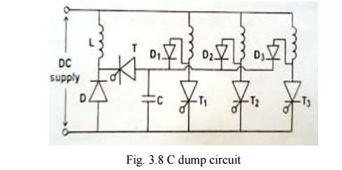
A control failure in the energy-recovery circuit would result in the rapid build-up of charge on the capacitor and if protective measures were not taken the entire converter could fail from over voltage.
Demerits
❖ Dump capacitor voltage is maintained ―2 Vdc‖ to allow fast demagnetization. But use of a capacitor and an inductor in the dump circuit and also the voltage rating of other devices is twice the bus voltage
❖ Monitoring of the dump capacitor voltage 'C‘ and control of dump switch T makes the converter very complicated and also the converter does not allow freewheeling.

VOLTAGE AND TORQUE EQUATIONS OF SRM:
Basic voltage equation of SRM:

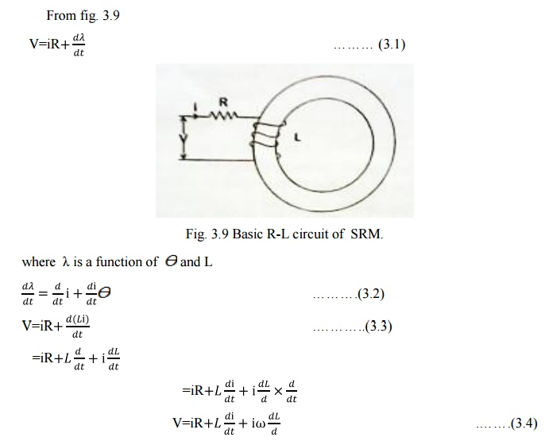
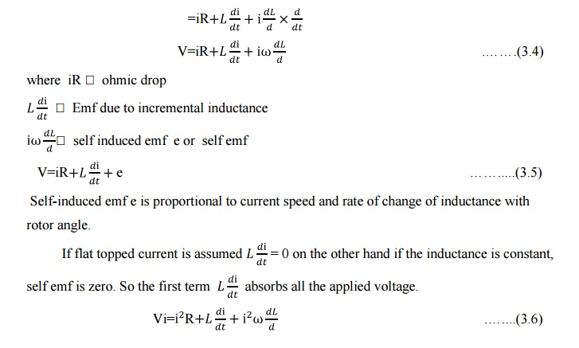
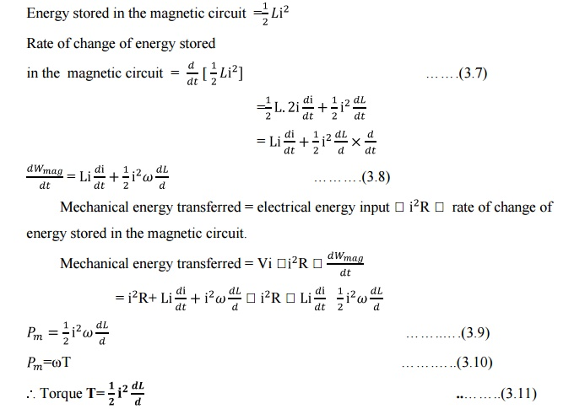

POWER SEMICONDUCTOR SWITCHING CIRCUITS FOR SRM :
The selection of controller (converter) depends upon the application. One of the main aspects of the research in SRM drives has been the converter design. The main objectives of the design of the converter are performance of the drive and cost of the drive.

The power semiconductor switching circuits used are
1. Two power semiconductor switching devices per phase and two diodes.
2. (n+1) power semiconductor switching devices (n+1) diodes.
3. Phase winding using bifilar wires.
4. Split-link circuit used with even-phase number.
5. C-dump circuit.

CONTROL CIRCUITS FOR SRM:
For motoring operation the pulses of phase current must coincide with a period of accuracy inductance. The timing and dwell (i.e.) period of conductance of the current pulse determine the torque, the efficiency and other parameters. With fixed firing angles, there is a monotonic relationship exist between average torque and rms phase current but generally it is not linear. This may present some complications in feedback-controlled systems. Although it is possible to achieve ‗near servo-quality‘ dynamic performance, particularly in respects of speed range torque/inertia and reversing capability.
More complex controls are required for higher power drives, particularly where a wide speed range is required at constant power, and microprocessor controls are used. As high-speed operation, the peak current is limited by the self-emf of the phase winding. A smooth current waveform is obtained with a peak/rms ratio similar to that of a half sinewave.
At low speed, the self-emf of the winding is small and the current must be limited by chopping or PWM of the applied voltage.
Two types of control circuits used are:
1. Hysteresis type to maintain constant current
2. Voltage pulse width modulation control (or) duty cycle control.

HYSTERISIS TYPE CURRENT REGULATION:
As by this control circuit current is maintained more or less constant like ―hysteresis‖ throughout the conduction period in each phase it is known as hysteresis type control. Fig 1.10 (a) shows the current waveform controlled by the hysteresis type current regulator. The schematic arrangement of the control circuit is shown in fig 1.10 (b).
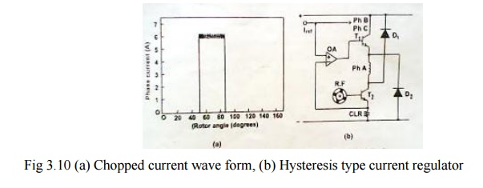
Principle of operation
As shown in fig. 1.10(b) the transducer (a tachogenerator) is connected from the rotor and then the output signal from the transducer is given as a feedback signal at the base of transistor T₂. From the emitter of transistor T_{2,} the portion of the feedback signal (current) is fed at the input of the operational amplifier (O.A). There it is compared with the reference current and correspondingly after amplification the feedback signal is given at the base of transistor T₁. This signal in combination with collector current will flow from the emitter of transistor T₁ through A phase winding of the machine. Thus the current through A phase winding can be controlled depending on the requirement. CLR is the resistance for limiting the current as per the design.
As the current reference increase the torque increases. At low currents the torque is roughly proportional to current squared but at higher current it becomes more nearly linear. At very high currents, saturation decreases the torque per ampere again. This type of control produces a constant-torque type of characteristics.
With loads whose torque increases monotonically with speed, such as fans and blowers, speed adjustment is possible without tachometer feedback but general feedback is needed to provide accurate speed control. In some cases the pulse train from the soft position sensor may be used for speed feedback, but only at relative high speeds.
As low speeds, a larger number of pulses per revolution are necessary and this can be generated by an optical encoder or resolver for alternatively by phase-locking a high frequency oscillator to the pulses of the commutation sensor. System with resolver-feedback or high-resolution optical encoders can work right down to zero speed.
The ―hysteresis type‖ current regulator may require current transducers of wide bandwidth, but the SR drive has the advantage that they can be grounded at one end with the other connected to the negative terminal of the lower phase leg switch. The sensors used are shunts or hall-effect sensors or sensefets with in build current sensing.

VOLTAGE PWM TYPE CURRENT REGULATION
The schematic arrangement of PWM type control circuit is shown in fig. 1.11

Principle of operation:
Through transducer (tachogenerator) the mechanical signal (speed) is converted into electrical signal (current), which is fed from at the base of transistor T2. Thos base current combining with collector current flows the emitter of transistor T2 through CLR to the
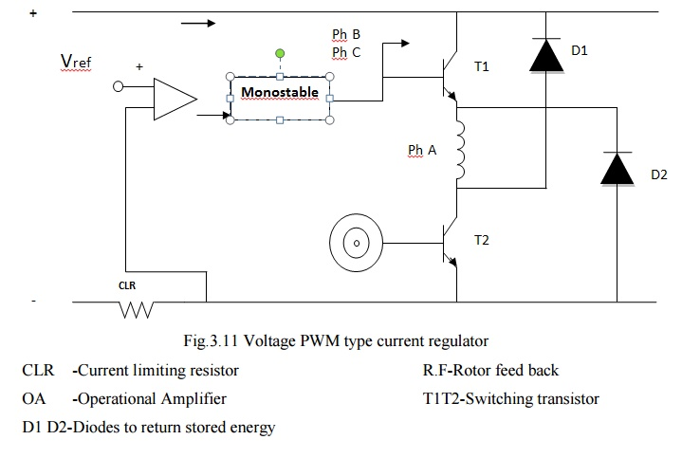
negative of the supply. Based on the feedback signal, the voltage at phase A changes. This feedback voltage is given as one input to the operational amplifier where it is compared with the reference voltage, correspondingly the difference is amplified and fed to the mono stable circuit. This circuit modulates the pulse width of the incoming signal based on the requirement and the modulated signal is given at the base of T1.This signal combines with collector current of T1 and flows through phase A as modulated current based on the requirement. Thus the current is regulated or controlled using pulse width modulation and rotor feedback.
A desirable future of both control methods is that the current wave form tends to retain the same shape over a wide speed range.
When the PWM duty cycle reaches 100%, the motor speed can be increased by increasing the conduction period. These increases eventually reach maximum values after which the torque becomes inversely proportional to speed squared but they can typically double the speed range at constant torque. The speed range over which constant power can be maintained is also quite wide and very high maximum speeds can be achieved, as in the synchronous reluctance motor and induction motor, because there is not the limitation imposed by fixed as in PM motors.

TORQUE-SPEED CHARACTERISTICS:
Torque developed (i.e.) average torque developed but SRM depends upon the current wave form of SRM phase winding. Current waveform depends upon the conduction period and chopping details. It also depends upon the speed.
Consider a case that conduction angle ϴ is constant and the chopper duty cycle is 1.(i.e.) it conducts continuously. For low speed operating condition, the current is assumed to be almost flat shaped. Therefore the developed torque is constant. For high speed operating condition, the current wave form gets changed and the average torque developed gets reduced.
Fig. 1.12(a) represents the speed torque characteristics of SRM for constant ϴ and duty cycle. It is constant at low speeds and slightly droops as speed increases. For various other constant value of ϴ , the family of curves for the same duty cycle is shown in fig.1.12.
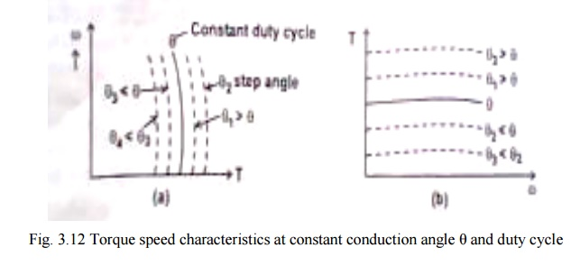
Torque speed characteristics for fixed ϴ and for various duty cycles are shown in fig. 1.12. ϴand duty cycle are varied by suitably operating the semiconductor devices.

1. Torque Speed Capability Curve
Maximum torque developed in a motor and the maximum power that can be transferred are usually restricted by the mechanical subsystem design parameters.
For given conduction angle the torque can be varied by varying the duty cycle of the chopper. However the maximum torque developed is restricted to definite value based on mechanical consideration.
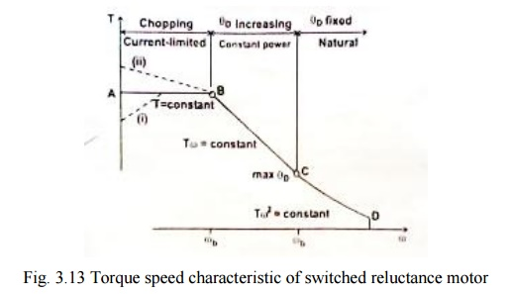
AB in the fig.1.13 represents constant maximum torque region of operation.
At very low speeds, the torque / speed capability curve may deviate from the clock torque characteristics. If the chopping frequency is limited or if the bandwidth of the current regulator is limited, it is difficult to limit the current without the help of self emf of the motor and the current reference may have to be reduced.
If very low windage and core loss permit the chopper losses to be increased, so that with higher current a higher torque is obtained. Under intermittent condition of course very much higher torque can be obtained in any part of the speed range up to Ѡ b.
The motor current limits the torque below base speed. The corner point‘ or base speed ‗Ѡ b‘ is the highest speed at which maximum current can be supplied at rated voltage with fixed firing angles. If these angles are still kept fixed, the maximum torque at rated voltage decreases with speed squared. But if the conduction angle is increased,(i.e.)ϴ on is decreased, there is a considerable speed range over which maximum current can be still be forced into the motor. This maintains the torque at a higher level to maintain constant power characteristic. But the core losses and windage losses increases with the speed. Thus the curve BC represents the maximum permissible torque at each speed without exceeding the maximum permissible power transferred. This region is obtained by varying ϴ D to its maximum value ϴ D max. ϴ D is dwell angle of the main switching devices in each phase. Point C corresponds to maximum permissible power; maximum permissible conduction angle ϴ D max and duty cycle of the chopper is unity.

Curve CD represents TѠ ² constant. The conduction angle is kept maximum and duty cycle is maximum by maintaining TѠ ² constant. D corresponds to maximum Ѡ permissible.
The region between the curve ABCD and X axis is the ―permissible region of operation of SRM‖

DISTINCTION BETWEEN SWITCHED RELUCTANCE MOTOR AND THE VARIABLE RELUCTANCE STEPPER MOTOR:

The conduction angle for phase currents is controlled and synchronized with the rotor position, usually by means of a shaft position sensor.
Thus , SR motor is exactly like a brushless dc motor. But the stepper motor is usually fed with a square-wave of phase current without rotor position feedback.
SR motor is designed for efficient power conversion at high speeds comparable with those of the PM brushless dc motor. The stepper motor is usually designed as a torque motor with a limited speed range.SR motor is more than a high-speed stepper motor. Its performance and low manufacturing cost make it a competitive motor to PM brushless dc system.

1. Merits of SRM:
1. Construction is simple and robust, as there is no brush.
2. Rotor carries no windings, no slip rings and brush-less maintenance.
3. No permanent magnet, neither in the stator nor in the rotor.
4. Ventilating system is simpler as losses takes place mostly in stator.
5. Power semiconductor switching circuitry is simpler.
6. No shoot-through fault is likely to happen in power semiconductor circuits.
7. Torque developed does not depend upon the polarity of the current in the phase winding.
8. The operation of the machine can be easily changed from motoring mode to generating mode by varying the region of conduction.

9. It is impossible to have very high speeds.
10. Depending upon the requirement, the desired torque speed characteristics can be tailor made.
11. It is a self-starting machine.
12. Starting torque can be very high without excessive inrush currents.

2. Demerits of SRM
1. Stator phase winding should be capable of carrying the magnetizing current also, for setting up the flux in the air gap.
2. For high speed operations, the developed torque has undesirable ripples. As a result it develops undesirable acoustic losses (noise).
3. For high speeds, current waveform also has undesirable harmonics. To suppress this effect alarge size capacitor is to be connected.
4. The air gap at the aligned axis should be very small while the air gap at the inter-polar axis should be very large. It is difficult to achieve. No standardized practice is available.
5. The size of the motor is comparable with the size of variable speed induction motor drive.
6. Number of power wires between power semiconductor circuitry and the motor and the number of control cables from one controller to the power semiconductor circuitry are more and all to be properly connected.
7. It requires a position sensor.

3. Application of SRM
1. Washing machines
2. Vacuum cleaners
3. Fans
4. Future automobile applications
5. Robotic control applications

SHAFT POSITION SENSING:
❖ Commutation requirement of the SR motor is very similar to that of a PM brushless motor.
❖ The shaft position sensor and decoding logic are very similar and in some cases it is theoretically possible to use the same shaft position sensor and the same integrated circuit to decode the position signals and control PWM as well.
❖ The shaft position sensors have the disadvantage of the associated cost, space requirement and possible extra source of failure. Reliable methods are well established. In position sensors or speed sensors, resolvers or optical encoders may be used to perform all the functions of providing commutation signals, speed feedback and position feedback.
❖ Operation without position sensor is possible. But to have good starting and running performance with a wide range of load torque and inertias, sensor is necessary.
❖ When the SR motor is operated in the 'open-loop‘ mode like a stepper motor in the slewing range, the speed is fixed by the reference frequency in the controller as long as the motor maintains 'step integrity‘. (i.e) stay in synchronism. Therefore like an ac synchronous motor, the switched reluctance motor has truly constant speed characteristics.

This open-loop control suffers from two dis-advantages.
(a) To ensure that synchronism is maintained even though the load torque may vary.
(b) To ensure reliable starting.

❖ Because of the large step angle and a lower torque/inertia ratio, the SR motor usually does not have reliable ‗starting rate‘ of the stepper motor.
❖ Also some form of inductance sensing or controlled current modulation (i.e) such as sine wave modulation may be necessary in the control at low speeds.

MICROPROCESSOR OR COMPUTER BASED CONTROL OF SRM DRIVE:

Today in industrial places there is high demands on control accuracies, flexibility, ease of operation, repeatability of parameters for many drive applications. Nowadays switched reluctance motors are increasingly used in industries. To meet the above requirements, uses of microprocessor have become important.
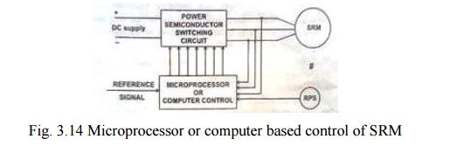
Fig. shows the block diagram of microprocessor based control of SRM drive. This control system consists of power semiconductor switching circuit, SRM with rotor position sensor and microprocessor system. In this system microprocessor acts as a controller for the switched reluctance motor and generate control pulses to the power semiconductor switching circuits.
The input DC supply is fed to the power semiconductor switching circuits. Different types of power semiconductor switching circuits are used for different application. Normally the circuits are inverter circuit configuration.
The power semiconductor devices are turned on and off by controller circuit. Here the controller circuit is microprocessor or computer based control system.
In the SRM drive shown in fig. 3.14, the rotor position sensor gives the information about the rotor with respect to the reference axis to the microprocessor or computer control. The controller also receives the status of current, flow through the phase winding and reference signal.
The microprocessor or computer compares the signals obtained from the RPS and reference and generate square pulses to the power semiconductor devices. This signal is fed to the inverter circuit. The phase winding of the SRM is energized depending upon the turning on and off of the power semiconductor switching circuit.
The microprocessor or computer controller can perform the following functions.
a) Control the feedback loops.
b) PWM or square wave signal generation to inverters.
c) Optimal and adaptive control.
d) Signal monitoring and warning.
e) General sequencing control.
f) Protection and fault overriding control.
g) Data acquisition.

The superiority of microprocessor or computer control over the conventional hardware based control can be easily recognized for complex drive control system. The simplification of hardware saves control electronics cost and improves the system reliability. The digital control has inherently improves the noise immunity which is particularly important because of large power switching transients in the converters.

SHORT QUESTIONS AND ANSWERS:
- What is srm?

It is a doubly salient , single excited motor.this means that it has salient poles on both rotor and the stator.but only one member carries winding.the rotor has no windings,magnets or case windings.

What are the advantages od SRM?

- Construction is very simple
- Rotor carries no winding
- No brushes and requires less maintenance

What are the disadvantages of SRM?

- It requires a position sensor
- Stator phase winding shold be capable of carrying magnetizing currents

Why rotor position sensor is essential for the operation of switched reluctance motor?

It is necessary to use a rotor position sensor for commutation and speed feedback. The turning on and off operation of the various devices of power semiconductor switching circuit are influenced by signals obtained from rotor position sensor.

What are the different power controllers used for the control of SRM?
- Using two power semi conductors and two diodes per phase
- Phase windings and bifilar wires
- Dump – C converter
- Split power supply converter

What are the applications of SRM?

- Washing machines
- Fans
- Robotic control applications
- Vacuum cleaner
- Future auto mobile applications

What are the two types of current control techniques?

- Hysteresis type control
- PWM type control

What is meant by energy ratio?

Energy ratio = Wm/(Wm+R)=0.45 Wm=mechanicalenergy transformed
This energy cannot be called as efficiency. As the stored energy R is not wasted as a loss but it is feedback to the source through feedback diodes.

Write the torque equation of SRM?

T=1/2(i² dL/dθ)

What is phae winding?

Ststor poles carrying field coils.the field coils of opposite poles are connected in series such that mmf „s are additive and they are called „‟phase winding‟‟ of SRM.

Write the characteristics of SRM.

- Lowest construction complexity, many stamped metal elements
- Like a BLDC or stepper without the magnets
- High reliability (no brush wear), failsafe for Inverter but...acoustically noisy
- High efficiency

12. Write the voltage,power range of SRM.

Industrial
Voltage | Motor Power | Speed Range
100 - 240 Vac | 50W - 10'sKW | 0 - 60,000 RPM

Automotive
Voltage | Motor Power | Speed Range
12 - 42Vdc | 50W -1kW | 0 - 20,000 RPM

Define the control system of SRM.

The control system is responsible for giving the required sequential pulses to the power circuitry in order to activate the phases as required. There are two options for producing the sequence including a microcontroller to produce the signal or a timer circuit which could also produce the desired signal.

Define the timer circuit of SRM.

The use of a timer circuit would be very effective in producing the necessary signal in which to control the circuit. As the required signal is very simple it could easily be implemented by digital timer, such as the 555 timer. A digital timer is more precise than any other form of timer, such as a mechanical timer. With the widespread use of digital logic within integrated circuits the cost of these timers has reduced considerably. The latest controllers in use incorporate programmable logic controllers (PLC‟s) rather than electromechanical components in its implementation. Within PLC‟s, the timers are normally simulated by the software incorporated in the controller; the timer is therefore controlled by the software. There are obvious advantages to this system, although the control of a soft start could be hard to implement in this way.

Write the soft starters of SRM.

Mechanical – come in the form of torque limiters utilizing clutches and various couplings,

Electrical – these soft starters alter the power supply to the motor to reducing the torque and current demand. This is normally performed either by reducing the supply voltage, or controlling the frequency of excitation. Since switched reluctance motors are driven by a controlled pulsed supply, frequency control is an obvious choice in this case.

What are the goals to contro, soft starting?

Fixed start-up time - the start up will be controlled to achieve full speed within a fixed time
Current limit - the motor current can be monitored and the start up controlled to keep it below a specified limit

Torque limit - an intelligent starter can calculate the motor torque based on the current and voltage demand and control the start up to provide a constant starting torque

What are the major advantages of frequency control of SRM?

This has a major advantage of being easily controlled and changed at any point by simply altering the programming. By using this method the development time is reduced and the number of modules to implement is also reduced.

Define the isolation of SRM.

The electrical isolation of the control and power circuitry modules is very important and is used so that the control electronics are protected from any voltage fluctuations in the power circuitry. The major method of isolation used today are optoisolators, these isolators use short optical transmission paths to transfer a signal from one part of a circuit to another. The isolator incorporates a transmitter and a receiver, the signal therefore converts from electrical to optical before converting back to electrical thereby breaking any electrical connection between input and output.

Define the power circuitry of SRM.

- The most common approach to the powering of a switched reluctance motor is to use an asymmetric bridge converter.
- There are 3 phases in this in an asymmetric bridge converter corresponding to the phases of the switched reluctance motor. If both of the power switches either side of the phase are turned on, then that corresponding phase shall be actuated. Once the current has risen above the set value, the switch shall turn off. The energy now stored within the motor winding shall now maintain the current in the same direction until that energy is depleted.
- N+1 Switch And Diode
- This basic circuitry may be altered so that fewer components are required although the circuit shall perform the same action. This efficient circuit is known as the (n+1) switch and diode configuration.
- A capacitor can be added to either configuration, and is used to address noise issues by ensuring that the switching of the power switches shall not cause fluctuations in the supply voltage.

What are the current control schemes?

- Hysteresis type current regulator
- PWM type current regulator

PART – B

- Explain the construction and working principle of switched reluctance motor. (16)
- Describe the various power controller circuits applicable to switched reluctance motor and explain the operation of any one scheme with suitable circuit diagram. (16)
- Draw a schematic diagram and explain the operation of a „C‟ dump converter used for the control of SRM. (16)
- Derive the torque equation of SRM. (16)
- Draw and explain the general torque-speed characteristics of SRM and discuss the type of control strategy used for different regions of the curve. Sketch the typical phase current waveforms of low speed operation. (16)
- Describe the hysterisis type and PWM type current regulator for one phase of a SRM. (16)

UNIT II - STEPPER MOTOR
INTRODUCTION
It is an electrodynamics and electromagnetic equipment.
These motors are also referred to as step motors or stepping motors.
On account of its unusual construction, operation and characteristics it is difficult to define a stepper motor. Definition given in British Standard specification (BSS) is -
A stepper motor is brushless dc motor whose rotor rotates in discrete angular displacements when its stator windings are energized in a programmed manner. Rotation occurs because of magnetic interaction between rotor poles and poles of the sequentially energized winding. The rotor has no electrical windings, but has salient and magnetic/or magnetized poles.
The stepper motor is a digital actuator whose input is in the form of digital signals and whose output is in the form of discrete angular rotation. The angular rotation is dependent on the number of input pulses the motor is suitable for controlling the position by controlling the number of input pulses. Thus they are identically suited for open position and speed control.

Applications:
Printers, Graph plotters , Tape driver , Disk Drives , Machine Tools, X-Y Recorders,
Robotics space Vehicle, IC Fabrication and Electric Watches.

CLASSIFICATION OF STEPPER MOTORS:
As construction is concerned stepper motors may be divided into two major groups.
1. Without Permanent Magnet (PM)
(a) Single Stack
(b) Multi Stack

2. With Permanent Magnet
(a) Claw Pole Motor
(b) Hybrid Motors

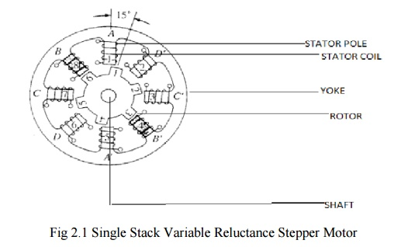
SINGLE STACK VARIABLE RELUCTANCE STEPPER MOTOR

1. Construction:
The VR stepper motor characterized by the fact there is no permanent magnet either on the rotor or the stator. The construction of a 3-phase VR stepper motor with 6 poles on the stator and 4-pole on the rotor as shown.
The Stator is made up of silicon steel stampings with inward projected even or odd number of poles or teeth. Each and every stator poles carries a field coil an exciting coil. In case of even number of poles the exciting coils of opposite poles are connected in series. The two coils are connected such that their MMF gets added .the combination of two coils is known as phase winding.
The rotor is also made up of silicon steel stampings with outward projected poles and it does not have any electrical windings. The number of rotor poles should be different from that of stators in order to have self-starting capability and bi direction. The width of rotor teeth should be same as stator teeth. Solid silicon steel rotors are extensively employed. Both the stator and rotor materials must have lowering a high magnetic flux to pass through them even if a low magneto motive force is applied.

2. Electrical Connection
Electrical connection of VR stepper as shown fig. Coil A and A‘ are connected in series to form a phase winding. This phase winding is connected to a DC source with the help of semiconductor switch S1.Similary B and B‘ and C and C‘ are connected to the same source through semiconductor switches S2 and S3 respectively. The motor has 3 –phases a, b and c.
‘ a’ phase consist of A and A‘ Coils
‘ b ‘ phase consist of B and B‘ Coils
‘ c ‘ phase consist of C and C‘ Coils

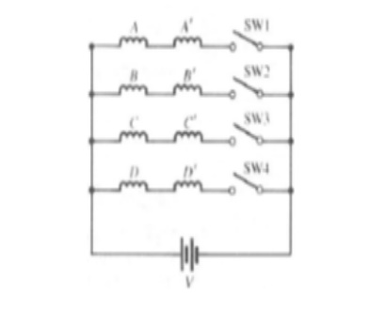
3. Principle of Operation
It works on the principle of variable reluctance. The principle of operation of VR stepper motor explained by referring the fig.

(a).Mode 1 : One phase ON or full step operation
In this mode of operation of stepper motor only one phase is energized at any time. If current is applied to the coils of phase ‗a‘ (or) phase ‗a‘ is excited, the reluctance torque causes the rotor to run until aligns with the axis of phase a. The axis of rotor poles 1 and 3 are in alignment with the axis of stator poles ‗A‘ and ‗A‘‘. Then angle θ = 0° the magnetic reluctance is minimized and this state provides a rest or equilibrium position to the rotor and rotor cannot move until phase ‗a‘ is energized.

Next phase b is energized by turning on the semiconductor switch S2 and phase ‗a‘ is de –energized by turning off S1.Then the rotor poles 1 and 3 and 2 and 4 experience torques in opposite direction. When the rotor and stator teeth are out of alignment in the excited phase the magnetic reluctance is large. The torque experienced by 1 and 3 are in clockwise direction and that of 2 and 4 is in counter clockwise direction. The latter is more than the former. As a result the rotor makes an angular displacement of 30° in counterclockwise direction so that B and B‘ and 2 and 4 in alignment. The phases are excited in sequence a, b and c the rotor turns with a step of 30° in counter clockwise direction. The direction of rotation can be reversed by reversing the switching sequence in which are energized and is independent of the direction of currents through the phase winding.

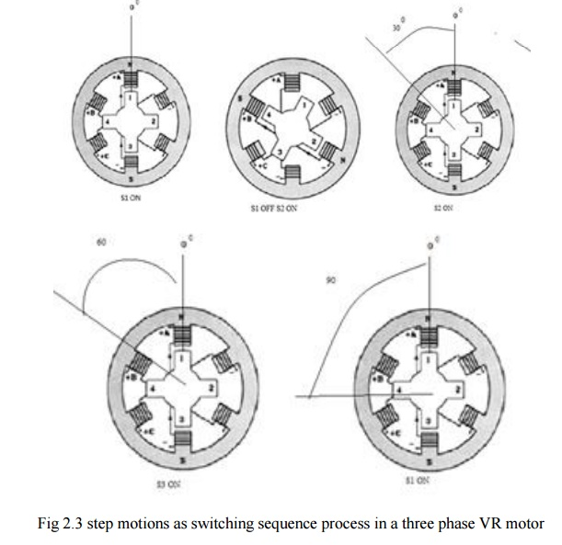

The truth table for mode I operation in counter and clockwise directions are given in the table
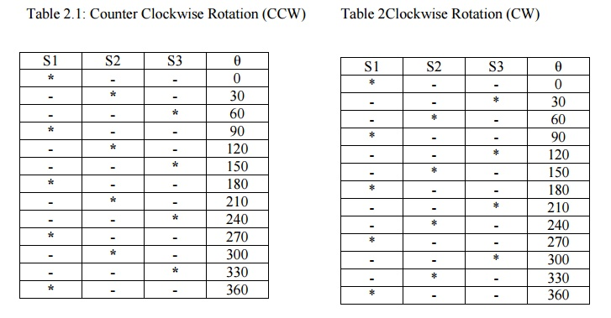

(b).Mode II: Two Phase on Mode
In this mode two stator phases are excited simultaneously. When phases a and b are energized together, the rotor experiences torque from both phases and comes to rest in a point mid-way between the two adjacent full step position. If the phases b and c are excited, the rotor occupies a position such that angle between AA‘ axis of stator and 1-3 axis of rotor is equal to 45°.To reverse the direction of rotation switching sequence is changed a and b,a and c etc. The main advantage of this type of operation is that torque developed by the stepper motor is more than that due to single phase ON mode of operation.
The truth table for mode II operation in counter clockwise and clockwise directions is given in table a 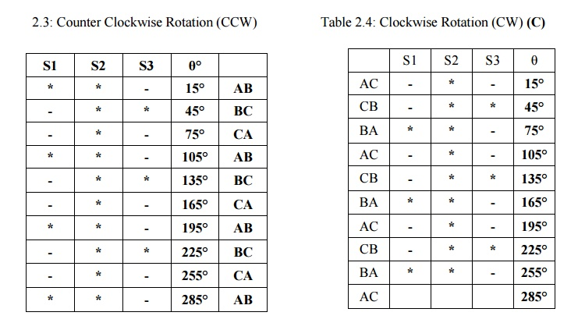

Mode III: Half step Mode
In this type of mode of operation on phase is ON for some duration and two phases are ON during some other duration. The step angle can be reduced from 30° to 15° by exciting phase sequence a, a+b, b,b+c, c etc. The technique of shifting excitation from one phase to another from a to b with an intermediate step of a+b is known as half step and is used to realize smaller steps continuous half stepping produces smoother shaft rotation.
The truth table for mode III operation in counter and clockwise directions are given in the table
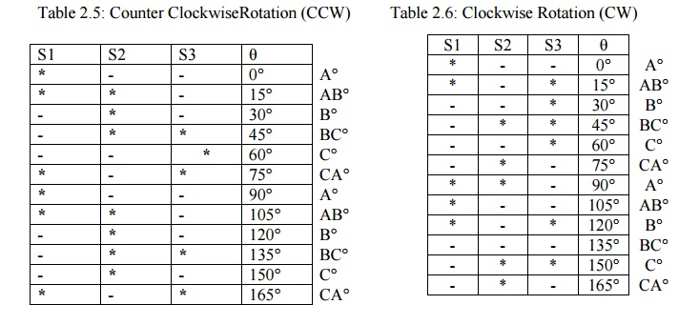
MICRO STEPPING CONTROL OF STEPPING MOTOR
Stepping motor is a digital actuator which moves in steps of θs in response to input pulses. such incremental motion results in the following limitations of the stepper motor

Limited resolution
As θs is the smallest angle through which the stepper motor can move, this has an effect on position accuracy of incremental servo system employing stepper motors because the stepper motor cannot position the load to an accuracy finer than θs.

Mid frequency Resonance
A phenomenon in which the motor torque suddenly drops to a low value at certain pulse frequencies as in fig
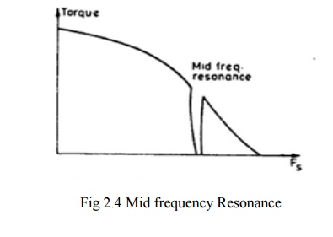
A new principal known as micro stepping control has been developed with a view of overcoming the above limitation .It enables the stepping motor to move through a tiny micro step of size ∆ θs << θs full step angle is response to input pulses.

1. Principle of micro stepping
Assume a two phase stepper motor operating in ‗one phase ON‘ sequence. Assume also that only B2 winding is On and carrying current IB2 = IR, the rated phase current. All the other winding are OFF. In this state the stator magnetic field is along the positive real axis as show in fig (a). Naturally the rotor will also as be in θ = 0° position.

When the next input pulse comes, B2 is switched OFF while A1 is switched ON.In this condition IA1= IR while all the phase current are zero. As a result the stator magnetic field rotates through 90® in counter clockwise direction as show in fig (a).
The rotor follows suit by rotating through 90° in the process of aligning itself with stator magnetic field. Thus with a conventional controller the stator magnetic field rotates through 90° when a new input pulse is received causing the rotor to rotate full step.
However in micro stepping we want the stator magnetic field to rote through a small angle θs << 90° in respect to input pulse. This is achieved by modulating the current through

B2 and A1 winding as show in fig (b) such that
IA1= IR sin θ
IB1= IR cos θ
Then the resulting stator magnetic field will be at an angle θ ° with respect to the positive real axis. consequently the rotor will rotate through an angle θs << 90° .
This method of modulating current through stator winding so as to obtain rotation of stator magnetic field through a small angle θ °

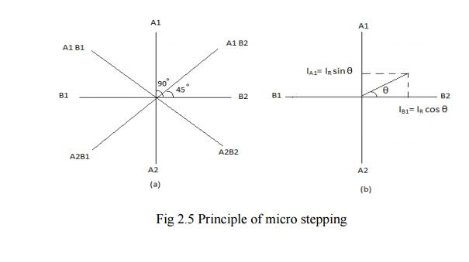

MULTISTACK VARIABLE RELUCTANCE STEPPER MOTOR
These are used to obtain smaller step sizes, typically in the range of 2° to 15°. Although three stacks are common a multistack motor may employ as many as seven stacks. This type is also known as the cascade type. A cutaway view of a three stack motor is shown in fig. 2.6.
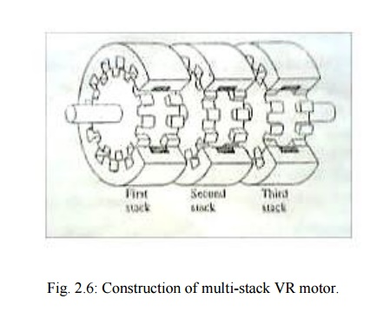
A multistack (or m-stack) variable reluctance stepper motor can be considered to be made up of ‘m‘ identical single stack variable reluctance motors with their rotors mounted on a single shaft. The stators and rotors have the same number of poles (or teeth) and therefore same pole (tooth) pitch. For a m0stack motor, the stator poles (or teeth) in all m stacks are aligned, but the rotor poles (teeth) are displaced by 1/m of the pole pitch angle from one another. All the stator pole windings in a given stack are exited simultaneously and, therefore the stator winding of each stack forms one phase. Thus the motor has the same number of phases as number of stacks.
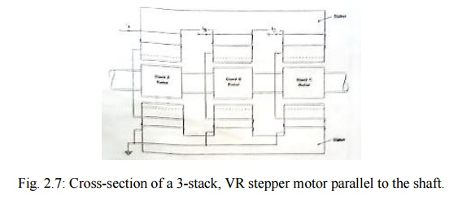
Figure 2.7 shows the cross section of a three stack (3-phase) motor parallel to the shaft. In each stack, stator and rotors have 12 poles (teeth). For a 12 pole rotor, pole pitch is 30° and therefore, the rotor poles (teeth) are displaced from each other by 1/3rd of the pole pitch or 10°. The stator teeth in each stack are aligned. When the phase winding A is excited rotor teeth of stack A are aligned with the stator teeth as shown in fig. 2.8.
When phase A is de-energized and phase B is excited the rotor teeth of stack B are aligned with stator teeth. The new alignment is made by the rotor movement of 10° in the anticlockwise direction. Thus the motor moves one step (equal to ½ pole pitch) due to change of excitation from stack A to stack B
Next phase B is de-energized and phase C is excited. The rotor moves by another step 1/3rd of pole pitch in the anticlockwise direction. Another change of excitation from stack C to stack A will once more align the stator and rotor teeth in stack A. however during this process (A → B → C → A) the rotor has moved one rotor tooth pitch.
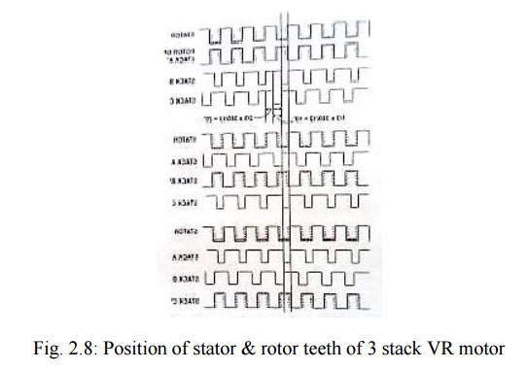
Let Nr be the number of rotor teeth and ‗m‘ the number of stacks or phases, then
Tooth pitch Tp= 360/Nr ……………… (2.1)
Step Angle α= 360°/mNr ………………. (2.2)

HYBRID STEPPER MOTOR

Principle of operation
Most widely used hybrid motor is the two phase type as shown in fig2.11. This model has four poles and operates on one phase on excitation.
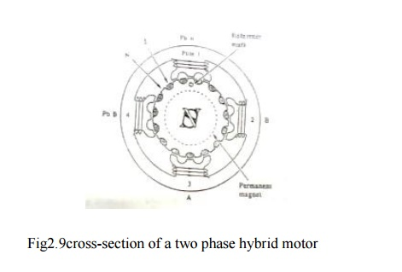
The coil in pole 1 and that in pole 3 are connected in series consisting of phase A, and pole 2 and 4 are for phase B. Fig 2.12 shows the proce3ss of rotor journey as the winding currents are switched in one phase ON excitation.
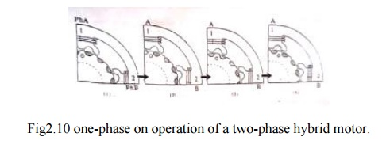

The poles of phase A are excited the teeth of pole 1 attract some of the rotors north poles, while the teeth of pole 3 align with rotor‘s south poles. Current is then switched to phase B, The rotor will travel a quarter tooth pitch so that tooth alignment takes place in 2 and 4.

Next current is switched back to phase A but in opposite polarity to before, the rotor will make another quarter tooth journey. The tooth alignment occurs in opposite magnetic polarity to state 1. When current is switched to phase B in opposite polarity (4) Occurs as a result of quarter tooth pitch journey.

The structures of two phase motor considered in fig.2.11 will not produce force in a symmetrical manner with respect to the axis. The motor having 8 poles in the stator shown in fig2.13 considered as the structure in which torque is generated at a symmetrical position on the surface.
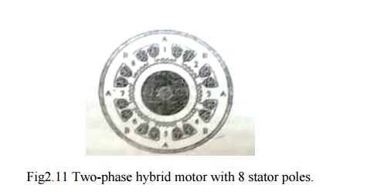

SINGLE PHASE STEPPING MOTOR
These are motors which are designed to be operated from single phase supply. They are widely use in watches and clocks, timers and counters. Present single phase stepping motors use one or more (two) permanent magnets, because permanent magnets are quite necessary to raise the ratio of torque to input power in a miniature motor.

The two requirements of single phase stepping motor are -
To detent the motor at a particular position when the coil is not excited.
To rotate the motor at desired direction by switching the magnetic polarity of only one coil.

1. CONSTRUCTION
It is a permanent magnet type stepper motor with two poles. Rotor is a circular type of permanent magnet as shown in figure 2.27.ststor is made of silicon steel stampings with two salient poles. Stator carries a coil which is connected to a pulsed supply. The air gap is specially designed so that specific reluctance at different radial axes are different. Minimum values occur at one tip of the poles. Under normal conditions the rotor occupies any one of the decent position shown in fig 2.28(a0 or as in (b) to minimum reluctance position. two positions shown in figures 2.28(a) & (b) are the detent positions of the rotor of the stepper motor.
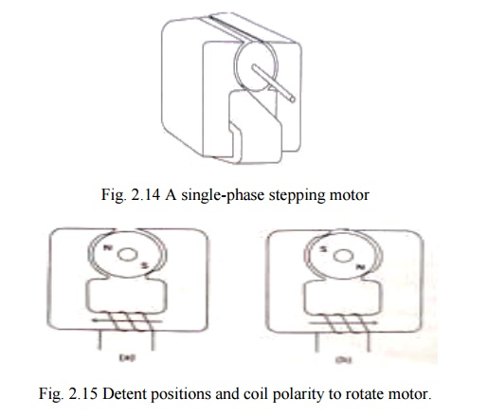

2. PRINCIPLE OF OPERATION
When the coil is given an electric positive pulse, pole A in position 1 as shown in figure. 2.28(a) it experiences a torque in clockwise direction and finally attains a steady state as in fig 2.28(b).then pulse given to the coil is zero. After a lapse of a second, from the start of the pulse, a negative pulse is given to the coil which makes the pole A as south and pole B as north. Rotor experiences another torque in figure 2.28(a).by repeating the cycle the rotor rotates continuously in step .it is not possible to develop torque in counter clockwise direction by altering pulses.

THEORY OF TORQUE PREDICTION
According to Faradays laws of electromagnetic induction
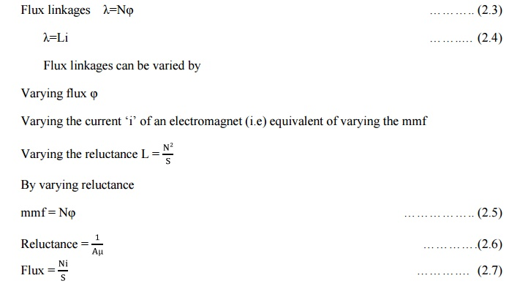
If the reluctance of magnetic circuit can be varied, inductance L and the flux linkages λ can also be varied.

Consider a magnetic circuit as shown in fig. 2.29.
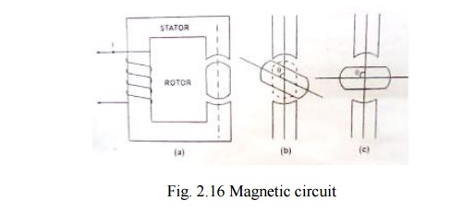
The stator consists magnetic core with two pole arrangement. Stator core carries a coil. Rotor is also made up of ferrous material. The motor core is similar to a salient pole machine. Let the angle between the axis of stator pole and rotor pole be θ. let the angular displacement be illustrated using fig. 2.29 (a, b and c).
Case 1: θ = 0
As shown in fig. 2.29 (a) the air gap between the stator and rotor is very very small. Thereby the reluctance of the magnetic path is least. Due to minimum reluctance, the inductance of the circuit is minimum. Let it be Lmax
Case 2 : θ = 45⁰
As shown in fig. 2.29(b) in this only a portion of rotor poles cover the stator poles. Therefore reluctance of the magnetic path is more than that of case 1.due to which the inductance becomes less than Lmax .
Case 3: θ = 90⁰
As shown in fig. 2.29(c) the air gap between the stator poles has maximum value. Thereby reluctance has a value yielding minimum inductance. Let it be Lmax.

Variation in inductance with respect to the angle between the stator and rotor poles is shown in fig. 2.30.
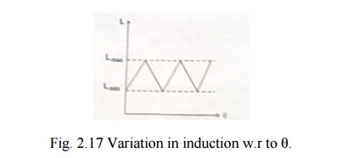

Derivation for reluctance torque
As per faradays law of electromagnetic induction an emf induced in an electric circuit when there exists a change in flux linkages.
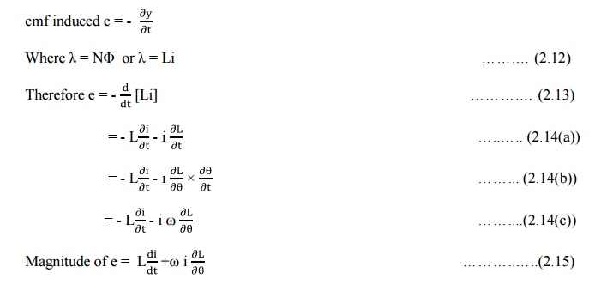
If the direction of current I is opposite to that of e, then the electric power is transferred from the source to the inductor. On the other hand, if the direction of current I is same as that of e, then the source gets the electrical power from the inductor.

On the basis of magnetic circuit/field theory it is known that the stored energy in a magnetic field.
The rate of change of energy transfer due to variation in stored energy or power due to variation in stored energy.
Mechanical power developed/consumed = power received from the electrical source – power due to change in stored energy in the inductor
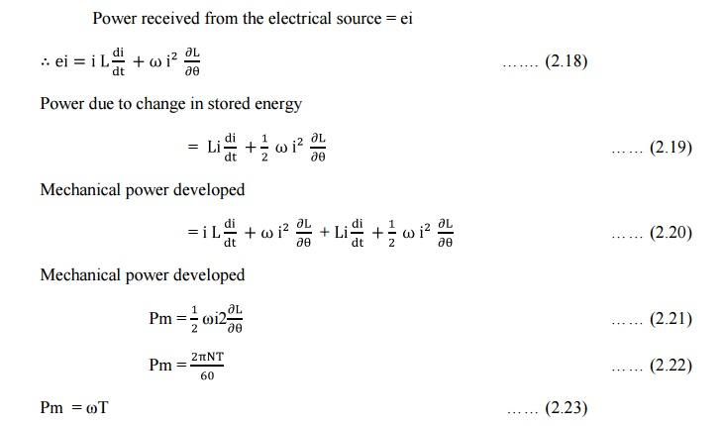
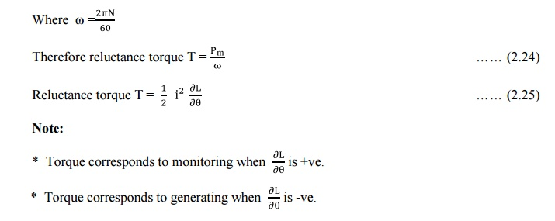
* Torque is proportional to i2 : Therefore, it does not depend upon the direction of the current.
TERMINOLOGIES USED IN STEPPER MOTOR
1. Step angle 2. Resolution 3. Stepping rate
4. Hold position 5. Detent position 6. Stepping error
7. Position Error

1. Step angle (θs or β)
It is the angular displacement of rotor of a stepper motor for every pulse of excitation given to the stator winding of the motor. it is determined by the number of teeth on the rotor and stator, as well as the number of steps in the energisation sequence. It is given by
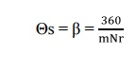
Where, m = Number of phases (m and q)
Nr- number of teeth on rotor.
Also, Θs=((Ns~Nr)/(Ns.Nr))*360

2. Resolution
It is the number of steps per revolution. It is denoted as S or Z. it is given by
Z=360/(Θs)
For variable reluctance motor Z=(q Nr) or (m Nr)
For PM motor and hybrid motor Z=2q Nr
Also , Z=(Ns.Nr)/(Ns~Nr)
Where Ns-number of teeth/poles on stator.

3. Stepping Rate
The number of steps per second is known as stepping rate or stepping frequency.

4. Hold Position
It corresponds to the rest position when the stepper motor is excited or energized (this corresponds to align position of VR motor)

5. Detent Position
It corresponds to rest position of the motor when it is not excited.

6. Stepping Error
Actual step angle is slightly different from the theoretical step angle. This is mainly due to tolerances in the manufacture of stepper motor and the properties of the magnetic and other materials used.

The error in the step angle is expressed as a percentage of the theoretical step angle.
%error= ((step angle – theoretical step angle)/theoretical step angle)*100

Percentage error is restricted to ± 5%.In some cases it is restricted to ±2%. The cumulative error between the actual angular displacement and theoretical angular displacement is expressed as a percentage of theoretical angular displacement. It is usually considered for one complete cycle.

7. Positional Error
The maximum range of cumulative percentage of error taken over a complete rotation of stepper motor is referred to as positional accuracy as shown in fig below.
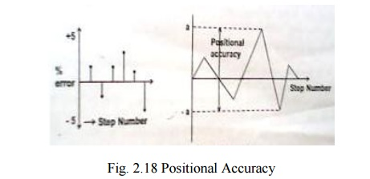

CHARACTERISTICS OF STEPPER MOTOR
Stepper motor characteristics are divided into two groups
Static characteristics
Dynamic characteristics

1. Static characteristics
It is divided into two characteristics.
(i)Torque Angle curve
(ii)Torque current curve

(i)Torque-Angle curve
Torque angle curve of a step motor is shown in fig.2.32. it is seen that the Torque increases almost sinusoid ally, with angle Θ from equilibrium.
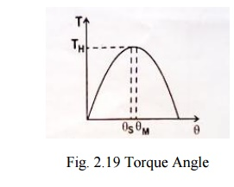
Holding Torque (TH)
It is the maximum load torque which the energized stepper motor can withstand without slipping from equilibrium position. If the holding torque is exceeded, the motor suddenly slips from the present equilibrium position and goes to the static equilibrium position.

Detent torque (TD):
It is the maximum load torque which the un-energized stepper motor can withstand slipping. Detent torque is due to magnetism, and is therefore available only in permanent magnet and hybrid stepper motor. It is about 5-10 % of holding torque.

(ii)Torque current curve
A typical torque curve for a stepper motor is shown in fig.2.34. It is seen the curve is initially linear but later on its slope progressively decreases as the magnetic circuit of the motor saturates.

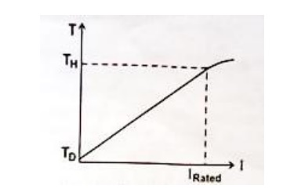
Torque constant (Kt)
Torque constant of the stepper is defined as the initial slope of the torque-current (T-I) curve of the stepper motor. It is also known as torque sensitivity. Its units N-mA, kg-cm/A or OZ-in/A

2. Dynamic characteristics:

A stepper motor is said to be operated in synchronism when there exist strictly one to one correspondence between number of pulses applied and the number of steps through which the motor has actually moved. There are two modes of operation.

Start-Stop mode
Also called as pull in curve or single stepping mode.

Slewing mode
In start –stop mode the stepper motor always operate in synchronism and the motor can be started and stopped without using synchronism. In slewing mode the motor will be in synchronism, but it cannot be started or stopped without losing synchronism. To operate the motor in slewing mode first the motor is to be started in start stop mode and then to slewing mode. Similarly to stop the motor operating in slewing mode, first the motor is to be brought to the start stop mode and then stop.

Start Stop mode
Start stop mode of operation of stepper motor is shown in fig.2.35 (a).In this second pulse is given to the stepper motor only after the rotor attained a steady or rest position due to first pulse. The region of start-stop mode of operation depends on the operation depends on the torque developed and the stepping rate or stepping frequency of stepper motor.
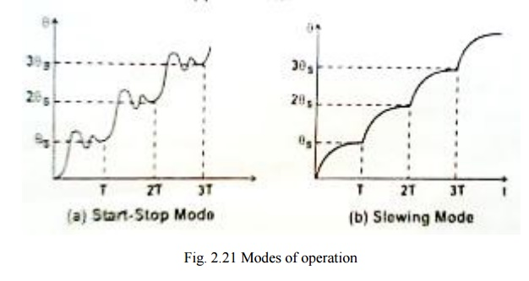
pulse is given to the stepper motor only after the rotor attained a steady or rest position due to first pulse. The region of start-stop mode of operation depends on the operation depends on the torque developed and the stepping rate or stepping frequency of stepper motor.
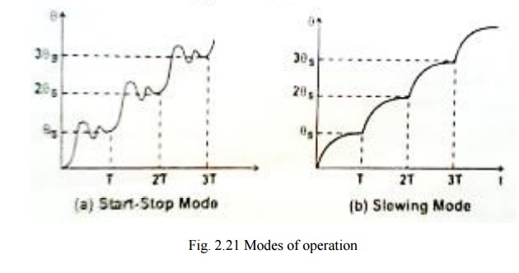
TORQUE-SPEED CHARACTERISTICS
Torque developed by the stepper motor and stepping rate characteristics for both modes of operation are shown in fig.2.36.the curve ABC represents the "pull in" characteristics and the curve ADE represents the "pull-out" characteristics.

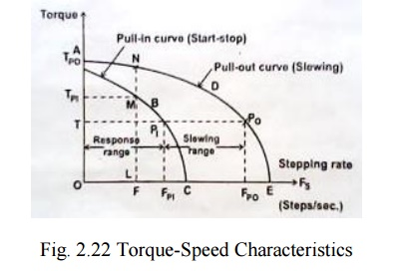

The area OABCO represents the region for start stop mode of operation. At any operating point in the region the motor can start and stop without losing synchronism. The area ABCEDA refers to the region for slewing mode of operation. At any operating point without losing synchronism to attain an operating point in the slewing mode at first the motor is to operate at a point in the start-stop mode and then stepping rate is increased to operate in slewing mode, similarly while switching off it is essential to operate the motor from slewing mode to start-stop mode before it is stopped.

Pull in torque
It is the maximum torque developed by the stepper motor for a given stepping rate in the start-stop mode of operation without losing synchronism. In the fig.2.36 LM represents the pull in torque (i.e)TPI corresponding to the stepping rate F (i.e.) OL.

Pull out torque
It is the maximum torque developed by the stepper motor for a given stepping rate in the slewing mode without losing synchronism. In fig.2.36 LN represents the pull in torque (i.e.) TPO corresponding to F (i.e.) OL.

Pull in range
It is the maximum stepping rate at which the stepper motor can operate in start-stop mode developing a specific torque (without losing synchronism).In fig. 2.36 PIT represents pull in range for a torque of T (i.e.) OP. This range is also known as response range of stepping rate for the given torque T.

Pull out range
It is the maximum stepping rate at which the stepper motor can operate in slewing mode developing a specified torque without losing synchronism. In fig.2.36 PIPO represents the pull out range for a torque of T. The range PIPO is known slewing range.

Pull in rate (FPI)
It is the maximum stepping rate at which the stepper motor will start or stop without losing synchronism against a given load torque T.

Pull out rate (FPO)
It is the maximum stepping rate at which the stepper motor will slew, without missing steps, against load torque T.

Synchronism
This term means one to one correspondence between the number of pulses applied to the stepper motor and the number of steps through which the motor has actually moved.

Mid frequency resonance
The phenomenon at which the motor torque drops to a low value at certain input pulse frequencies.

FIGURES OF MERIT (FM'S)
Figures of merit (FM'S) are performance indices which give quantitative information on certain aspects of performance and design of actuators such as stepper motors. DC or AC servomotors etc.

1. Electrical Time constant (Te)
Te=Lm/Rm ……….. (2.26)
Where, Lm - Inductance of motor winding
Rm - resistance of motor.
Te - governs the rate at which current rises when the motor winding is turned on.It also determines how quickly the current decays when the winding is turned off.
In motion control, the speed of response is of importance. Hence electrical time constant Te must be minimized.
Te dependent upon inductance and resistance of the motor winding. Inductance is determined by magnetic circuit. (i.e.) magnet iron volume as well as volume of copper used in the motor design. Once these have been designed, neither reducing conductor size nor increasing the number of turns will reduce Te. Otherwise magnetic circuit itself has to be redesigned.

2. Motor time constant (Tm)
Tm=J/(Ke.KtRm)=JRm/Ke ………… (2.27)
Where, J-moment of inertia of motor (kg-m2)
Rm-resistance of the motor winding (Ω)
Ke-back emf constant(volt s/ rad)
Kt- torque constant (Nm/A)

Motor back emf and torque constants are determined by magnetic circuit and phase winding design. Winding resistance also from winding design. Moment of inertia is determined by mechanical design.
In this way motor time constant Tm combines all the three aspects of motor design viz, magnetic circuit, electrical circuit and mechanical design. Achieving a low Tm requires excellence in motor design. As a thumb rule the ratio of Te/Tm 0.1

Initial Acceleration (A0):
A0=T/J(rad/S2)
Where , T-rated torque (N-M)
J-moment of inertia(kg-m2)
A0 gives a quantitative idea of how fast the motor accelerates to its final velocity or position. Maximization of A0 calls for good magnetic circuit design to produce high torque in conjunction with good mechanical design to minimize rotor inertia. The moment of inertia of the load coupled to motor also determines A0.

Motor Constant (km)
km=T/√ ω
where , T- rated motor torque
ω -rated power(w) of the motor
km=√Kt Ke/Rm
This shows that maximizing km causes minimizing R, maximizing Ke and Kt. Maximizing Ke and Kt. Call for optimization of magnetic circuit design, decreasing electrical time constant Te which is undesirable. A trade off between electrical and magnetic circuit design is necessary to achieve a good km.

Power rate (dP/dt):
Power rate is (dP/dt)=(d/dt)(T.(dϴ /dt))= T.(d2ϴ /dt2)=T.(T/J)=(T2/J) | …..(2.28)
Now T=Kt I so

DRIVE SYSTEM AND CONTROL CIRCUITRY FOR STEPPER MOTOR

1. DRIVE SYSTEM
The stepper motor is a digital device that needs binary (digital) signals for its operation .Depending on the stator construction two or more phases have to be sequentially switched using a master clock pulse input. The clock frequency determines the stepping rate, and hence the speed of the motor. The control circuit generating the sequence is called a translator or logic sequencer.
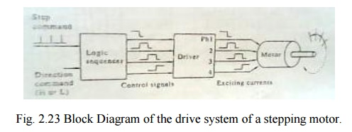
The fig 2.38 shows the block diagram of a typical control circuit for a stepper motor. It consists of a logic sequencer, power driver and essential protective circuits for current and voltage limiting. This control circuit enables the stepper motor to be run at a desired speed in either direction. The power driver is essentially a current amplifier, since the sequence generator can supply only logic but not any power. The controller structure for VR or hybrid types of stepper motor
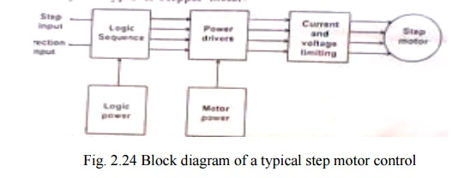

2. LOGIC SEQUENCER :
The logic sequencer is a logic circuit which control the excitation of the winding sequentially, responding to step command pulses. A logic sequencer is usually composed of a shifter register and logic gates such as NANDs, NORs etc. But one can assemble a logic sequencer for a particular purpose by a proper combination of JK flip flop, IC chips and logic gate chips.

Two simple types of sequencer build with only two JK-FFs are shown in fig 2.39 for unidirectional case. Truth tables for logic sequencer also given for both the directions.

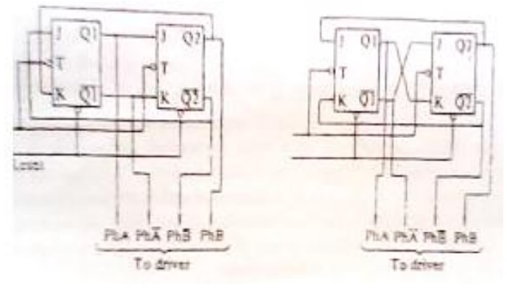
Fig.2.25 A unidirectional logic sequencer for two phase on operation of a two phase hybrid motor
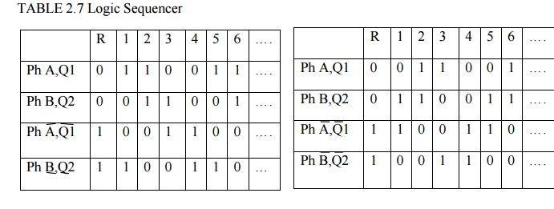
The corresponding between the output terminals of the sequencer and the phase windings to be controlled is as follows.
If Q1 is on the H level the winding Ph A is excited and if Q1is on L level, Ph A is not excited.
To reserve the rotational direction, the connection of the sequencer must be interchanged. The direction switching circuits shown in fig 2.40 may be used for this purpose. The essential functions being in the combination of three NAND gates or two AND gates and a NOR gate.

3. Power Driver Circuit
The number of logic signals discussed above is equal to the number of phases and the power circuitry is identical for all phases. Fig. 2.44(a) shows the simplest possible circuit of one phase consisting of a Darlington pair current amplifier and associated protection circuits. The switching waveform shown in fig. 2.44(c) is the typical R-L response with an exponential rise followed by decay at the end of the pulses.

In view of the inductive switching operation, certain protective elements are introduced in the driver circuit. These are the inverter gate 7408, the forward biased diode D1 and the freewheeling diode D. The inverter IC provides some sort of isolation between the logic circuit and the power driver.

There are some problems with this simple power circuit. They can be understood by considering each phase winding as a R-L circuit shown in fig. 2.44(b) subject to repetitive switching. On application of a positive step voltage, the current rises exponentially as

Where I=V/R – rated current and
Ԏ=L/R winding time constant.
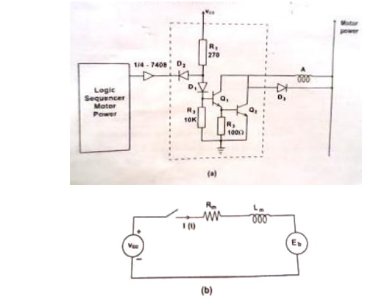
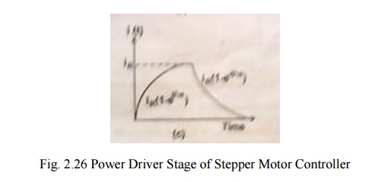
In practice, the time constant Ԏ limits the rise and fall of current in the winding. At low stepping rate the current rises to the rated value in each ON interval and falls to zero value in each OFF interval. However as the switching rate increases, the current is not able to rise to the steady state, nor fall down to zero value with in the on/off time intervals set by the pulse waveform. This in effect, smoothens the winding current reducing the swing as shown in fig. 2.45. As a result the torque developed by the motor gets reduced considerably and for higher frequencies, the motor just ‗vibrates‘ or oscillates within one step of the current mechanical position.
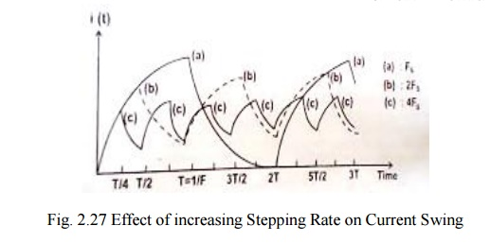
In order to overcome these problems and to make improvement of current build up several methods of drive circuits have been developed.
For example when a transistor is turned on to9 excite a phase, the power supply must overcome effect of winding inductances has tendency to oppose the current built up. As switching frequency increases the position that the buildup time takes up within the switching cycle becomes large and it results in decreased torque and slow response.

4. Improvement of current buildup/special driver circuit
(a) Resistance drive (L/R drive)
Here the initial slope of the current waveform is made higher by adding external resistance in each winding and applying a higher voltage proportionally. While this increases the rate of rise of the current, the maximum value remains unchanged as shown in fig. 2.46.
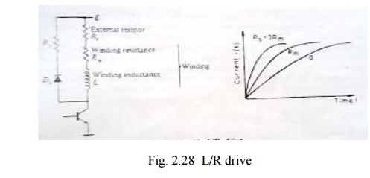
The circuit time constant is now reduced and the motor is able to develop normal torque even at high frequencies. The disadvantage of this method is Flow of current through external resistance causesI²R losses and heating. This denotes wastage of power as far as the motor is concerned.
In order to reach the same steady state current I_{R} as before, the voltage required
To be applied is much higher than before. Hence this approach is suitable for small instrument stepper motor with current ratings around 100 mA, and heating is not a major problem.

(b) Dual voltage driver (or) Bi-level driver
To reduce the power dissipation in the driver and increase the performance of a stepping motor, a dual-voltage driver is used. The scheme for one phase is shown in fig. 2.47.

When a step command pulse is given to the sequencer, a high level signal will be put out from one of the output terminal to excite a phase winding. On this signal both T1 and T2 are turned on, and the higher voltage E_{H}will be applied to the winding. The diode D1 is now reverse biased to isolate the lower voltage supply. The current build up quickly due to the higher voltage E_{H}. The time constant of the monostable multivibrator is selected so that transistor T1 is turned off when the winding current exceeds the rated current by a little. After the higher

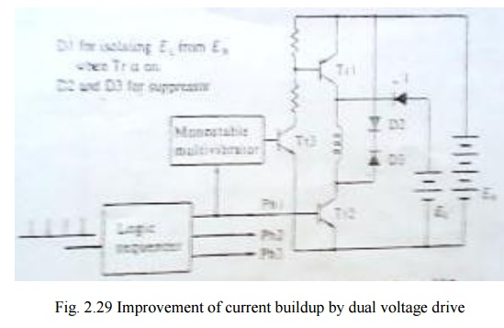

Voltage source is cut off the diode is forward biased and the winding current is supplied from the lower voltage supply. A typical current wave form is shown in fig. 2.48.
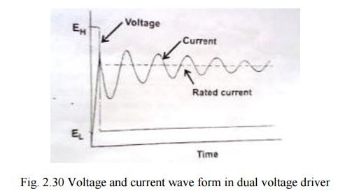

When the dual voltage method is employed for the two phase on drive of a two phase hybrid motor, the circuit scheme will de such as that shown in fig.2.49. Two transistor T 1 &T 2 and two diodes D1 and D2 are used for switching the higher voltage. In dual voltage scheme as the stepping rate is increased, the high voltage is turned on for a greater percentage of time.
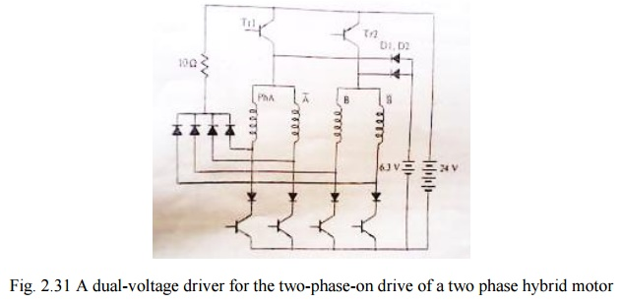

This drive is good and energy efficient. However it is more complex as it requires two regulated power supplies EH& EL end two power transistor switches Tr1 & Tr2 and complex switching logic. Hence it is not very popular.

(c)Chopper drive
Here a higher voltage 5 to 10 times the related value is applied to the phase winding as shown in fig.2.50(a) and the current is allowed to raise very fast. As soon as the current reaches about 2 to 5% above the rated current, the voltage is cut off ,allowing the current to decrease exponentially. Again as the current reaches some 2 to 5% below the rated value, the voltage is applied again. The process is repeated some 5-6 times within the ON period before the phase is switched off. During this period the current oscillates about the rated value as shown in fig. A minor modification is to chop the applied dc voltage at a high frequency of around 1khz, with the desired duty cycle so as to obtain the average on-state current equal to the rated value.
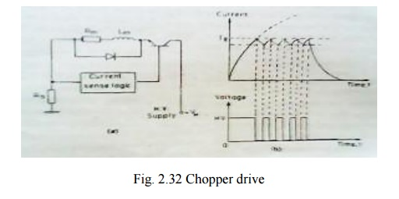
The chopper drive is particularly suitable for high torque stepper motors. It is ener4gy efficient like the bi-level drive but the control circuit is simpler.

(d) Problems with driver circuits
A winding on a stepping motor is inductive and appears as a combination of inductance and resistance in series. In addition, as a motor revolves a counter emf is produced in the winding. The equivalent circuit to a winding is hence, such as that shown for designing a power driver one must take into account necessary factors and behavior of this kind of circuit. Firstly the worst case3 conditions of the stepping motor, power transistors, and supply voltage must be considered. The motor parameters vary due to manufacturing tolerance and operating conditions. Since stepping motors are designed to deliver the highest power from the smallest size, the case temperature can be as high as about 100°c and the winding resistance therefore increases by 20 to 25 per cent.

Suppressor circuits
These circuits are needed to ensure fast decay of current through the winding when it is turned off. When the transistor in the above fig is turned off a high voltage builds up to Ldi/dt and this voltage may damage the transistor. There are several methods of suppressing this spike voltage and protecting the transistor as shown in the following.

(a) Diode suppressor
If a diode is put in parallel with the winding in the polarity as shown in fig. a circulating current will flow after the transistor is turned off, and the current will decay with time. In this scheme, no big change in current appears at turn off, and the collector potential is the supply potential E plus the forward potential of the diode. This method is very simple but a drawback is that the circulating current lasts for a considerable length of time and it produces a braking torque.
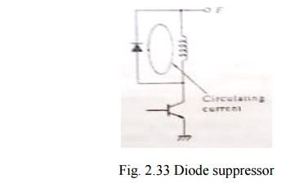
(b)Diode-Resistor suppressor
A resistor is connected in series with the diode as shown in fig to damp quickly the circulating current. The voltage V_{CE} applied to the collector at turn-off in this scheme is
V_{CE} = E+ IR_{S}+ V_{D}
Where E= supply potential
I= Current before turning off
R _{S} -resistance of suppressor resistor and V_{D} -forward potential of diode
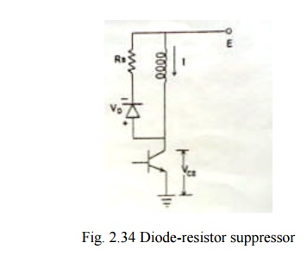
A high resistance RS is required to achieve a quick current decay, but this also results in a higher collector potential VCE, thus a transistor with a high maximum voltage rating is necessary.

(a) Zener diode suppressor
In this zener diode are often used to connect in series with the ordinary diode as shown in fig. Compared with preceding two cases zener diode which provides negative bias causes the current to decay more quickly after turn off. In addition to this, it is a merit of this method that the potential applied to the collector is the supply potential plus the zener potential, independent of the current. This makes the determination of the rating of the maximum collector potential easy. However zeners are signal diodes, rather than power diodes. Their power dissipation is limited to 5w. Consequently, this suppressor can be used for very small instrument stepper motors of typical size 8 to 11.
Comparison of effects of various suppressor schemes of various suppressor schemes
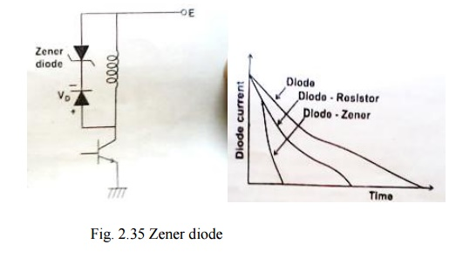
(d)Condenser suppressor
This scheme is often employed for bifilar-wound hybrid motor. An explanation is given for the given for the circuit shown in fig:

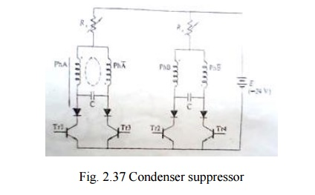

A condenser is put between ph A and ph A1. These condensers serve two fold purposes.
1. When a transistor is turned off, the condenser connected to it via a diode absorbs the decaying current from the winding to protect the transistor.
Let us see the situation just after the Tr 1 is turned off in the one phase on mode. Either Tr2 or Tr4 will turn on, but Tr3 will still be in the turned off state . Since the winding of ph A and ph A1 are wound in the bifilar fashion, a transient current will circulate in loop. If Tr 3 is turned on when the transient current becomes zero and the charge stored in the condenser becomes maximum, a positive current can easily flow through phase A winding. By this resonance mechanism, currents are used efficiently in this scheme. This feature remains in the two phase on mode too. The condenser suppressor is suited to drives in which stepping rate is limited in a narrow range.

2 .Another utility of condensers is as an electrical damper, a method of damping rotor oscillations is to provide a mechanism to convert kinetic energy to joule heating. If a rotor having a permanent magnet oscillates, an alternating emf is generated in the winding. However if a current path is not provided or a high resistance is connected, no current will be caused by this emf. When the condenser is connected between phases an oscillatory current will flow in the closed loop and joule heat is generated in the windings, which means that the condenser works as an electrical damper.

LINEAR AND NON LINEAR ANALYSIS
The linear and nonlinear analysis of the motor performance with respect to the torque produced by the rotor of the motor is explained.
Let,
T_{m} be the motor torque produced by the rotor in Nm
J be the inertia of the rotor and load combination in kgm2
ω be the angular velocity of the rotor
D be the damping coefficient or viscous frictional coefficient
T_{f} be the frictional load torque independent of the speed
Θs be the step angle in radians
F be the stepping rate in steps/sec or pps
Frictional load torque T_{f} = K θ
According to rotor dynamics
Tm=―J*dω/dt+Dω+Tf ………….. (2.30)
Also θs=θ=ωt=step angle
ω=θs/t=f θs …………..(2.31)
where f=1/t ………….(2.32)
By putting ω=f θs
Tm=J *d/dt(f θs )+D(f θs )+Tf …………..(2.33)
θs=360/mNr is fixed for a particular type of motor
S o θs can be considered as constant
Therefore Tm=J θs* d/dt(f)+D θs(f)+Tf ………….(2.34)
In equation 2.47 if viscous friction constant is neglected the equation will be a linear equation, the corresponding acceleration will be nonlinear and the equation will be nonlinear which given rise to nonlinear analysis.

Linear acceleration on linear analysis-------
If the damping coefficient is neglected D=0
The expression for motor torque becomes
Tm=―J*dω/dt+Tf ………………(2.35)
Tm-Tf= J*dω/dt
(Tm-Tf)/J = dω/dt
dω=((Tm-Tf)/J)dt ……………….. (2.36)

Integrating
ω=((Tm-Tf)/J)dt+ω1 ……………….. (2.37)

Where,
ω1=Integration constant

Mathematically ω1 is the constant of integration but it indicates the initial angular velocity of the motor before the occurrence of acceleration.
Therefore,
ω=θs f and ω1= θs f1

Substituting ω and ω1 in equation 2.50
((Tm-Tf)/J)t+ θs f1= θsf ………………..(2.38)
Dividing throughout by θs we get
((Tm-Tf)/J θs)t+ f1=f
Therefore stepping rate f=((Tm-Tf)/J θs)t+ f1 ……………(2.39)
And Tf = K θ
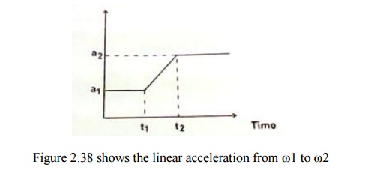
Nonlinear (exponential) acceleration on Nonlinear analysis-----
Considering the torque produced by the motor
Tm=jθs df/dt +Dθsf+Tf …….(2.40)
(Tm-Tf)= jθs df/dt +Dθsf
Dividing throughout by jθs , we get
(df/dt)+(D/J)f-(Tm-Tf /j θs )=0
(or) (df/dt)+(D/J)f=(Tm-Tf /j θs ) …. (2.41)
The above eqn. 2.54 is of the form
(dy/dx)+py=Q Which have the solution of
ye∫pdx =∫Q e∫pdx+C …..………….(2.42 )
Here y=f; x=t; p=(D/j) and Q=(Tm-Tf)/jθs =constant
fe∫D/J dt=∫(Tm-Tf)/jθse∫D/J dt+C …………………(2.43)
fe∫D/J t=∫(Tm-Tf)/jθse∫D/J t+C ………….…….(2.44)
fe∫D/J t=(Tm-Tf)/jθs(e∫D/J t/(D/J))+C ………………..(2.45)
where C is the integration constant
To find C substituting initial condition at t=0; f=f(0)=f1f1e0==(Tm-
Tf)/jθs(1/(D/J))+C …………..…..(2.46)
f1===(Tm-Tf)/Jθs(J/D))+C ………..…...(2.47)
f1=(Tm-Tf)/Dθs+C ……….…..(2.48)
C= f1-(Tm-Tf)/Dθs ……………...(2.49)
Substituting eqn. (2.62) in eqn. (2.58)
f e(D/J)t=(Tm-Tf)/Jθs(J/D)e(D/J)t+( f1-(Tm-Tf)/Dθs) …………….….(2.50)
f e(D/J)t=(Tm-Tf)/Dθs e(D/J)t+( f1-(Tm-Tf)/Dθs) ………..……( 2.51)
Dividing throughout by e(D/J)t we get
F=Tm-Tf/Dθs +(f1-Tm-Tf/Dθs)e-D/j t ……………(2.52)
Stepping frequency, f= Tm-Tf/Dθs + (f1-Tm-Tf/Dθs)e-D/j t
The above equation is a nonlinear exponential equation which gives rise to nonlinear acceleration of the rotor of the motor.

APPLICATION OF STEPPER MOTOR:
The main application of stepper motor may be divided into the following groups.
1. Instrumentation applications.
2. Computer peripherals & Office equipment‘s.
3. Numerical control of machine tools and robotics.
4. Applications in semiconductor technology.
5. Space vehicles and satellites.
6. Electro medical and
7. Miscellaneous applications.

1. Instrumentation application:
This involve low torque applications such as -----
Quartz watches.
Synchronized clocks.
Camera shutter operations.

2. Stepper motor application in computer peripherals:
This involve medium torque, high performance and high volume application such as
Dot matrix and line printers.
Graph plotters.
Floppy disk drives
Digital X-Y plotters.
Magnetic tape drives.
Paper tape drives.

3. Application is office equipment:
Electronic typewriters.
Copiers
Facsimile machines.
4. Machine tool applications:
This involve high torque application such as ---------
Numerical control system for milling machine
X-Y tables and index table.
Home use and industrial sewing machines.

5. Application in semiconductor technology:
Stepper motors used in high vacuum.
Goniometer-An instrument used to determine crystalline structure.
Electron beam micro fabricator.

6. Stepper motor used in space vehicles and satellites.
7. Robotics.

8. Electro medical applications:
This involve high torque applications such as
X-ray machines.
Radiation therapy units.
Ultra sound scanner.

9. Miscellaneous applications:
Nuclear reactors.
Heavy industry applications.
Automatic focusing mechanism in camera

SHORT QUESTIONS AND ANSWERS:
- What is stepper motor?

A stepper motor is a digital actuator whose input is in the form of programmed energization of the stator windings and whose output is in the form of discrete angular rotation.

Define step angle.

Step angle is definrd as the angle through which the motor rotates for each command pulse.it is denoted as β.

β=(Ns-Nr/Ns.Nr)360 (or)360/(mNr)

Define slewing

The stepper motor operates at very high speed is called slew angle.i,e (25000 steps per sec).

Define resolution

It is defined as the no.of steps needed to complete one revolution of the shaft. Resolution = no . of steps /revolution

Mention some applications of stepper motor

I.floppy disc drives
- qurtz watch
- camera shutter operation
- dot matrix and line printers
- small tool application
- robotics

What are the advantages and disadvantages of stepper motor?

Adv:
- it can be driven in open loop without feedback
- it is mechanically simple
- it requires little or no maintenance.

Disadv:
1.low efficiency 2.fixed step angle 3.limited power output

Define holding torque.

Holding torque is the maximum load torque which the energized stepper motor can withstand without slipping from equilibrium position

Define detent torque

Detent torque is the maximum torque which the unenergised stepper motor can withstand without slipping.it is also known as cogging torque.

What is meant by full step operation?

Full step operation or single phase on mode is the one in which at a time only one phase winding is energized, due to which one stator winding is energized and causes the rotor to rotate some angle.

What is meant by two phase mode of operation?

Two phase on mode is the one in which two phase windings are energized at a time, due to which two stator windings are energized and causes the rotor to rotate through some angle.

Define pull in torque.

It is the maximum torque the stepper motor can develop in start – stop mode at a given stepping rate Fs (step/sec) without losing synchronism.

Define pull out torque.

It is the maximum torque the stepper motor can develop in slewing mode at a given stepping rate Fs (step/sec) without losing synchronism.

What is synchronism in stepper motor?

It is the one to one correspondence between the number the number of pulses applied to the stepper motor and the number of steps through which the motor has actually moved.

Define mid frequency resonance in stepper motor.

The phenomenon at which the motor torque drops to a low value at certain input pulse frequencies.

Define static stiffness.

It is a measure of ability of the actuator to resist disturbing torques and forces and thereby to maintain position.it is defined as
S=torque / rad

Give the types of driver circuits.

- Resistance or L/R drive
- Dual voltage or bilevel drive
- Chopper drive

What is multi stack VR motor

Multi stack VR motor is the one in which the stepper motor has three separate magnetically nisolated sections or stacks.here the rotor and stator teeths are equal.

What is meant by micro stepping in stepper motor.

The methods of modulating currents through stator windings so as to obtain rotation of stator magnetic field through a small angle to obtain micro stepping action is known as micro stepping.

What are the advantages of micro stepping?

- Improvement in resolution.
- Dc motor like performance
- Elimination of mid frequency resonance
- Rapid motion at micro stepping rate.

Define bandwidth in stepper motor.

It is a measure of the frequencies upto which the actuator or servo motor system can respond.

PART-B

- Explain the construction and various modes of excitation of VR stepper motor. (16)
- Explain the construction and various modes of excitation of PM stepper motor. (16)
- Explain the construction and working principle of Hybrid Stepper motor. (16)
- State and explain the static and dynamic characteristics of a stepper motor. (16)
- Explain in detail about different types of power drive circuits for stepper motor. (16)
- Explain the mechanism of torque production in VR stepper motor. (16)
- Draw any two drive circuits for stepper motor. (16)

UNIT III - PERMANENT MAGNET BRUSHLESS D.C. MOTORS
INTRODUCTION:
Conventional DC motors are highly efficient and their characteristics make them suitable for use as servomotors. However, their only drawbacks that they need a commutator and brushes which are subject to wear and require maintenance.

When the functions of commutator and brushes were implemented by solid state switches, maintenance free motors were realized. These motors are known as brushless DC motors. The function of magnets is the same in both brushless motor and the dc commutator motor. The motor obvious advantage of brushless configuration is the removal of brushes. Brush maintenance is no longer required, and many problems associated with brushes are removed.

An advantage of the brushless configuration in which the rotor inside the stator is that more cross sectional area is available for the power or armature winding. At the same time conduction of heat through the frame is providing greater specific torque. The efficiency is likely to be higher that of a commutator motor of equal size and the absence of brush friction help further in this regard.

CONSTRUCTIONAL FEATURES OF BLPM MOTORS:
1. Construction:
The stator of the BLPM dc motor is made up of silicon steel stampings with slots in its interior surface. These slots accommodate either a closed or opened distributed armature winding usually it is closed. This winding is to be wound for a specified number of poles. This winding is suitably connected to a dc supply through a power electronic switching circuitry (named as electronic commutator).
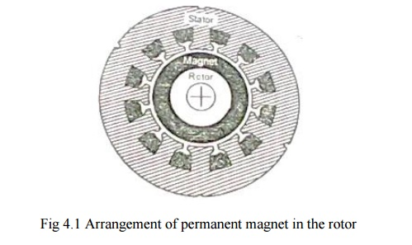
Rotor is made of forged steel. Rotor accommodates permanent magnet. Number of poles of the rotor is the same as that of the stator. The rotor shaft carries a rotor position sensor. This position sensor provides information about the position of the shaft at any instant to the controller which sends suitable signals to the electronic commutator.

2. Merits and Demerits
Merits
❖ There is no field winding. Therefore there is no field cu loss.
❖ The length of the motor is less as there is no mechanical commutator.
❖ Size of the motor becomes less.
❖ It is possible to nave very high speeds.
❖ It is self-starting motor. Speed can be controlled.
❖ Motor can be operated in hazardous atmospheric condition.
❖ Efficiency is better.
Demerits
❖ Field cannot be controlled.
❖ Power rating is restricted because of the maximum available size of permanent magnets.
❖ A rotor position sensor is required.
❖ A power electronic switch circuitry is required.

3. Comparison of brushless dc motor relative to induction motor drives
❖ In the same frame, for same cooling, the brushless PM motor will have better efficiency and p.f and therefore greater output. The difference may be in the order of 20 – 50% which is higher.
❖ Power electronic converter required is similar in topology to the PWM inverters used in induction motor drives.
❖ In case of induction motor, operation in the weakening mode is easily achieved providing a constant power capability at high speed which is difficult in BLPM dc motor.
❖ PM excitation is viable only in smaller motors usually well below 20 kw also subject to speed constraints, In large motors PM excitation does not make sense due to weight and cost.

4. Commutator and brushes arrangement
Because of the hetropolar magnetic field in the air gap of dc machine the emf induced in the armature conductors is alternating in nature. This emf is available across brushes as unidirectional emf because of commutator and brushes arrangement.
The dc current passing through the brushes is so distributed in the armature winding that unidirectional torque is developed in armature conductor.
A dc current passing through the brushes because of commutator and brushes action, always sets up a mmf whose axis is in quadrature with the main field axis, irrespective of the speed of the armature.

5. Construction of Mechanical Commutator
Commutator Segment:
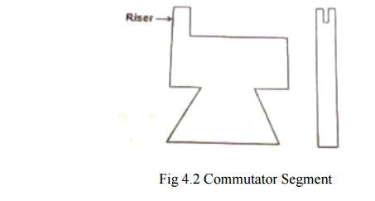
Commutator is made up of specially shaped commutator segments made up of copper. These segments are separated by thin mica sheets (ie) Insulation of similar shape. The commutator segments are tapered such that when assembled they form a cylinder.
These segments are mechanically fixed to the shaft using V – shaped circular steel clamps, but are isolated electrically from the shaft using suitable insulation between the clamps and the segment.
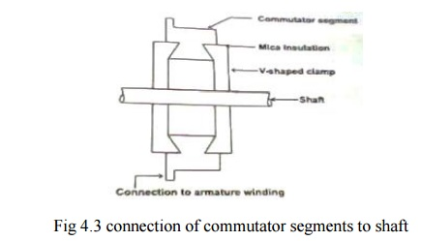

6. Mechanical Commutator and Brushes Arrangement

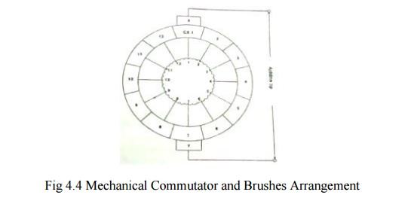
The figure represents a case with 2poles and 12 commutator segments.
To start with the brush X contacts with CSI and brush Y with 7.A dc supply is connected across the brushes X and Y. The dc current I passes through brush X,CSI,tapping 1,tapping 7and brush Y. There are two armature parallel paths between tapping‘s 1 and 7.the current passing through the armature winding aets up a magneto motive force whose axis is along the axes of tapping 7 and 1 of the brush axes Y and X.
Allow the armature to rotate by an angle in a counter clockwise direction. Then the brush X contacts CS2 and the tapping‘s a and the brush Y. Contact CS8 and tapping 8.The dc current passes through the tapping‘s 2 and 8 there are two parallel paths.
(i) 2 – 3 – 4 – 5 – 6 – 7 – 8
(ii) 2 – 1 – 12 – 11 – 10 – 9 – 8

Now the mmf set up by the armature winding is form tapping 8 to 2 along the brush axis YX Thus the armature mmf direction is always along the brush axis YX, even though the current distribution in the armature winding gets altered.
In a normal dc machine brushes are kept in the interpolar axis. Therfore, the axis of the armature mmf makes an angle 90˚elec with the main field axis.

The function of commutator and brushes arrangement in a conventional dc machine is to set up an armature mmf always in quadrature with the main field mmf respectively of the speed of rotation of the rotor.

7. Electronic commutator
The armature winding which is in the stator has 12 tapping‘s. each tapping is connected to the positive of the dc supply node and through 12 switches designated as S1 ,S2,….S12 and negative of the supply at node Y through switches S‘1,S‘2,…….S‘12.
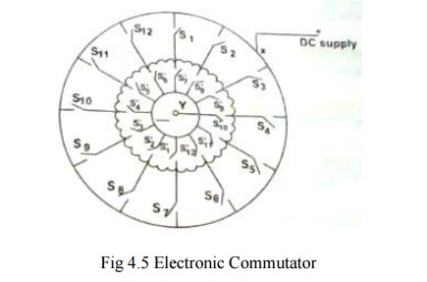

When S1 and S‘1 are closed the others are in open position, the dc supply is given to the trappings 1 and 7.there are two armature parallel path.
(i) 1 – 2 – 3 – 4 – 5 – 6 – 7
(ii) 1 – 12 – 11 – 10 – 9 – 8 – 7
They set up armature mmf along the axis 7 to 1.
After a small interval S1 and S‘1 are kept open and S2 and S‘2 are closed. Then dc current passes from tapping 2 to 8 sets up mmf in the direction 8 – 2.
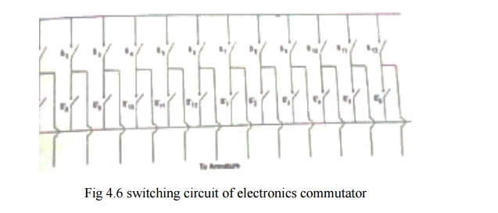
Thus by operating the switch in a sequential manner it is possible to get a revolving mmf in the air gap. The switches S1 to S12 and S‘1 to S‘12 can be replaced by power electronic switching devices such as SCR‘s MOSFET‘s IGBT‘s, power transistor etc.

When SCR‘s are used suitable commutating circuit should be included. Depending upon the type of forced commutated employed, each switch requires on or two SCRs and other commutating devices. As number of devices is increased, the circuit becomes cumbersome.
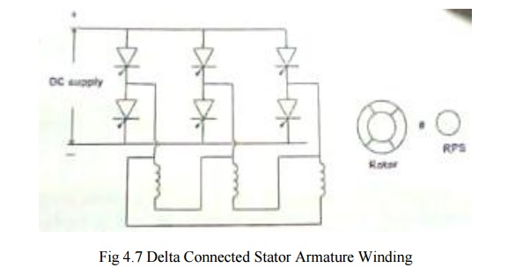
For normal electronic commutator, usually six switching devices are employed. Then the winding should have three tapping‘s. Therefore the winding can be connected either in star or in delta.
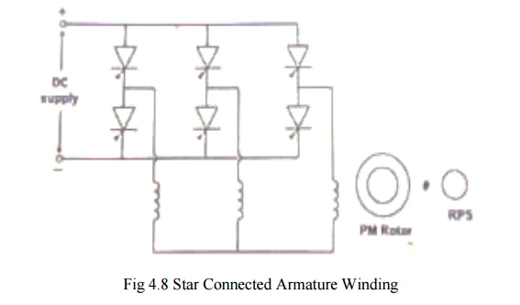
8. Comparison between mechanical Commutator and brushes and Electronic Commutator
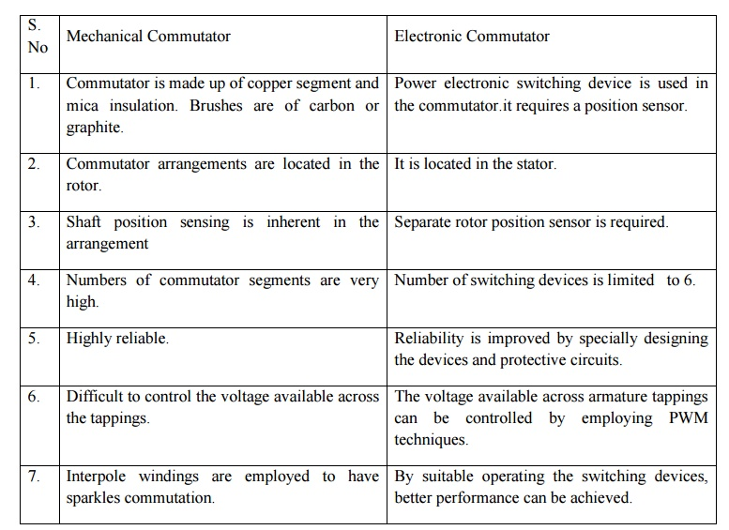

B–H LOOP AND DEMAGNETIZATION CHARACTERISTICS:
1. Permanent Magnets Material
NdFeB – Neodymium – iron – boron has the highest energy product of all commercially available magnets at room temperature. It has high remanence and coercivity in the motor frame size for the same output compared with motors using ferrite magnets. But it is costlier. But both of the above stated magnets are sensitive to temperature and care should be taken for working temperature above 100˚.For very high temperature applications, alnico or rare earth cobalt magnets must be used.

2. B – H Loop
It is used for understanding characteristics hysteresis loop as shown.

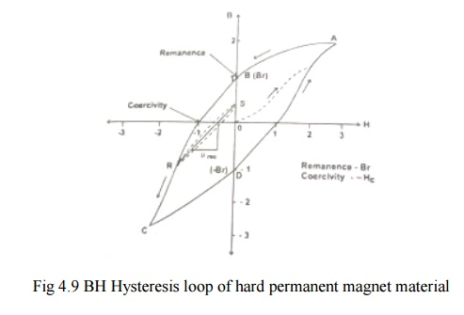

X – axis – Magnetizing force or field intensity H.
Y – axis – Magnetic flux density B in the material.
❖ An un-magnetized sample has B = 0 and H = 0 and therefore starts out at the origin.

Curve OA
❖ If it is subjected to a magnetic field, magnetic fixture (an electromagnetic with shaped pole pieces to focus flux into the magnet), then B and H in the magnet follow the curve OA as the external ampere – turns are increased.

Curve AB
❖ If the external ampere – turns are switched off, the magnet relaxes along AB. The operating point (H, B) depends on the shape of the magnet and permanence of the surrounding magnetic circuit.If the magnet is surrounded by a highly permeable magnetic circuit, that is if it is keepered then its poles are effectively shorted together so that H = 0 and then the flux density is the value at point remanence Br.
Pemanence: Maximum flux density that can be retained by the magnet at a specified temperature after being magnetized to saturation.
Curve BC
❖ External ampere turns applied in the opposite direction cause the magnets operating point to follow the curve from B through the second quadrant to C.

Curve CD
❖ If the ampere – turns are switched off at c the magnet relaxes along CD. It is now magnetized in the opposite direction and the maximum flux density it can retain when keepered is – Br.
❖ To bring B to zero from negative remanence point D, the field +Hc must be applied.
❖ The entire loop is usually symmetrical and be measured using instruments such as hysteresis graph.

3. Soft PM
❖ Soft PM materials have Knee in the second quadrant such as Alnico.
❖ Alnico magnets have very high remanence and excellent mechanical and thermal properties. But they are limited in the demagnetizing field they can withstand.
❖ These soft PM are hard when compared with lamination steels the hysteresis loop of typical non oriented electrical steel is very narrow when compared with Alnico.

4. Demagnetization curve

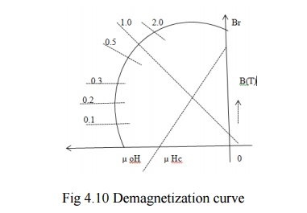

In the absence of externally applied ampere – turn, the magnets operating point is at the intersection of the demagnetization curve and the load line.
❖ The slope of the load line is the product of µ₀ and the permeance co efficient of the external circuit.

In a permanent magnet, the relationship between B and H is
B = µ₀ H + J
µ₀ H – flux density that would exist if the magnet were removed and the magnetizing force remain at the value H.
J – contribution of the magnet to the flux - density within its own volume.

❖ If the demagnetization curve is a straight line, and therefore its relative slope and there by the µ_{rec} is unity, Then J is constant.
J – Magnetization of the magnet, unit T tesla

❖ Hard magnets have µ_{rec}>= 1,J decreases as the –Hc increases.
❖ The magnet can recover or recoil back to its original flux density as long as the magnetization is constant.
❖ The coercive force required to permanently demagnetize the magnet is called the intrinsic coercivity and it is Hci.

PRINCIPLE OF OPERATION OF BRUSHLESS PM DC MOTOR
Starting
When dc supply is switched on to the motor the armature winding draws a current. The current distribution within the stator armature winding depends upon rotor position and the devices turned on. An emf perpendicular to the permanent magnet field is set up. Then the armature conductors experience a force. The reactive force develops a torque in the rotor. If this torque is more than the opposing frictional and load torque the motor starts. It is a self-starting motor.

Demagnetization curve
As the motor picks up speed, there exists a relative angular velocity between the permanent magnet field and the armature conductors. AS per faradays law of electromagnetic induction, an emf is dynamically induced in the armature conductors. This back emf as per len‘s law opposes the cause armature current and is reduced. As a result the developed torque reduces. Finally the rotor will attain a steady speed when the developed torque is exactly equal to the opposing frictional load torque. Thus the motor attains a steady state condition.

Electromechanical transfer
When the load – torque is increased, the rotor speed tends to fall. As a result the back emf generated in the armature winding tends to get reduced. Then the current drawn from the mains is increased as the supply voltage remains constant. More torque is developed by the motor. The motor will attain a new dynamic equilibrium position when the developed torque is equal to the new torque. Then the power drawn from the mains V *I is equal to the mechanical power delivered 2ᴨNT/60 = Pm =ωT and the various losses in the motor and in the electronic switching circuitry.

CLASSIFICATION OF BLPM DC MOTOR
BLPM dc motors can be classified on the basis of the flux density distribution in the air gap of the motor. They are
(a). BLPM Square wave dc motor [BLPM SQW DC Motor]
(b).BLPM sinusoidal wave dc motor [BLPM SINE WAVE DC Motor]

(a) BLPM Square wave motor
These are two types: 180Ԏ pole arc. 120Ԏ pole arc.

Air gap flux density distribution in 180Ԏ BLPM SQW motor as shown in fig.
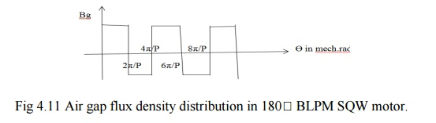

Air gap density distribution of BLPM DC SQW motor with 120Ԏ pole arc, as shown in fig.
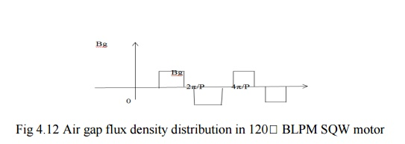

(b)BLPM Sine wave DC Motor
Air gap density distribution of BLPM dc sine wave motor as shown in fig.

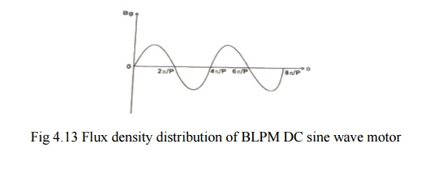
EMF EQUATION OF BLPM SQW DC MOTORS

The basic torque emf equations of the brushless dc motor are quite simple and resemble those of the dc commutator motor.
The co-ordinate axis have been chosen so that the center of a north pole of the magnetic is aligned with the x-axis at Ө = 0 .the stator has 12 slots and a three phasing winding. Thus there are two slots per pole per phase.

❖ Consider a BLPM SQW DC MOTOR
Let, ‘p‘be the number of poles (PM)
‘B_{g}‘ be the flux density in the air gap in wb/m².
B_{k} is assumed to be constant over the entire pole pitch in the air gap (180^{Ԏ} pole arc)
‘r‘ be the radius of the airgap in m.
‘l‘ be the length of the armature in m.
‘T_{c}‘ be the number of turns per coil.
‘ω_{m}‘ be the uniform angular velocity of the rotor in mechanical rad/sec.
ω_{m}=2πN/60 where N is the speed in rpm.
Flux density distribution in the air gap is as shown in fig .At t=0(it is assumed that the axis of the coil coincides with the axis of the permanent magnet at time t=0).
Let, at ω_{mt}=0,the centre of N-pole magnet is aligned with x-axis.
At ω_{mt}=0,x-axis is along PM axis.

Therefore flux enclosed by the coli is
Φ_{max}=B x 2πr/p x l ………………...(1)
=flux/pole
Φ_{max}=rl∫₀^{π} B(θ)dθ
=B_{g} rl[θ]₀^{π}
=B_{g}rl[π]

At ω_{mt}=0,the flux linkage of the coil is
Λ_{max}= (B_{g} x 2πr/p x l)T_{c} ωb-T …………………….(2)
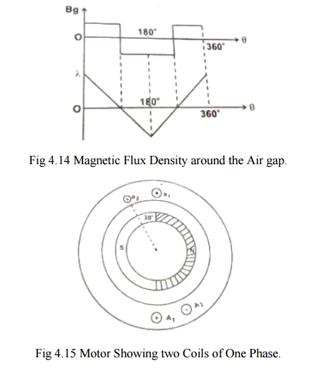

Let the rotor rotating in ccw direction and when ω_{mt}=π/2, the flux enclosed by the coil Φ, Therefore λ=0.

The flux linkages of the coil vary with θ variation of the flux linkage is as shown above.
The flux linkages of the coil changes from B_{g}rlTcπ/p at ω_{mt}=0 (i.e) t= 0 t0 θ at t=π/pω_{m}.
Change of flux linkage of the coil (i.e) ∆λ is

∆λ/∆t =Final flux linkage – Initial flux linkage/time.
=0- (2B_{g}rlTcπ/p)/ (π/pω_{m})
= -(2B_{g}rlTcω_{m)} …………………………...(3)
The emf induced in the coil e_{c}= - dλ/dt
e_{c} =2B_{g}rlTcω_{m} …………………………….(4)

Distribution of e_{c} with respect to t is shown in fig

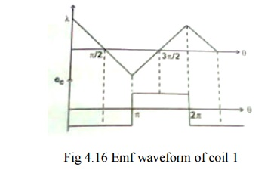
It is seen that the emf waveform is rectangular and it toggles between + e_{c} to - e_{c}. The period of the wave is 2πr/pω_{m} sec and magnitude of e_{c} is

e_{c} =2B_{g}rlTcω_{m} volts ………………………………...(5)

Consider two coils a1A1 and a2A2 as shown in fig .Coil a2A2 is adjacent to a1A1 is displaced from a1A1 by an angle 30^{Ԏ}(i.e.) slot angle ϒ .

The magnitude of emf induced in the coil a1A1
e_{c2} =B_{g}rlTcω_{m} volts …………………………….(6)

The magnitude of emf induced in the coil a2A2
e_{c2} =B_{g}rlTcω_{m} volts …………………………...(7)

Its emf waveform is also rectangular but displaced by the emf of waveform of coil e_{c1} by slot angleϒ .

If the two coils are connected in series, the total phase voltage is the sum of the two separate coil voltages.
e_{c1} +e_{c2} =2B_{g}rlTcω_{m} ………………………………..(8)
Let nc be the number of coils that are connected in series per phase n_{c}T_{c} =T_{ph} be the number of turns/phase.

e_{ph}= n_{c} [2B_{g}rlTcω_{m} ] ……………………………….(9)
e_{ph}= 2B_{g}rlTphωm volts ………………………………..(10)
e_{ph}=resultant emf when all nc coils are connected in series.

The waveforms are as shown in fig
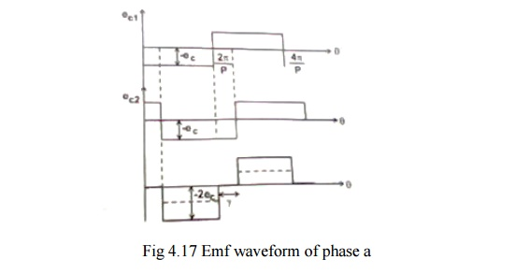

The waveform of e_{ph} is stepped and its amplitude is 2B_{g}rlTphω_{m} volts.

At any instant 2-phase windings are connected in series across the supply terminals as shown in fig .

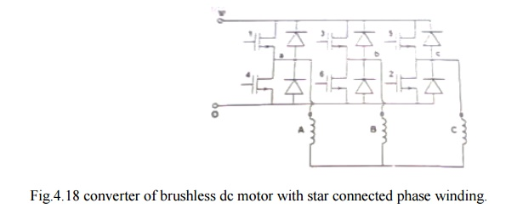
Assumption
Armature winding is Y connected.
Electronic switches are so operated using rotor position sensor that the resultant emfs across the winding terminals is always = 2 eph.
Amplitude of back emf generated in Y connected armature winding E = 2 eph.

BASIC VOLTAGE EQUATION OF BLPMDC MOTOR

Let, V be the dc supply voltage
I be the armature current
R_{ph} be the resistance per phase of the λ connected armature winding.
V_{dd} be the voltage drop in the device (it is usually neglected)
e_{ph} be the back emf generated per phase of Y connected armature winding
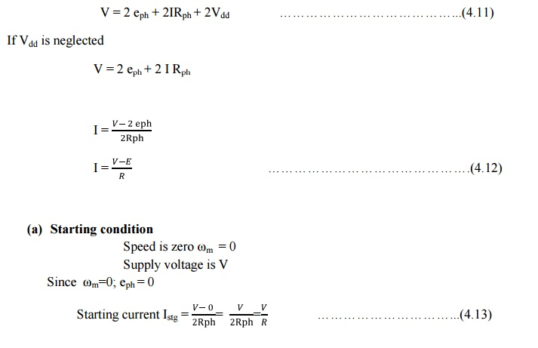
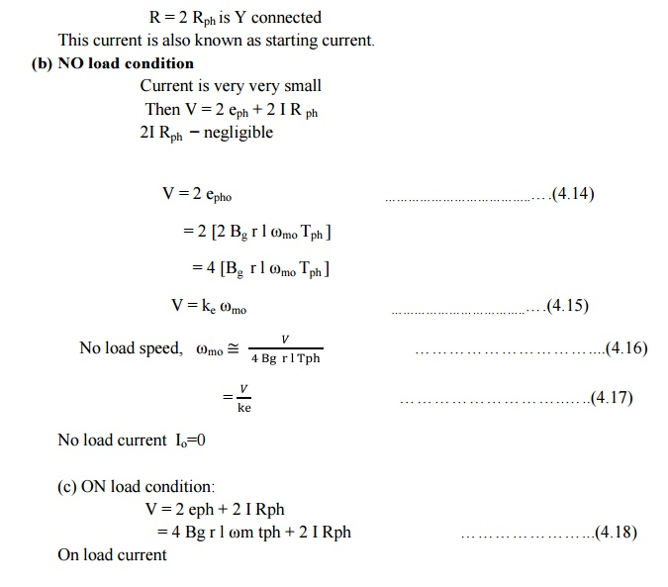

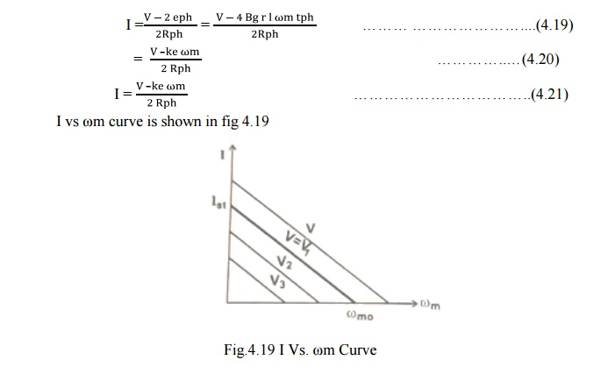

TORQUE EQUATION OF BLPM SQUARE WAVE MOTOR

Power input = VI
=[ 2 eph + 2 I Rph + 2 Vdd] I …………………….(4.22)
VI=[ 2 eph + 2 I Rph + 2 Vdd] I ……………………..(4.23)
Where,
VI= electrical power input
2 eph I = power converted as mechanical
2 I2 Rph = power loss in the armature winding
2 Vdd I = power loss in the device

Mechanical power developed= 2 eph I …………………..….(4.24)
eph= 2(2BgrlTphωm)I
eph= 4BgrlTphωm ……………….(4.25)

Mechanical power = (2πN/60)T ………………..…(4.26)
= ωmT ……………………..(4.27)
Where, N=Speed in rpm
T=Torque in N-m
ωm=Speed in rad/sec

Therefore, T=4BgrlTphI ……………………….…(4.28)
=KtT ……………………..…..(4.29)

Where Kt = 4BgrlTph=Ke …………………………....(4.30)

(a) Case1: Starting Torque
ωm=0
Istg=(V/2Rph) ……………………….…(4.31)
Tstg=4BgrlTph(V/2Rph) ………………………....(4.32)
Tstg=Kt(V/2Rph) ………………………...(4.33)
Starting torque or stalling torque depends upon V.
To vary the starting torque the supply voltage is to be varied.
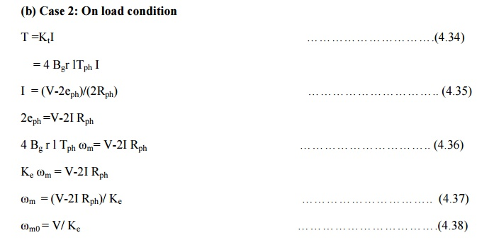

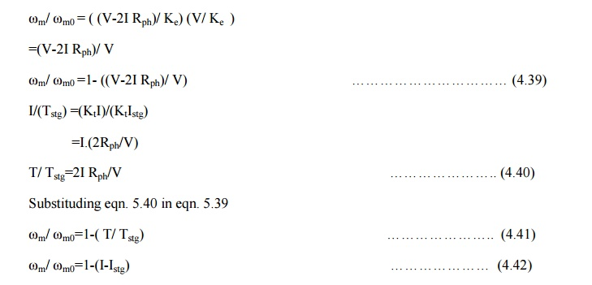

TORQUE- SPEED CHARACTERSISTICS OF BLPM SQM DC MOTOR
Let the supply voltage V be constant. A family of torque speed characteristics for various constant supply voltages is as shown in figure
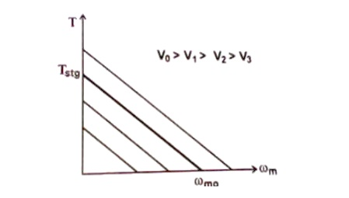
Fig 4.20 T-ω_{m} curve for various supply voltages

Permissible region of operation in T-ω_{m} plane

Torque speed characteristics of BLPM square wave motor is shown in fig.4.21. The constraints are

1. The continues current should not exceed the permissible current limit I_{n} (i.e) Torques should not exceed K_{t} I_{n}.
2. The maximum permissible supply voltage = V_{n}.
3. The speed should not exceed ω_{mn}.
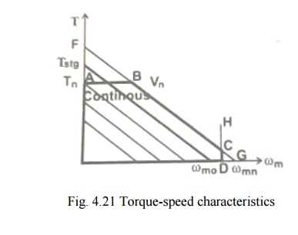
Line AB
Parallel to X-axis represents maximum permissible torque line which corresponds to maximum permissible current I_{n}.

Line FG
It represents T-ω_{m} characteristics corresponding to the maximum permissible V_{n.} B and C are points in Fg. B is the point of intersection between AB and FG.

Line DH
It represents constant maximum permissible speed line (i.e) ω_{mn} is constant. DH intersects FG and x axis at D.

The area OABCDO is the permissible region of operation. To obtain a particular point P corresponding to given load-torque and speed condition the only way to operate the motor at P is by suitably adjusting the supply voltage fed to the motor.
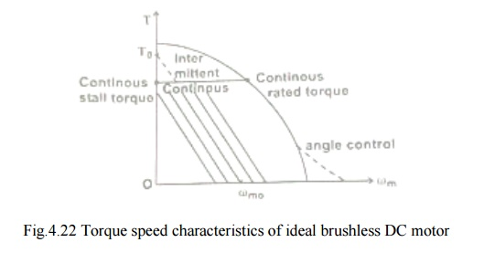

❖ If the phase resistance is small as it should be in an efficient design, then the characteristics to that of a shunt dc motor. The speed is essentially controlled by the voltage V and may be changed by changing the supply voltage. Then the current drawn just to drive the torque at its speed.

❖ As the load torque is increased, the speed drops and the drop is directly proportional to the phase resistance and the torque.
❖ The voltage is usually controlled by chopping or PWM. This gives rise to a family of torque speed characteristics as shown in fig. . The boundaries of continuous and intermittent limits are shown.

Continuous limit - determined by the heat transfer and temperature rise.
Intermittent limit – determined by the maximum ratings of semiconductor devices in circuit.

In practice the torque speed characteristics deviates from the ideal form because of the effects of inductance and other parasitic influences. Also the speed range can be extended by increasing the dwell of conduction period relative to the rotor position.

COMMUTATION IN MOTORS WITH 120° AND 180° MAGNET ARC

BLPM dc motor with 180° magnet arcs and 120° square wave phase currents arc shown in figs.

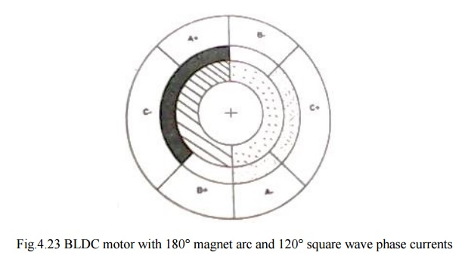
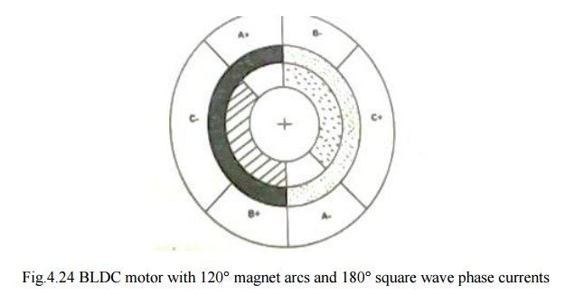
In Fig. the rotor magnet poles are shaded to distinguish north and south. The phase belts are shaded us complete 60° sector of the stator bore. There are two slots in each of these phase belts. The current in these two slots are identical and conductors in them are in series

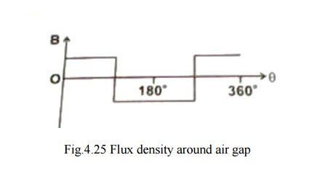
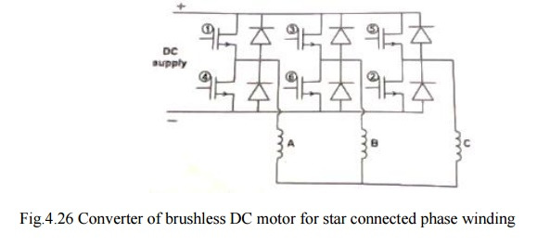
Between the rotor ring and the stationary belt ring in fig. there is a third ring called the ‖mmf ring‖. This represents the mmf distribution of the stator currents at a particular instant.

❖ At the instant shown wt=0, phase A is conducting positive current and phase C is conducting negative current. The resulting mmf distribution has the same shading as the N and S rotor poles to indicate the generation of torque,

❖ Where the mmf distribution has like shasing, positive torque is produced. Where mmf and flux shading are unlike, negative torque is produced. Where one is zero, no torque is zero, no torque is produced. The total torque is the integral of the contributions from around the entire air gap periphery.

The rotor is rotating in the clockwise direction. After 60º of rotation, the rotor poles start to ‗uncover‘ the C phase belts and the torque contribution of phase C starts to decrease linearly.

During this period, the magnet poles, have been 'covering‘ the B phase belts. Now if the negative current is commutated from C to B exactly at then point 60º, then the torque will be unaffected and will continue constant for a further 60º. After 120º, positive current must be commutated from A to C.

COMMUTATION TABLES FOR THREE-PHASE BRUSHLESS DC MOTORS.

TABLE : 180º Magnet-Star Winding. 120º Square wave phase Currents

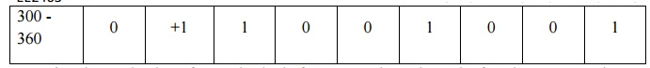
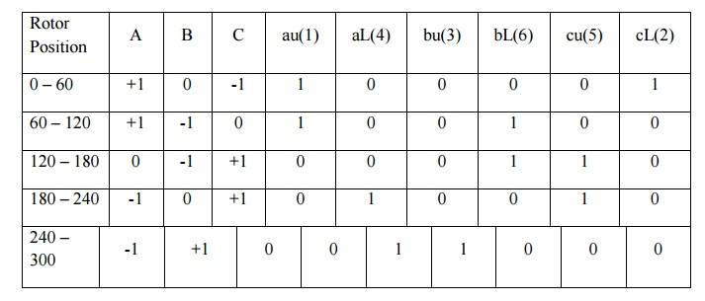
❖ The production of smooth, ripple free torque depends on the fact the magnet pole arc exceeds the mmf arc by 60º.
❖ Here only 2/3 of the magnet and 2/3 of the stator conductors are active at any instant

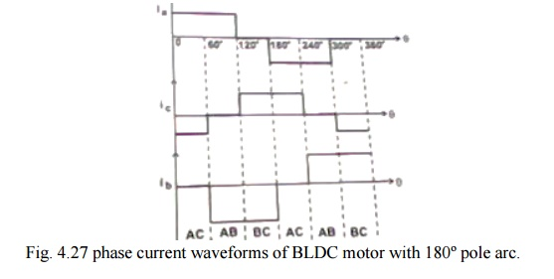
In a practical motor the magnet flux-density distribution cannot be perfectly rectangular as shown in fig.. for a highly coercive magnets and full 180º magnet arcs there is a transition section of the order of 10-20º in width. This is due to fringing effect. Likewise on the stator side, the mmf distribution is not rectangular but have a stepped wave form as shown in fig.4.28 that reflects the slotting.
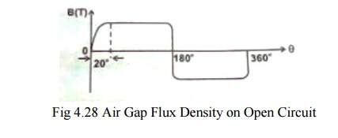
To some extent these effects cancel each other so that s that satisfactory results are obtained with a magnet arc as short as 150º, and two slots per pole per phase.

But there is always dip in the torque in the neighborhood of the commutation angles. This torque dip occurs every 60º elec degrees, giving rise to a torque ripple component with a fundamental frequency equal to 6P times the rotation frequency where P is the number of pole pairs. The magnitude and width of the torque dip depends on the time taken to commutate the phase current.

Phase current waveforms corresponding to high speed and low speed operations are as shown in fig. (a & b)

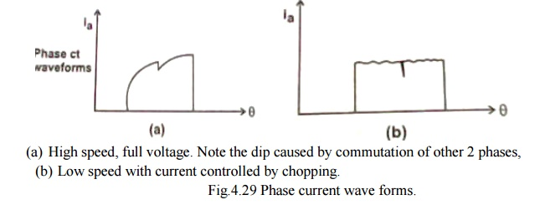
❖ The back emf is of equal value in the incoming phase and is in such a direction as to oppose the current build up.

❖ While the flux distribution of the magnet rotates in a continuous fashion, the mmf distribution of the stator remains stationary for 60º and then jumps to a position 60º ahead.

Similar analysis is made with a motor having 120 º pole arc magnets with delta connected armature winding.

Table 120º Magnet Delta Winding, 180º Square Wave Phase Currents.
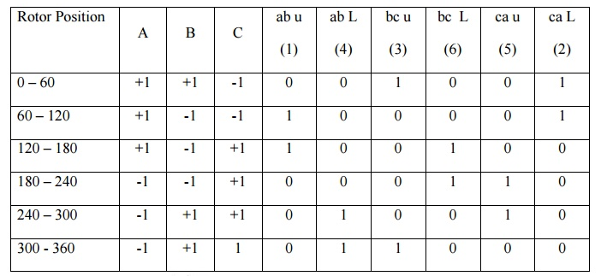
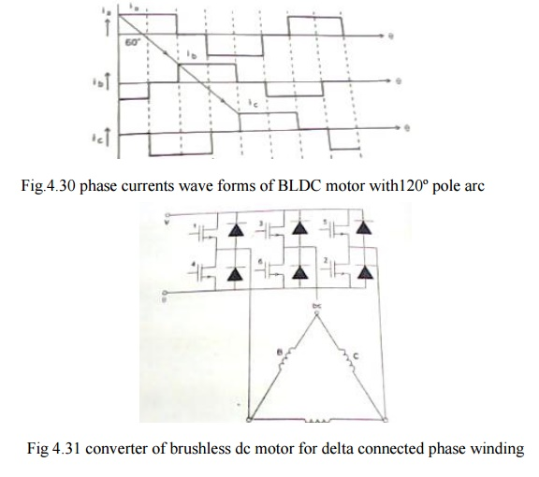
❖ C phase belt remains covered by the magnet poles. While the coverage of A phase belt increases thereby decreasing that of B phase belt.
❖ Since all the conductors are varying same current the increasing torque contribution of phase A is balancing by the decreasing contribution of phase B. Therefore, the total torque remains constant.
❖ Similarly there is a linear increase in the back emf of A and equal and opposite decrease in the back emf in phase B, Therefore the back emf at the terminals remains constant.
❖ Line current divides equally between two paths One-phase C Second-phase A & B series.
This balance is not perfect in practice because of the resistance and inductance of the windings.But the current balance should be maintained, otherwise circulating current may produce excessive torque ripple and additional losses.

When compared with 180° pole arc machine.
❖ For the same ampere-conductors per slot and for the same peak flux density, the 120° pole arc machine has 1.5 times copper losses, but produces the same torque.
❖ Also the ampere-conductors per slot would have to be reduced because the duty cycle is 1.0 instead of 2/3.
Merits
❖ For the same magnet flux density the total flux is only 2/3 of that of 180° pole arc motor, so that only 2/3 of the stator yoke thickness is required. If the stator outside diameter is kept the same, the slots can be made deeper so that the loss of ampere conductors can be at least partially covered .consequently the efficiency of the motor may not be very much less than that of 180° pole arc machine.
❖ In this machine also, the effects of fringing flux, slotting and communication overlap combine to produce torque ripple.
❖ Only emf and torque are discussed. The concept of hanging flux-linkage and energy balance can also be used to analyze the operation.

MAGNETIC CIRCUIT ANALYSIS ON OPEN CIRCUIT
Cross section of a 2 pole brushless dc motor having high energy rare earth magnets on the rotor and the demagnetization curve are as shown in fig

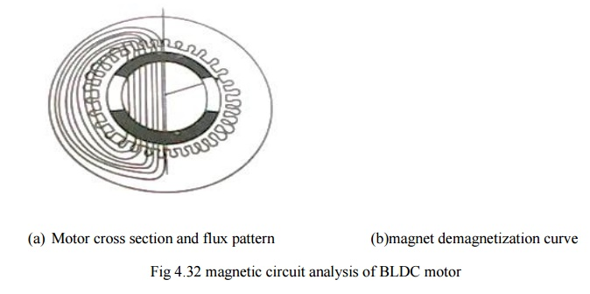
First step to analyze a magnetic circuit is to identify the main flux paths and the reluctance or permeances assigned to them.
The equivalent magnetic circuit is shown in fig .only half of the equivalent circuit is shown & the lower half is the mirror image of the upper half about the horizontal axis, which is at equipotential. This assumption is true only if the two halves are balanced. If not the horizontal axis might still be an equipotential but the fluxes and the magnetic potentials in the two halves would be different and there could be residual flux in the axial direction .along the shaft. The axial flux is undesirable because it can induce current to flow in the bearing.
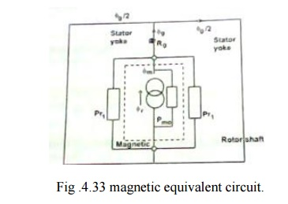
The steel cores of the stator and rotor shaft are assumed to be infinitely permeable.

Each magnet is represented by a ‗Norton‘ equivalent circuit consisting of a flux generator in parallel with an internal leakage permeance p_{mo.}
υr=BrAm …….(4.43)
Pmo=μ0μrecAm/lm …….(4.44)
where Am – pole area the magnet
lm – length of the magnet in the direction of magnetization (in this case its radial thickness)
Br- remanent flux density
μrec- relative recoil permeability (the slope of the demagnetization curve)

In this case the outer pole area is larger than the inner pole area but to keep the analysis simple average pole area is considered.

with a magnet arc of 120°
Am=2/3^{ᴨ}[r1–g-lm/2]l ……….(4.45)
r1- radius of the rotor
g- air gap length
Most of the magnet flux crosses the air gap via the air gap reluctance, Rg
Rg=g‘/μ0Ag ………..(4.46)
g‘- equivalent air gap length allowing for slotting.

The slotting can be taken into account by means of carter‘s coefficient, which case,
g‘=Kc g ………………………...(4.47)

Ag- air gap area through which the flux passes as it crosses he gap . the precise boundary of this area is uncertain because of fringing both at the edges of the magnet and at the ends of the rotor.An approximate allowance for fringing can be made by adding ‗g‘ at each of the four boundaries ,giving

Ag=[2/3 (r1- g/2)+2g](l+2g) ............................…..(4.48)

the remaining permeance in the magnetic circuit I the rotor leakage permeance ρrl, which represents the paths of the magnet flux components that fails to cross the air gap. this can be conveniently included in a modified magnet internal permeance by writϖing
pm=pmo+prl …………(4.49(a))
pm=pmo(1+prl) …….(4.49(b))
prl-normalized rotor leakage permeance

A controller for BLPM SQW DC Motor
1. Power Circuit
Power Circuit of BLPM de motor is as shown fig consists of six power semiconductor switching device connected in bridge configuration across a dc supply. A suitable shunt resistance is connected in series to get the current feedback. Feedback diodes are connected across the device. The armature winding is assumed to be star connected. Rotor has a rotor position sensor and a techo-generator is coupled to the shaft to get feedback signal.
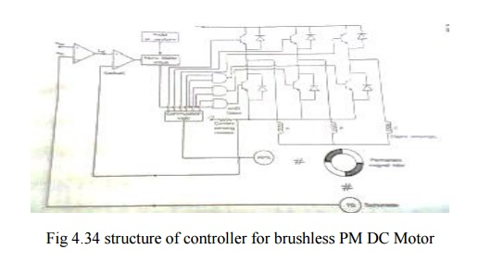

2. Control circuit
The control circuits consist of a commutation logic unit. Which get the information about the rotor shaft position and decides which switching devices are to be turned on and which devices are to be turned off. This provides six output signals out of which three are used as the base drive for the upper leg devices. The other three output signal are logically AND with the high frequency pulses and the resultant signals are used to drive the lower leg devices.

A comparator compares the tachogenerator output with reference speed and the output signal is considered as the reference current signal for the current comparator which compare the reference current with the actual current and the error signal output is fed to the monostable multivibrator which is excited by high frequency pulses. The duty cycle of the output of monostable is controlled by error signal. This output signal influences the conduction period and duty cycle of lower leg devices.

Rotor Position sensors for BLPM motor
It converts the information of rotor shaft position into suitable electrical signal. This signal is utilized to switch ON and OFF the various semiconductor devices of electric switching and commutation circuitry of BLPM motor.

Two popular rotor sensors are --- (a) Optical Position Sensor.
(b) Hall Effect Position Sensor.

(a) Optical position sensor
This makes use of six photo transistors. This device is turned into ON state when light rays fall on the devices. Otherwise the device is in OFF state the schematic representation is shown in fig.

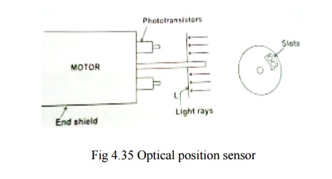
The phototransistors are fixed at the end shield cover such that they are mutually displaced by 60 degree electrical by a suitable light source. The shaft carries a circular disc which rotates along the shaft. The disc prevents the light ray falling on the devices. Suitable slot are punched in the disc such turned into on state suitably turns the main switching devices of electronic commutation circuitry into on state.
As the shaft rotates, the devices of electronic commutation which are turned into ON are successively changed.

(b) Hall effect position sensor
Consider a small pellet of n-type semiconducting material as shown in fig .

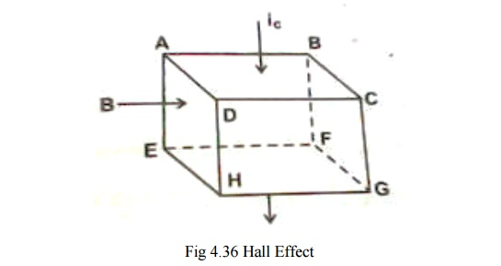
A current ic is allowed to pass from the surface ABCD to the surface EFGH. Let the surface ABEF be subjected to a North pole magnetic field of flux density B tesla. As per Fleming left hand rule, the positive charge in the pellet get concentrated near surface ADHE and negative charges near the surface BCFG. Since n-type material has free negative charges, there electrons gets concentrated near the surface BCGF.This charge in distribution makes the surface ADHE more positive than the surface BCGF. This potential known as Hall emf or emf due to Hall Effect.
It has been experimentally shown that emf due to hall effect is V_{H} is given by
V_{H} = R_{H}(i_{c} / d) volts
Where, i_{c-} current through the pellet in amps B- Flux density in tesla
d- Thickness of the pellet in m.
R_{H} – Constant which depends upon the physical dimensions or physical properties of the pellet. If the polarity of B is changed from North Pole to South Pole the polarity of the emf due to Hall Effect also get changed.

3. Hall Effect Position Sensor
Hall effect position sensor can be advantageously used in a BLPM motor. Consider a 2 pole BLPM motor with two winding w1 and w2 as shown in fig.

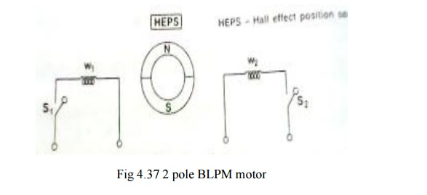

When w1 carries a current on closing S1 it set up a North Pole flux in the air gap. Similarly when s2 is closed w2 is energized and sets up a North Pole flux.w1 and w2 are located in the stator such that their axes are 180 degree apart. A Hall Effect position sensor is kept in an axis of the winding.

When Hall Effect position sensor is influenced by North Pole flux the hall emf is made to operate the switch S1. Then w1 sets up North Pole flux. The rotor experiences a torque and South Pole of the rotor tends to align with the axis of w1.because of interia.it overshoot the rotor hence rotates in clockwise direction. Now HEPS is under the influence of S pole flux of the rotor. Then the polarity of hall emf gets changed. This make the switch S1 in off state and S2 is closed. Now w2 sets up N pole flux in the air gap, the rotor rotates in clockwise direction. So that the s pole gets aligned with w2 axis.Then this process continuous. The rotor rotates continuously.

Types of BLPM motor:
BLPM motor is classified on the basis of number of phase windings and the number of pulses given to the devices during each cycle.

1. One phase winding one pulse BLPM motor
The stator has one phase winding as shown in fig.
It is connected to the supply through a power semiconductor switch. When the rotor position sensor is influenced by say n pole flux, the stator operates and the rotor developed a torque. When the RPS is under the influence of S pole, the transistor is in off state. The rotor gets torque whenever the rotor position is under the influence of n pole.
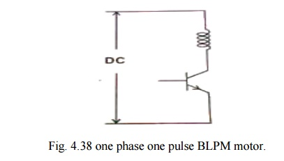
The current and torque are approximated as sinusoidally varying as shown in fig.
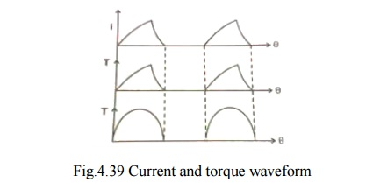
Advantages:
❖ One transistor and one position sensor is sufficient.
❖ Inertia should be such that the rotor rotates continuously.
❖ Utilization of transistor and winding are less than 50%.

2. One phase two pulse BLPM motor
Stator has only one winding. It is connected to DC three wire supply through two semiconductor devices as shown in fig. .
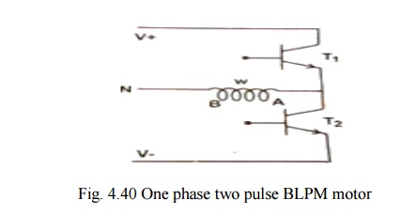

There is only one position sensor. When the position sensor is under the N-pole influence,T1 is in on-state and T2 is in off-state. When it is under the influence of S-pole, T2 is on and T1 is off.
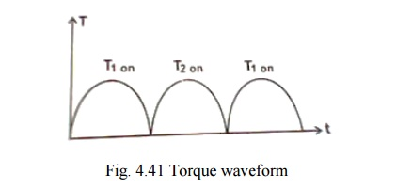

In the first case, the winding carries current from A to B and when T2 is on, the winding carries current from B to A. The polarity of the flux setup by the winding gets alerted depending upon the position of the rotor. This provides the unidirectional torque as shown in fig. .

Advantages:
❖ Winding utilization is better.
❖ Torque developed is more uniform.
Disadvantages:
❖ Transistor utilization is less
❖ The current needs a 3-wire dc supply.

3. Two phase winding and two pulse BLPM motor
Stator has two phase windings which are displaced y 180° electrical. Electrical connections are as shown in fig.. It makes use of two semiconductor switches.
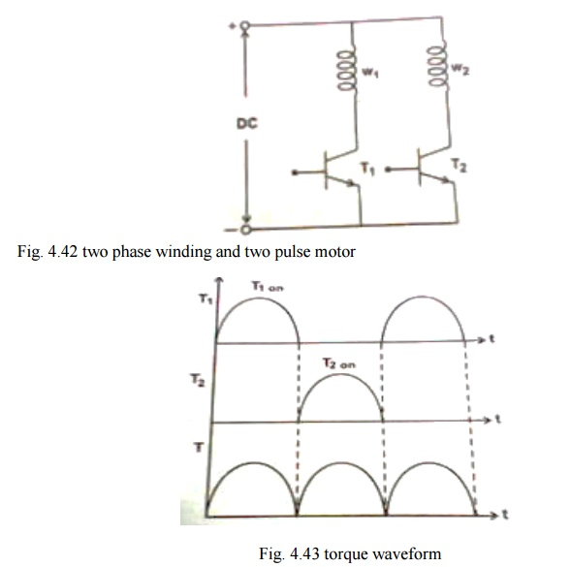

Performance of this type is similar to one phase 2 pulse BLPM motor. Torque waveform are as shown in fig. . However it requires two independent phase windings.

Merit
❖ Better torque waveform.

Demerit
❖ Their utilization is only 50% which is less.
❖ Cabling with rotor position sensor should be made proper.

4. Three phase winding and three pulse BLPM motor
The stator has 3Φ windings as shown in fig.. Whose areas are displaced by 120°elec. apart. Each phase windings is controlled by a semiconductor switch which is operated depending upon the position of the rotor. Three position sensors are required for this purpose.
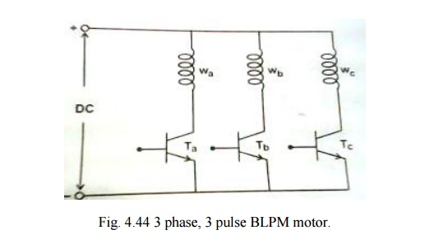

5. Three phase six pulse BLPM motor
Most commonly used. It has 3 phase windings and six witching devices as shown in fig. .

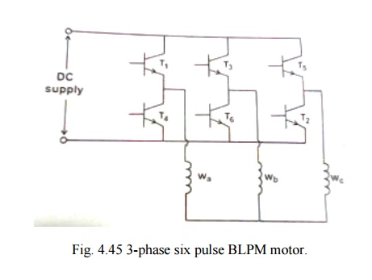
Short Questions and Answers:
- what are the advantages of brushless dc motors drives?

- Regenerative braking is possible
- Speed can be easily controllable

what are the disadvantages of brushless dc motors drives?

- It requires a rotor position sensor
- It requires a power semiconductor switching circuits.

Define mechanical commutators?

Its arrangement is located in the rotor
No of commutators segments are very high . 4.Define electronic commutators?
- Its arrangement is located in the stator
- No of switching devices limited to six

Mention some applications of PMBL DC motor?

- Power alternators
- Automotive applications
- Computer and Robotics applications
- Textile and Glass industries

What are conventional Dc motor?

- Field magents on the stator
- Maintenance is high

What are PMBL DC motor?

- Field magents on the rotor
- Low maintanace

Why is the PMBLDC motor called electronically commulated motor?

The PMBL DC motor is also called electronically commutated motor because the phase windings of PLMBL DC motor is energized by using power semiconductor switching circuits.here the power semiconductor switching circuits act as a commutator.

What are the classification of BLPM DC motor?

- BLPM square wave motor
- BLPM sine wave motor

What are the two types of BLPM SQW DC motor?

- 180”polerarc BLPM SQW motor
- 120”polearc BLPM SQW motor

What are the two types of rotor position sensors?

- Optical position sensor
- Hall effect position sensor

What are the materials used for making Hall IC pallet?

- Indiem-antinomy
- Gallium-arsenide

What are applications of stator?

- Automotive applications
- Veticular electric drive motors

What are the classification of BLPM dc motor?

- One phase winding and one pulse BLPM dc motor
- One phase winding and two pulse BLPM dc motor
- Two phase winding and two pulse BLPM dc motor
- Three phase winding and three pulse BLPM dc motor
- Three phase windings and six pulse circuits

What are the features of one phase winding and one pulse BLPM dc motor?

- It is inertia should be high,such that rotor rotates continuously
- Utilization of transistor and windings are less

What are the features of one phase winding and two pulse BLPM dc motor?

- In this case winding utilization is better,however transistor utilization is less.
- Torque developed is more uniform

What are the features of two phase winding and two pulse BLPM dc motor?

- Winding utilization is only 50%which is less
- It provide better torque waveforms

What are the features of three phase windings and 6 pluse circuits?

- Utilization factor of winding will be better
- Torque pulse and ripple frequency components are less

What is meant by self control?

Self control ensures that for all opearating points the armature and rotor fields move exactly at the same speed.

What is meant by vector control?

PMSM are employed for variable speed applications. The process of controlling voltage and frequency to get the desired speed and torque is known as vector control of PMSM

PART – B

- Sketch the structure of controller for PMBLDC motor and explain the functions of various blocks. (16)
- Explain the closed loop control scheme of a permanent magnet brushless dc motor drive with a suitable schematic diagram. (16)
- Drive the expressions for the emf and torque of a PMBLDC motor. (16)
- Draw the diagram of electronic Commutator. Explain the operation of electronic Commutator. (16)
- Discuss the use of Hall sensors for position sensing in PMBLDC motor. (16)
- Sketch the torque-speed characteristics of a PMBLDC motor. (16)

