UNIT – II
ELECTRIC HEATING

INTRODUCTION:
Electric heating is extensively used both for domestic and industrial applications. Domestic applications include (i) room heaters (ii) immersion heaters for water heating (iii) hot plates for cooking (iv) electric kettles (v) electric irons (vi) pop-corn plants (vii) electric ovens for bakeries and (viii) electric toasters etc.
Industrial applications of electric heating include (i) melting of metals (ii) heat treatment of metals like annealing, tempering, soldering and brazing etc. (iii) moulding of glass (iv) baking of insulators (v) enameling of copper wires etc.

Advantages of Electric Heating:
As compared to other methods of heating using gas, coal and fire etc., electric heating is far superior for the following reasons:
- Cleanliness: Since neither dust nor ash is produced in electric heating, it is a clean system of heating requiring minimum cost of cleaning. Moreover, the material to be heated does not get contaminated.
- No Pollution: Since no flue gases are produced in electric heating, no provision has to be made for their exit.
- Economical: Electric heating is economical because electric furnaces are cheaper in their initial cost as well as maintenance cost since they do not require big space for installation or for storage of coal and wood. Moreover, there is no need to construct any chimney or to provide extra heat installation.
- Ease of Control: It is easy to control and regulate the temperature of an electric furnace with the help of manual or automatic devices. Temperature can be controlled within ± 5°C which is not possible in any other form of heating.
- Special Heating Requirement: Special heating requirements such as uniform heating of a material or heating one particular portion of the job without affecting its other parts or heating with no oxidation can be met only by electric heating.
- Higher Efficiency: Heat produced electrically does not go away waste through the chimney and other by-products. Consequently, most of the heat produced is utilised for heating the material itself. Hence, electric heating has higher efficiency as compared to other types of heating.
- Better Working Conditions: Since electric heating produces no irritating noises and also the radiation losses are low, it results in low ambient temperature. Hence, working with electric furnaces is convenient and cool.
- Heating of Bad Conductors: Bad conductors of heat and electricity like wood, plastic and bakery items can be uniformly and suitably heated with dielectric heating process.
- Safety: Electric heating is quite safe because it responds quickly to the controlled signals.
- Lower Attention and Maintenance Cost: Electric heating equipment generally will not require much attention and supervision and their maintenance cost is almost negligible. Hence, labour charges are negligibly small as compared to other forms of heating.

Different Methods of Heat Transfer:
The different methods by which heat is transferred from a hot body to a cold body are as under:
- Conduction:
In this mode of heat transfer, one molecule of the body gets heated and transfers some of the heat to the adjacent molecule and so on. There is a temperature gradient between the two ends of the body being heated.
Consider a solid material of cross-section A sq.m. and thickness x metre as shown in Fig. 1
If T1 and T2 are the temperatures of the two sides of the slab in °K, then heat conducted between the two opposite faces in time t seconds is given by:

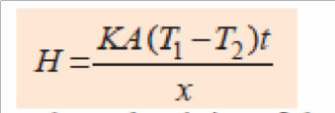
Where K is thermal conductivity of the material

Convection:
In this process, heat is transferred by the flow of hot and cold fluid currents. This process is applied in the heating of water by immersion heater or heating of buildings. The quantity of heat absorbed by the body by convection process depends mainly on the temperature of the heating element above the surroundings and upon the size of the surface of the heater. It also depends, to some extent, on the position of the heater. The amount of heat dissipated is given by
H = a b(T1 – T2),
where a and b are constants and T1 and T2 are the temperatures of the heating surface and the fluid in °K respectively.
In electric furnaces, heat transferred by convection is negligible

- Radiation:
It is the transfer of heat from a hot body to a cold body in a straight line without affecting the intervening medium. The rate of heat emission is given by Stefan‘s law according to which Heat dissipated 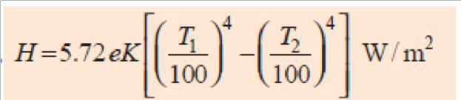
where K is radiating efficiency and e is known as emissivity of the heating element.

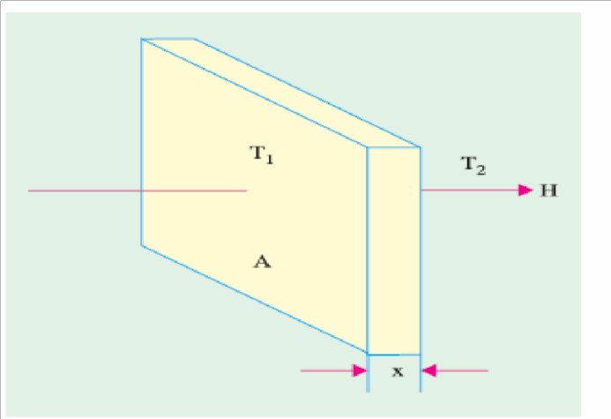
Fig 1

Methods of Electric Heating:
Basically, heat is produced due to the circulation of current through a resistance. The current may circulate directly due to the application of potential difference or it may be due to induced eddy currents. Similarly, in magnetic materials, hysteresis losses are used to create heat. In dielectric heating, molecular friction is employed for heating the substance. An arc established between an electrode and the material to be heated can be made a source of heat. Bombarding the surface of material by high energy particles can be used to heat the body.

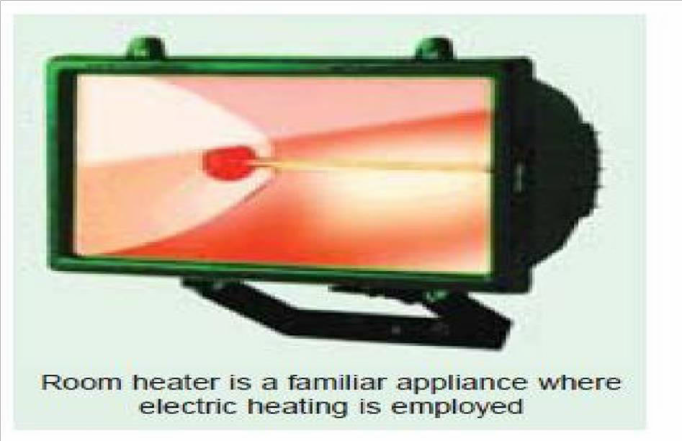
Fig 2

Different methods of producing heat for general industrial and domestic purposes may be classified below:
.

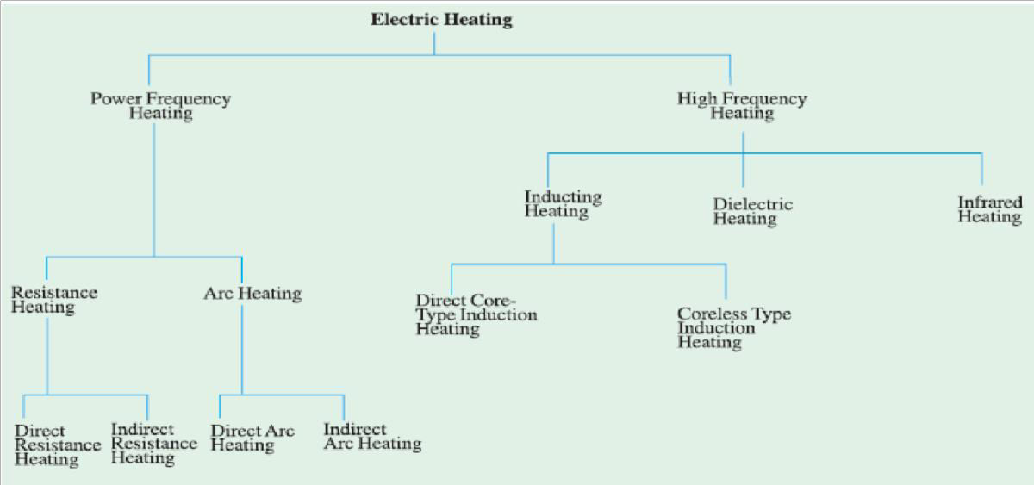

Resistance Heating:
It is based on the I²R effect. When current is passed through a resistance element ^{I2}R loss takes place which produces heat. There are two methods of resistance heating.
- Direct Resistance Heating: In this method the material (or charge) to be heated is treated as a resistance and current is passed through it. The charge may be in the form of powder, small solid pieces or liquid. The two electrodes are inserted in the charge and connected to either a.c. or d.c. supply (Fig.3). Obviously, two electrodes will be required in the case of d.c. or single-phase a.c. supply but there would be three electrodes in the case of 3-phase supply. When the charge is in the form of metal pieces, a powder of high resistivity material is sprinkled over the surface of the charge to avoid direct short circuit.
Heat is produced when current passes through it. This method of heating has high efficiency because the heat is produced in the charge itself.

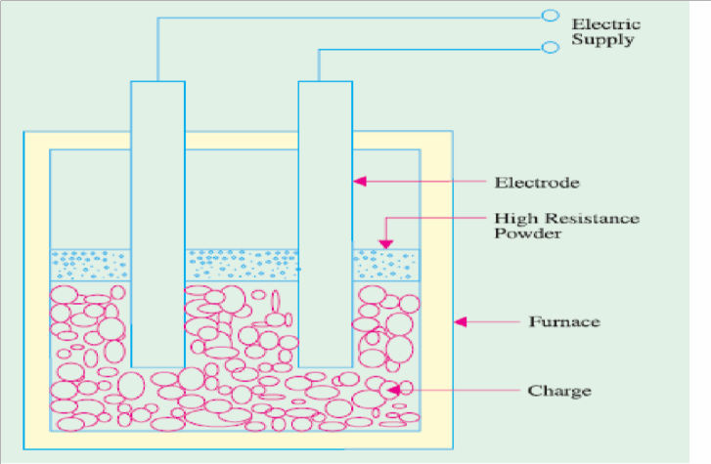

Fig 3

Indirect Resistance Heating:
In this method of heating, electric current is passed through a resistance element which is placed in an electric oven. Heat produced is proportional to I2R losses in the heating element. The heat so produced is delivered to the charge either by radiation or convection or by a combination of the two.
Sometimes, resistance is placed in a cylinder which is surrounded by the charge placed in the jacket as shown in the Fig.4. This arrangement provides uniform temperature. Moreover, automatic temperature control can also be provided.

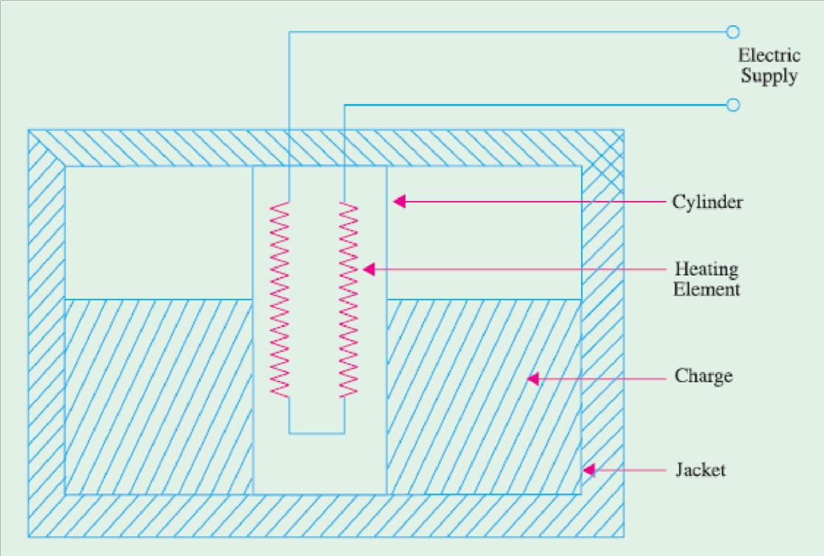

Fig 4

Requirement of a Good Heating Element:
Indirect resistance furnaces use many different types of heating elements for producing heat. A good heating element should have the following properties:
- High Specific Resistance: When specific resistance of the material of the wire is high, only short length of it will be required for a particular resistance (and hence heat) or for the same length of the wire and the currrent, heat produced will be more.
- High Melting Temperature: If the melting temperature of the heating element is high, it would be possible to obtain higher operating temperatures.
- Low Temperature Coefficient of Resistance: In case the material has low temperature coefficient of resistance, there would be only small variations in its resistance over its normal range of temperature. Hence, the current drawn by the heating element when cold (i.e., at start) would be practically the same when it is hot.
- Oxidizing Temperature: Oxidization temperature of the heating element should be high in order to ensure longer life.

- Positive Temperature Coefficient of Resistance: If the temperature coefficient of the resistance of heating element is negative, its resistance will decrease with rise in temperature and it will draw more current which will produce more wattage and hence heat. With more heat, the resistance will decrease further resulting in instability of operation.
- Ductile: Since the material of the heating elements has to have convenient shapes and sizes, it should have high ductility and flexibility.
- Mechanical Strength: The material of the heating element should posses high mechanical strength of its own. Usually, different types of alloys are used to get different operating temperatures. For example maximum working temperature of constant an (45% Ni, 55% Cu) is 400°C, that of nichrome (50%, Ni 20% Cr) is 1150°C, that of Kanthal (70% Fe, 25% Cr, 5% Al) is 1200° C and that of silicon carbide is 1450°C.

With the passage of time, every heating element breaks open and becomes unserviceable. Some of the factors responsible for its failure are :
(1) Formation of hot spots which shine brighter during operation
(2) Oxidation
(3) Corrosion
(4) Mechanical failure

Resistance Furnaces or Ovens:

These are suitably-insulated closed chambers with a provision for ventilation and are used for a wide variety of purposes including heat treatment of metals like annealing and hardening etc., stoving of enamelled wares, drying and baking of potteries, vulcanizing and hardening of synthetic materials and for commercial and domestic heating. Temperatures upto 1000°C can be obtained by using heating elements made of nickel, chromium and iron. Ovens using heating elements made of graphite can produce temperatures upto 3000°C. Heating elements may consist of circular wires or rectangular ribbons. The ovens are usually made of a metal framework having an internal lining of fire bricks. The heating element may be located on the top, bottom or sides of the oven. The nature of the insulating material is determined by the maximum temperature required in the oven.
An enclosure for charge which is heated by radiation or convection or both is called a heating chamber.

Temperature Control of Resistance Furnaces:
The temperature of a resistance furnace can be changed by controlling the I2R or V2/R losses. Following different methods are used for the above purpose :
- Intermittent Switching. In this case, the furnace voltage is switched ON and OFF intermittently. When the voltage supply is switched off, heat production within the surface is stalled and hence its temperature is reduced. When the supply is restored, heat production starts and the furnace temperature begins to increase. Hence, by this simple method, the furnace temperature can be limited between two limits.

By Changing the Number of Heating Elements. In this case, the number of heating elements is changed without cutting off the supply to the entire furnace. Smaller the number of heating elements, lesser the heat produced. In the case of a 3-phase circuit, equal number of heating elements is switched off from each phase in order to maintain a balanced load condition.
- Variation in Circuit Configuration. In the case of 3-phase secondary load, the heating elements give less heat when connected in a star than when connected in delta because in the two cases, voltages across the elements is different (Fig 5.a). In single-phase circuits, series and parallel grouping of the heating elements causes change in power dissipation resulting in change of furnace temperature.

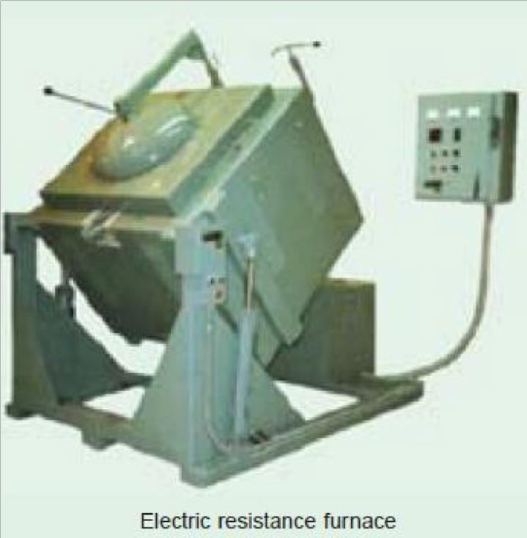

Fig 5

As shown in Fig. 5 heat produced is more when all these elements are connected in parallel than when they are connected in series or series-parallel.
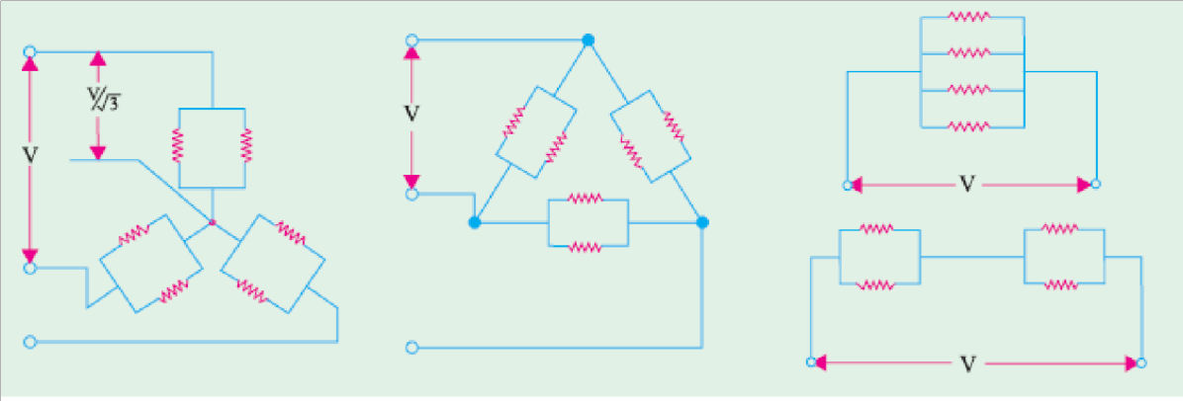
Fig 5.a.
- Change of Applied Voltage. (a) Obviously, lesser the magnitude of the voltage applied to the load, lesser the power dissipated and hence, lesser the temperature produced. So by selecting a suitable tapping on primary, a voltage across the secondary can be reduced or increased causing a change of temperature in the heating furnace.

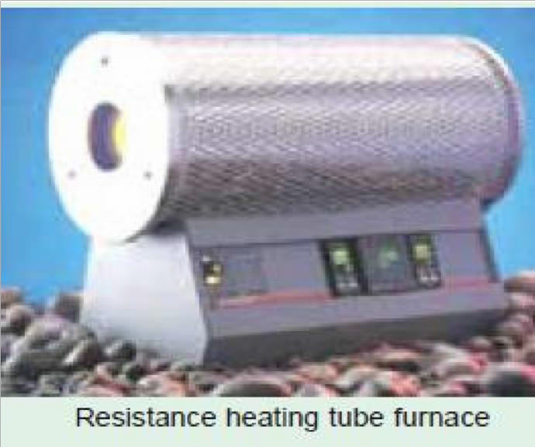

Fig 6

- Bucking-Boosting the Secondary Voltage. In this method, the transformer secondary is wound in two sections having unequal number of turns. If the two sections are connected in series aiding, the secondary voltage is boosted i.e., increased to (E2 + E3).
When the two sections are connected in series-opposing the secondary voltage is reduced i.e., there is bucking effect. Consequently, furnace voltage becomes (E2 – E3) and, hence, furnace temperature is reduced.
- Autotransformer Control. The use of tapped autotransformer used for decreasing the furnace voltage and, hence, temperature of small electric furnaces. The required voltage can be selected with the help of a voltage selector.

Series Reactor Voltage. In this case, a heavy-duty core-wounded coil is placed in series with the furnace as and when desired. Due to drop in voltage across the impedance of the coil, the voltage available across the furnace is reduced. With the help of D.P.D.T. switch, high/low, two mode temperature control can be obtained. Since the addition of series coil reduces the power factor, a power capacitor is simultaneously introduced in the circuit for keeping the p.f. nearly unity.

Design of Heating Element
Normally, wires of circular cross-section or rectangular conducting ribbons are used as heating elements. Under steady-state conditions, a heating element dissipates as much heat from its surface as it receives the power from the electric supply. If P is the power input and H is the heat dissipated by radiation, then P = H under steady-state conditions.
As per Stefan‘s law of radiation, heat radiated by a hot body is given by

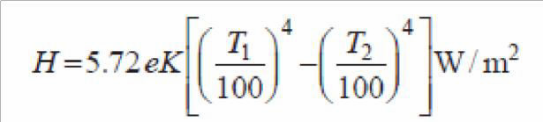 (1)
where T1 is the temperature of hot body in °K and T2 that of the cold body (or cold surroundings) in °K
$$Now, P=\frac{V^{2}}{R} and R=\frac{ρl}{A}=\frac{ρl}{\frac{πd^{2}}{4}}=4\frac{ρl}{πd^{2}}$$
$$Therefore, P=\frac{V^{2}}{4\frac{ρl}{πd^{2}}}= \frac{πd^{2}V^{2}}{4ρl}$$
$$\frac{l}{d^{2}}= \frac{πV^{2}}{4ρ.P} (2)$$
Now , $Surface Area, S= π.d.l$ and

$Heat Dissipated= πdl.H$

At steady Temperature we know,
Power input = Heat Dissipated
$P= πdl.H$
$\frac{πd^{2}V^{2}}{4ρl}= πdl.H$
$\frac{d}{l^{2}}=\frac{4ρH}{V^{2}} (3)$

Solving Expressions (2) & (3) length and diameter of wire can be determined.
For Ribbon Type of conductor, let w is the width of the ribbon and t its thickness then $P=\frac{V^{2}}{R}$
$P=\frac{V^{2}}{\frac{ρl}{a}}=\frac{V^{2}}{\frac{ρl}{wt}}$
$P=\frac{V^{2}wt}{ρl}$
$\frac{l}{wt}=\frac{V^{2}}{ρP} (4)$
Heat lost from ribbon surface = 2wl H (neglecting the side area 2tl )

Since at steady temperature, Power Input = Heat Dissipated

$$P= 2wl.H$$
$$\frac{V^{2}wt}{ρl}= 2wl.H$$
$$\frac{t}{l^{2}}=\frac{2Hρ}{V^{2}} (5)$$

By Solving Equations (4) & (5) length l and width w for a given ribbon of thickness t will be evaluated.

Induction Heating:

This heating process makes use of the currents induced by the electro-magnetic action in the charge to be heated. In fact, induction heating is based on the principle of transformer working. The primary winding which is supplied from an a.c. source is magnetically coupled to the charge which acts as a short circuited secondary of single turn. When an a.c. voltage is applied to the primary, it induces voltage in the secondary i.e. charge. The secondary current heats up the charge in the same way as any electric current does while passing through a resistance. If V is the voltage induced in the charge and R is the charge resistance, then heat produced = V ²/R. The value of current induced in the charge depends on
- magnitude of the primary current
- turn ratio of the transformer
(iii) co-efficient of magnetic coupling Low-frequency induction furnaces are used for melting and refining of different metals. However, for other processes like case hardening and soldering etc., high-frequency eddy-current heating is employed. Low frequency induction furnaces employed for the melting of metals are of the following two types :
- Core-type Furnaces which operate just like a two winding transformer. These can be further sub-divided into (i) Direct core-type furnaces (ii) Vertical core-type furnaces and (iii) Indirect core-type furnaces.
- Coreless-type Furnaces in which an inductively-heated element is made to transfer heat to the charge by radiation.

Core Type Induction Furnace:

It is shown in Fig. 7 and is essentially a transformer in which the charge to be heated forms a single-turn short-circuited secondary and is magnetically coupled to the primary by an iron core. The furnace consists of a circular hearth which contains the charge to be melted in the form of an annular ring. When there is no molten metal in the ring, the secondary becomes open- circuited there-by cutting off the secondary current. Hence, to start the furnace, molted metal has to be poured in the annular hearth. Since, magnetic coupling between the primary and secondary is very poor, it results in high leakage and low power factor. In order to nullify the effect of increased leakage reactance, low primary frequency of the order of 10 Hz is used. If the transformer secondary current density exceeds 500 A/cm2 then, due to the interaction of secondary current with the alternating magnetic field, the molten metal is squeezed to the extent that secondary circuit is interrupted. This effect is known as pinch effect.

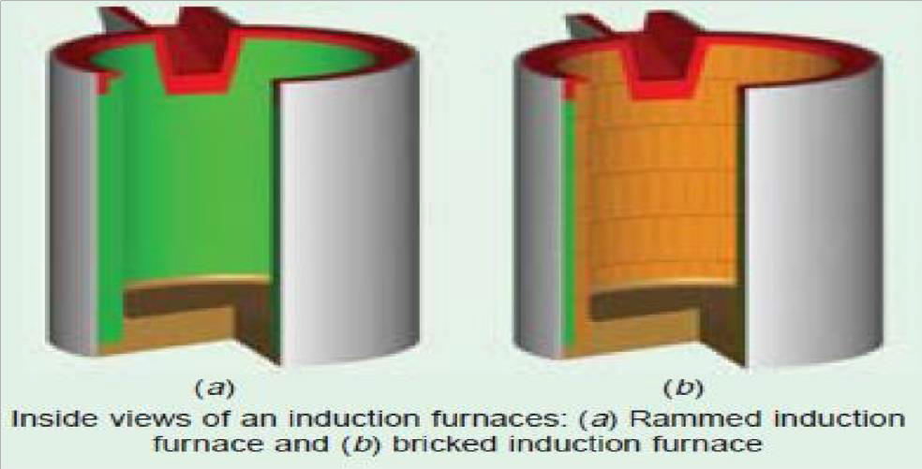

Fig 7

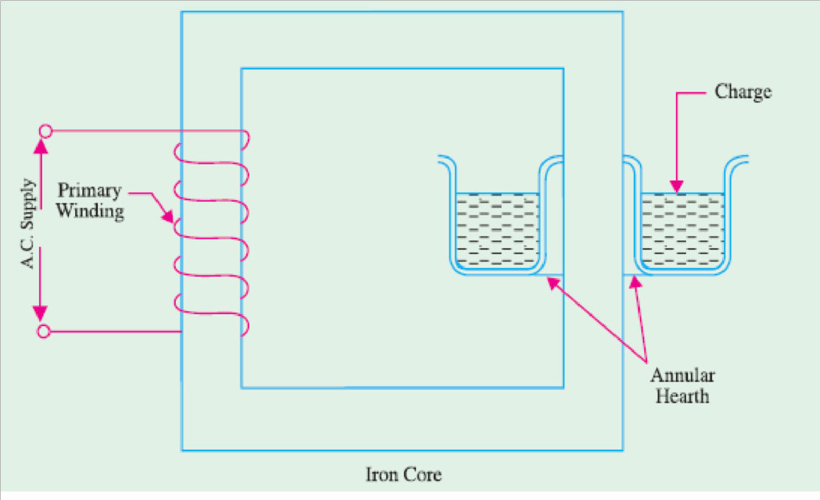

Fig 8

This furnace suffers from the following drawbacks:
- It has to be run on low-frequency supply which entails extra expenditure on motor-generator set or frequency convertor.
- It suffers from pinching effect.
- The crucible for charge is of odd shape and is very inconvenient for tapping the molten charge.
- It does not function if there is no molten metal in the hearth i.e. when the secondary is open. Every time molten metal has to be poured to start the furnace.
- It is not suitable for intermittent service. However, in this furnace, melting is rapid and clean and temperature can be controlled easily.
Moreover, inherent stirring action of the charge by electro-magnetic forces ensures greater uniformity of the end product.

Vertical Core-Type Induction Furnace

It is also known as Ajax-Wyatt furnace and represents an improvement over the core-type furnace discussed above. As shown in Fig., it has vertical channel (instead of a horizontal one) for the charge, so that the crucible used is also vertical which is convenient from metallurgical

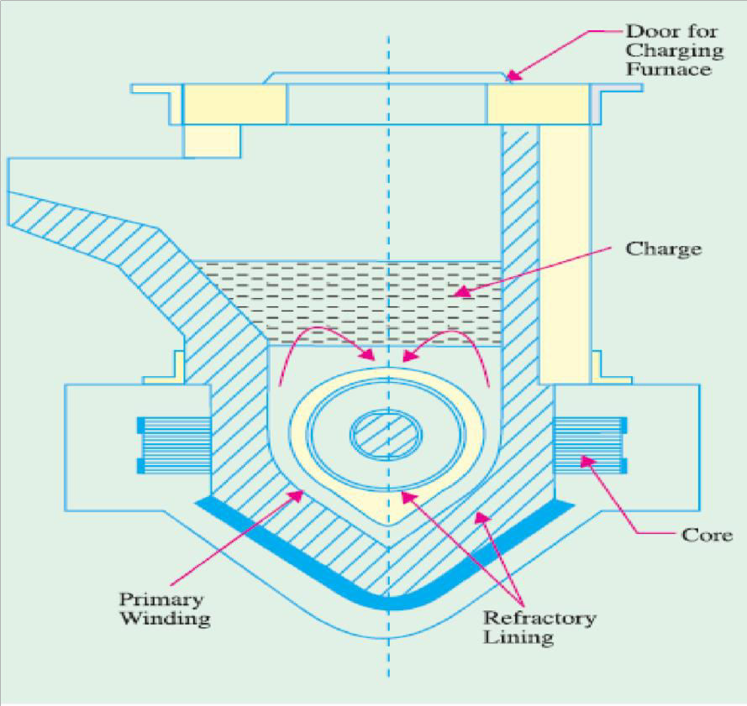
Fig 9

point of view. In this furnace, magnetic coupling is comparatively better and power factor is high. Hence, it can be operated from normal frequency supply. The circulation of the molten metal is kept up round the Vee portion by convection currents as shown in Fig 9. As Vee channel is narrow, even a small quantity of charge is sufficient to keep the secondary circuit closed. However, Vee channel must be kept full of charge in order to maintain continuity of secondary circuit.
This fact makes this furnace suitable for continuous operation. The tendency of the secondary circuit to rupture due to pinch-effect is counteracted by the weight of the charge in the crucible. The choice of material for inner lining of the furnace depends on the type of charge used. Clay lining is used for yellow brass. For red brass and bronze, an alloy of magnetia and alumina or corundum is used. The top of the furnace is covered with an insulated cover which can be removed for charging. The furnace can be tilted by the suitable hydraulic arrangement for taking out the molten metal.
This furnace is widely used for melting and refining of brass and other non-ferrous metals. As said earlier, it is suitable for continuous operation. It has a p.f. of 0.8-0.85. With normal supply frequency, its efficiency is about 75% and its standard size varies from 60-300 kW, all single- phase.

Indirect Core-Type Induction Furnace

In this furnace, a suitable element is heated by induction which, in turn, transfers the heat to the charge by radiation. So far as the charge is concerned, the conditions are similar to those in a resistance oven.
As shown in Fig.10, the secondary consists of a metal container which forms the walls of the furnace proper. The primary winding is magnetically coupled to this secondary by an iron core. When primary winding is connected to a.c. supply, secondary current is induced in the metal container by transformer action which heats up the container. The metal container transfers this heat to the charge. A special advantage of this furnace is that its temperature can be automatically controlled without the use of an external equipment. The part AB of the magnetic circuit situated inside the oven chamber consists of a special alloy which loses its magnetic properties at a particular temperature but regains them when cooled back to the same temperature. As soon as the chamber attains the critical temperature, reluctance of the magnetic circuit increases manifold thereby cutting off the heat supply. The bar AB is detachable and can be replaced by other bars having different critical temperatures.

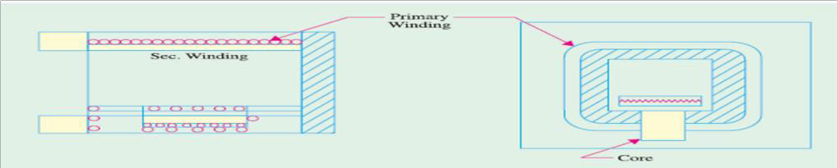

Fig 10

Coreless Induction Furnace

As shown in Fig. 11, the three main parts of the furnace are (i) primary coil (ii) a ceramic crucible containing charge which forms the secondary and (iii) the frame which includes supports and tilting mechanism. The distinctive feature of this furnace is that it contains no heavy iron core with the result that there is no continuous path for the magnetic flux. The crucible and the coil are relatively light in construction and can be conveniently tilted for pouring. The charge is put into the crucible and primary winding is connected to a high- frequency a.c. supply. The flux produce by the primary sets up eddy-currents in the charge and heats it up to the melting point. The charge need not be in the molten state at the start as was required by core-type furnaces. The eddy- currents also set up electromotive forces which produce stirring action which is essential for obtaining uniforms quality of metal. Since flux
density is low (due to the absence of the magntic core) high frequency supply has to be used because eddy-current loss We However, this high frequency increases the resistance of the primary winding due to skin effect, thereby increasing primary Cu losses. Hence, the primary winding is not made of Cu wire but consists of hollow Cu tubes which are cooled by water circulating through them. Since magnetic coupling between the primary and secondary windings is low, the furnace p.f. lies between 0.1 and 0.3. Hence, static capacitors are invariably used in parallel with the furnace to improve its p.f.
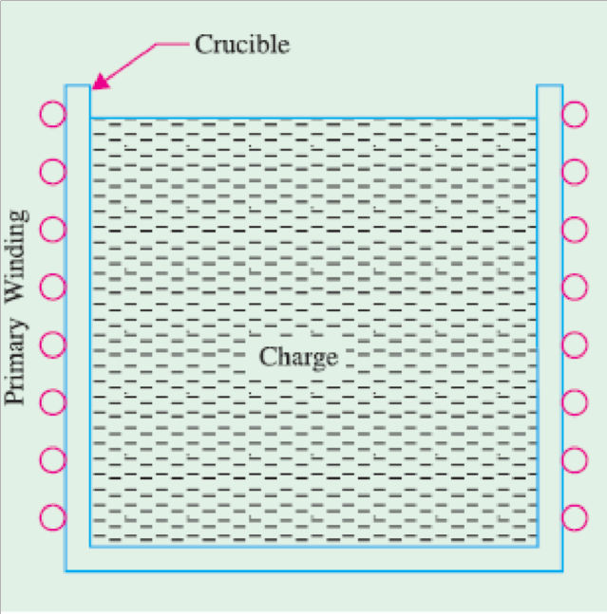

Fig 11

Such furnaces are commonly used for steel production and for melting of non-ferrous metals like brass, bronze, copper and aluminium etc., along with various alloys of these elements. Special application of these furnaces include vacuum melting, melting in a controlled atmosphere and melting for precision casting where high frequency induction heating is used. It also finds wide use in electronic industry and in other industrial activities like soldering, brazing hardening and annealing and sterilizing surgical instruments etc. Some of the advantages of coreless induction furnaces are as follows :
- They are fast in operation.
- They produce most uniform quality of product.
- They can be operated intermittenly.
- Their operation is free from smoke, dirt, dust and noises.
- They can be used for all industrial applications requiring heating and melting.
- They have low erection and operating costs.
- Their charging and pouring is simple.

High Frequency Eddy-current Heating:

For heating an article by eddy-currents, it is placed inside a high frequency a.c. current-carrying coil (Fig. 12). The alternating magnetic field produced by the coil sets up eddy-currents in the article which, consequently, gets heated up. Such a coil is known as heater coil or work coil and the material to be heated is known as charge or load. Primarily, it is the eddy-current loss which is responsible for the production of heat although hysteresis loss also contributes to some extent in the case of non-magnetic materials.

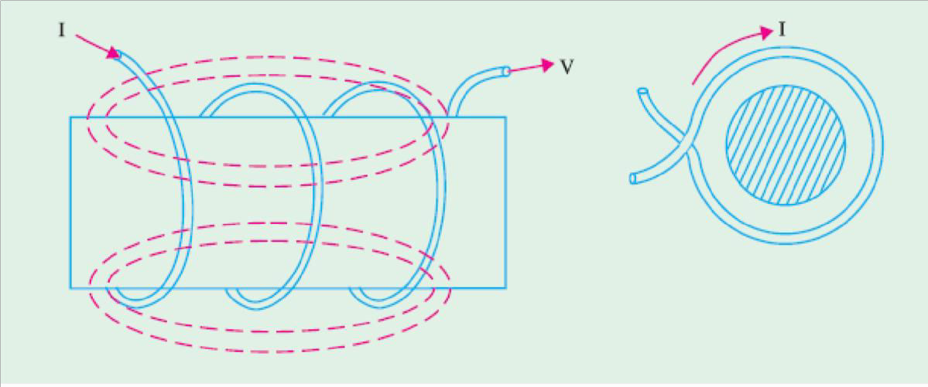

Fig 12

The eddy-current loss We α B2f2. Hence, this loss can be controlled by controlling flux density
B and the supply frequency ƒ. This loss is greatest on the surface of the material but decreases as we go deep inside. The depth of the material upto which the eddy-current loss penetrates is given by

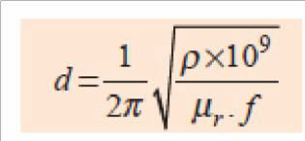

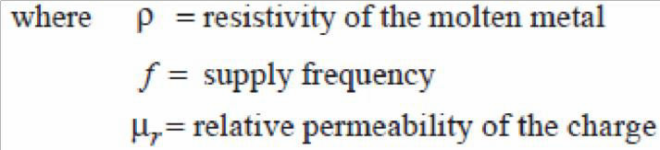

Advantages of Eddy-current Heating:

- There is negligible wastage of heat because the heat is produced in the body to be heated.
- It can take place in vacuum or other special environs where other types of heating are not possible.

- Heat can be made to penetrate any depth of the body by selecting proper supply frequently.

Applications of Eddy-current Heating:

- Surface Hardening: The bar whose surface is to be hardened by heat treatment is placed within the working coil which is connected to an a.c. supply of high frequency. The depth upto which the surface is to be hardened can be obtained by the proper selection of frequency of the coil current. After a few seconds, when surface has reached the proper temperature, a.c. supply is cut off and the bar is at once dipped in water.
- Annealing: Normally, annealing process takes long time resulting in scaling of the metal which is undesirable. However, in eddy-current heating, time taken is much less so that no scale formation takes place.
- Soldering: Eddy-current heating is economical for precise high-temperature soldering where silver, copper and their alloys are used as solders.

Dielectric Heating:
It is also called high-frequency capacitative heating and is used for heating insulators like wood, plastics and ceramics etc. which cannot be heated easily and uniformly by other methods. The supply frequency required for dielectric heating is between 10-50 MHz and the applied voltage is upto 20 kV. The overall efficiency of dielectric heating is about 50%.

Dielectric Loss:
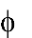
When a practical capacitor is connected across an a.c. supply, it draws a current which leads the voltage by an angle , which is a little less than 90°. It means that there is a certain component of the current which is in phase with the voltage and hence produces some loss called dielectric loss. At the normal supply frequency of 50 Hz, this loss is negligibly small but at higher frequencies of 50 MHz or so, this loss becomes so large that it is sufficient to heat the dielectric in which it takes place. The insulating material to be heated is placed between two conducting plates in order to form a parallel-plate capacitor as shown in Fig. 13 (a).

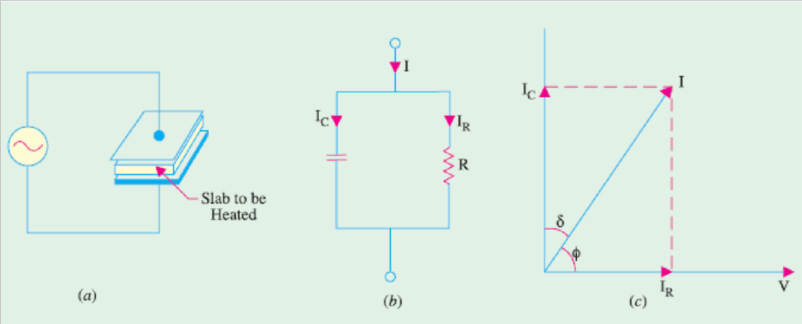

Fig 13
Fig. 13 (b) shows the equivalent circuit of the capacitor and Fig. 13 (c) gives its vector diagram.

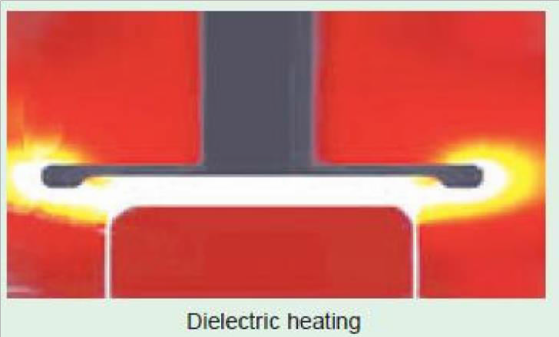
Fig 14

$$Power consumed is given as, P=VI_{c}CosØ$$
$$P=V.\frac{V}{X_{c}}CosØ$$
$${Where, X}_{c}=\frac{1}{2πfC}$$
$$P=V(V 2πfC)CosØ$$
$$P=V^{2}2πfC CosØ$$
From the (fig 13.c) vector diagram, $Ø={90}^{0}-$δ
$$P=V^{2}2πfC Cos({90}^{0}- δ)$$
$$P=V^{2}2πfC Sin\left(δ\right)$$
$$Since, [Sin\left(δ\right) = δ]$$
$$P=V^{2}2πfC δ$$
This power is converted into heat. Since for a given insulator material, C and δ are constant, the dielectric losses are directly proportional to V² f. That is why high-frequency voltage is used in dielectric heating. Generally, a.c. voltage of about 20 kV at a frequency of 10-30 MHz is used.

Advantages of Dielectric Heating:
- Since heat is generated within the dielectric medium itself, it results in uniform heating.
- Heating becomes faster with increasing frequency.
- It is the only method for heating bad conductors of heat.
- Heating is fastest in this method of heating.
- Since no naked flame appears in the process, inflammable articles like plastics and wooden products etc., can be heated safely.
- Heating can be stopped immediately as and when desired.

Applications of Dielectric Heating:

Since cost of dielectric heating is very high, it is employed where other methods are not possible or are too slow. Some of the applications of dielectric heating are as under:
- For gluing of multilayer plywood boards.
- For baking of sand cores which are used in the moulding process.
- For preheating of plastic compounds before sending them to the moulding section.
- For drying of tobacco after glycerine has been mixed with it for making cigarattes.
- For baking of biscuits and cakes etc. in bakeries with the help of automatic machines.
- For electronic sewing of plastic garments like raincoats etc. with the help of cold rollers fed with high- frequency supply.
- For dehydration of food which is then sealed in air-tight containers.
- For removal of moistures from oil emulsions.
- In diathermy for relieving pain in different parts of the human body.
- For quick drying of glue used for book binding purposes.

Electric Welding
Introduction:
Welding is the process of joining two pieces of metal or non-metal together by heating them to their melting point. Filler metal may or may not be used to join two pieces. The physical and mechanical properties of a material to be welded such as melting temperature, density, thermal conductivity, and tensile strength take an important role in welding. Depending upon how the heat applied is created; we get different types of welding such as thermal welding, gas welding, and electric welding. Here in this chapter, we will discuss only about the electric welding and some introduction to other modern welding techniques. Welding is nowadays extensively used in automobile industry, pipe-line fabrication in thermal power plants, machine repair work, machine frames, etc.
Advantages and Disadvantages of Welding: Some of the advantages of welding are:
- Welding is the most economical method to permanently join two metal parts.
- It provides design flexibility. o Welding equipment is not so costly.
- It joins all the commercial metals. o Both similar and dissimilar metals can be joined by welding.
- Portable welding equipment are available. Some of the disadvantages of welding are: o Welding gives out harmful radiations and fumes.
- Welding needs internal inspection. o If welding is not done carefully, it may result in the distortion of workpiece.
- Skilled welding is necessary to produce good welding.
ELECTRIC WELDING:
It is defined as the process of joining two metal pieces, in which the electrical energy is used to generate heat at the point of welding in order to melt the joint.
The classification of electric welding process is shown below
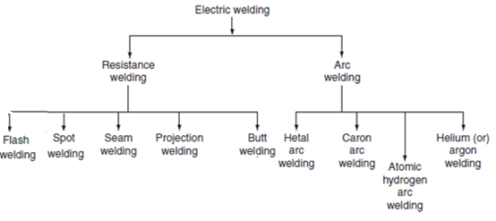
The selection of proper welding process depends on the following factors.
- The type of metal to be joined.
- The techniques of welding adopted.
- The cost of equipment used.
- The nature of products to be fabricated.
RESISTANCE WELDING:
Resistance welding is the process of joining two metals together by the heat produced due to the resistance offered to the flow of electric current at the junctions of two metals. The heat produced by the resistance to the flow of current is given by
H = I²Rt,
where I is the current through the electrodes, R is the contact resistance of the interface, and tis the time for which current flows.
Here, the total resistance offered to the flow of current is made up of:
1. The resistance of current path in the work.
2. The resistance between the contact surfaces of the parts being welded.
3. The resistance between electrodes and the surface of parts being welded.
In this process of welding, the heat developed at the contact area between the pieces to be welded reduces the metal to plastic state or liquid state, then the pieces are pressed under high mechanical pressure to complete the weld. The electrical voltage input to the welding varies in between 4 and 12 V depending upon area, thickness, composition, etc. and usually power ranges from about 60 to 180 W for each sq. mm of area. Any desired combination of voltage and current can be obtained by means of a suitable transformer in AC; hence, AC is found to be most suitable for the resistance welding.
The magnitude of current is controlled by changing the primary voltage of the welding transformer, which can be done by using an auto-transformer or a tap-changing transformer. Automatic arrangements are provided to switch off the supply after a pre-determined time from applying the pressure, why because the duration of the current flow through the work is very important in the resistance welding.
The electrical circuit diagram for the resistance welding is shown in Fig. This method of welding consists of a tap-changing transformer, a clamping device for holding the metal pieces, and some sort of mechanical arrangement for forcing the pieces to form a complete weld.
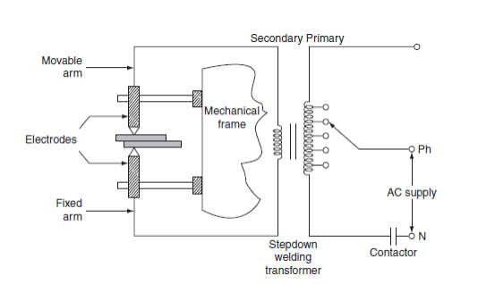
Fig.1. Electrical Circuit for Resistance Welding
Advantages:
- Welding process is rapid and simple.
- Localized heating is possible, if required.
- No need of using filler metal.
- Both similar and dissimilar metals can be welded.
- Comparatively lesser skill is required.
- Maintenance cost is less.
- It can be employed for mass production.
However, the resistance welding has got some drawbacks and they are:
- Initial cost is very high.
- The workpiece with heavier thickness cannot be welded, since it requires high input current.
Applications:
- It is used by many industries manufacturing products made up of thinner gauge metals.
- It is used for the manufacturing of tubes and smaller structural sections.
Types of resistance welding: Depending upon the method of weld obtained and the type of electrodes used, the resistance welding is classified as:
1. Spot welding.
2. Seam welding.
3. Projection welding.
4. Butt welding.
5. Flash welding.
1. Spot welding: Spot welding means the joining of two metal sheets and fusing them together between copper electrode tips at suitably spaced intervals by means of heavy electric current passed through the electrodes as shown in Fig
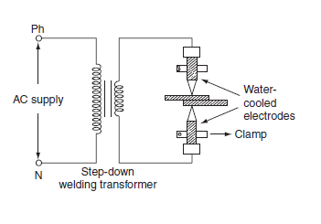.
Fig.2. Spot Welding
This type of joint formed by the spot welding provides mechanical strength and not air or water tight, for such welding it is necessary to localize the welding current and to apply sufficient pressure on the sheet to be welded. The electrodes are made up of copper or copper alloy and are water cooled.
The welding current varies widely depending upon the thickness and composition of the plates. It varies from 1,000 to 10,000 A, and voltage between the electrodes is usually less than 2 V. The period of the flow of current varies widely depending upon the thickness of sheets to be joined. A step-down transformer is used to reduce a high-voltage and low-current supply to low-voltage and high-current supply required.
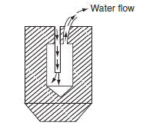
Fig.2a. Water cooled electrodes
Since the heat developed being proportional to the product of welding time and square of the current. Good weld can be obtained by low currents for longer duration and high currents for shorter duration; longer welding time usually produces stronger weld but it involves high energy expenditure, electrode maintenance, and lot of distortion of workpiece. When voltage applied across the electrode, the flow of current will generate heat at the three junctions, i.e., heat developed, between the two electrode tips and workpiece, between the two workpieces to be joined as shown in Fig. The generation of heat at junctions 1 and 3 will effect electrode sticking and melt through holes, the prevention of electrode striking is achieved by: 1. Using water-cooled electrodes shown in Fig. By avoiding the heating of junctions 1 and 3 electrodes in which cold water circulated continuously as shown in Fig. The material used for electrode should have high electrical and thermal conductivity. Spot welding is widely used for automatic welding process, for joining automobile parts, joining and fabricating sheet metal structure, etc.
2. Seam welding: Seam welding is nothing but the series of continuous spot welding. If number spots obtained by spot welding are placed very closely that they can overlap, it gives rise to seam welding. In this welding, continuous spot welds can be formed by using wheel type or roller electrodes instead of tipped electrodes as shown in Fig.
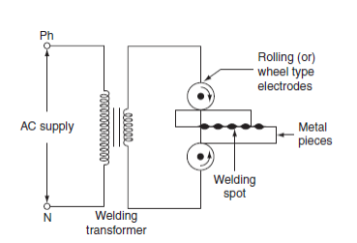
Fig.3. Seam Welding
Seam welding is obtained by keeping the job under electrodes. When these wheel type electrodes travel over the metal pieces which are under pressure, the current passing between them heats the two metal pieces to the plastic state and results into continuous spot welds. In this welding, the contact area of electrodes should be small, which will localize the current pressure to the welding point. After forming weld at one point, the weld so obtained can be cooled by splashing water over the job by using cooling jets. In general, it is not satisfactory to make a continuous weld, for which the flow of continuous current build up high heat that causes burning and wrapping of the metal piece.
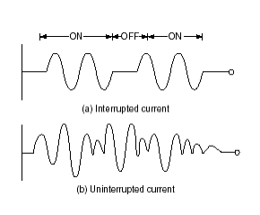
Fig.4. Welding Curreents
To avoid this difficulty, an interrupter is provided on the circuit which turns on supply for a period sufficient to heat the welding point. The series of weld spots depends upon the number of welding current pulses.The two forms of welding currents are shown in Fig.
Welding cannot be made satisfactorily by using uninterrupted or un-modulated current, which builds up high heat as the welding progress; this will over heat the workpiece and cause distortion.
Seam welding is very important, as it provides leak proof joints. It is usually employed in welding of pressure tanks, transformers, condensers, evaporators, air craft tanks, refrigerators, varnish containers, etc.
3. Projection welding:
It is a modified form of the spot welding. In the projection welding, both current and pressure are localized to the welding points as in the spot welding. But the only difference in the projection welding is the high mechanical pressure applied on the metal pieces to be welded, after the formation of weld.
The electrodes used for such welding are flat metal plates known as platens. The two pieces of base metal to be weld are held together in between the two platens, one is movable and the other is fixed, as shown in Fig.
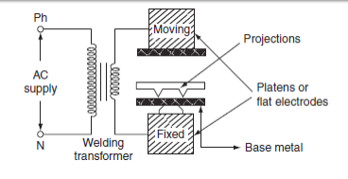
Fig.5. Projection Welding
One of the two pieces of metal is run through a machine that makes the bumps or projections of required shape and size in the metal. As current flows through the two metal parts to be welded, which heat up and melt. These weld points soon reach the plastic state, and the projection touches the metal then force applied by the two flat electrodes forms the complete weld.
The projection welding needs no protective atmosphere as in the spot welding to produce successful results. This welding process reduces the amount of current and pressure in order to join two metal surfaces, so that there is less chance of distortion of the surrounding areas of the weld zone. Due to this reason, it has been incorporated into many manufacturing process.
The projection welding has the following advantages over the spot welding.
Simplicity in welding process.
- It is easy to weld some of the parts where the spot welding is not possible.
- It is possible to join several welding points.
- Welds are located automatically by the position of projection.
- Simplicity in welding process.
- As the electrodes used in the projection welding are flat type, the contact area over the projection is sufficient.
This type of welding is usually employed on punched, formed, or stamped parts where the projection automatically exists. The projection welding is particularly employed for mass production work, i.e., welding of refrigerators, condensers, crossed wire welding, refrigerator racks, grills, etc.
4. Butt welding:
Butt welding is similar to the spot welding; however, the only difference is, in butt welding, instead of electrodes the metal parts that are to be joined or butted together are connected to the supply.
In Butt welding, the two metal parts to be welded are joined end to end and are connected across the secondary of a welding transformer as shown in Fig.
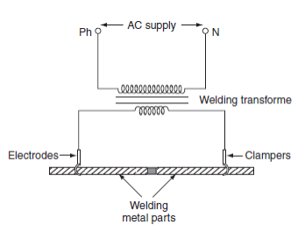
Fig.6. Butt welding
Due to the contact resistance of the metals to be welded, heating effect is generated in this welding. When current is made to flow through the two electrodes, heat will develop due to the contact resistance of the two pieces and then melts. By applying high mechanical pressure either manually or by toggle mechanism, the two metal pieces are pressed.
When jaw-type electrodes are used that introduce the high currents without treating any hot spot on the job. This type of welding is usually employed for welding of rods, pipes, and wires and for joining metal parts end to end.
5. Flash butt welding: Flash welding is a combination of resistance, arc, and pressure welding. This method of welding is mainly used in the production welding. A simple flash welding arrangement is shown in Fig.
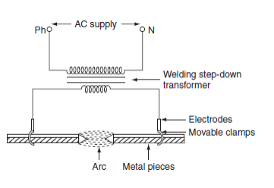
Fig.7. Flash welding
In this method of welding, the two pieces to be welded are brought very nearer to each other under light mechanical pressure. These two pieces are placed in a conducting movable clamps. When high current is passed through the two metal pieces and they are separated by some distance, then arc established between them. This arc or flashing is allowed till the ends of the workpieces reach melting temperature, the supply will be switched off and the pieces are rapidly brought together under light pressure. As the pieces are moved together, the fused metal and slag come out of the joint making a good solid joint.
Following are the advantages of the flash welding over the butt welding.
- Less requirement of power.
- When the surfaces being joined, it requires only less attention.
- Weld obtained is so clean and pure, due to the foreign metals appearing on the surfaces will burn due to flash or arc.
ELECTRIC ARC WELDING:
Electric arc welding is the process of joining two metallic pieces or melting of metal is obtained due to the heat developed by an arc struck between an electrode and the metal to be welded or between the two electrodes as shown in Fig.
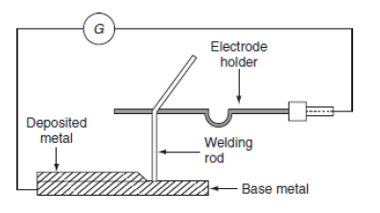
Fig.8. Arrangement of Electric welding equipment

In this process, an electric arc is produced by bringing two conductors (electrode and metal piece) connected to a suitable source of electric current, momentarily in contact and then
separated by a small gap, arc blows due to the ionization and give intense heat.
The heat so developed is utilized to melt the part of workpiece and filler metal and thus forms the weld.
In this method of welding, no mechanical pressure is employed; therefore, this type of welding is also known as 'non-pressure welding’.
The length of the arc required for welding depends upon the following factors:
- The surface coating and the type of electrodes used.
- The position of welding.
- The amount of current used.
When the supply is given across the conductors separated by some distance apart, the air gap present between the two conductors gets ionized, as the arc welding is in progress, the ionization of the arc path and its surrounding area increases. This increase in ionization decreases the resistance of the path. Thus, current increases with the decrease in voltage of arc.
For the arc welding, the temperature of the arc should be 3,500°C. At this temperature, mechanical pressure for melting is not required. Both AC and DC can be used in the arc welding.
Usually 70–100 V on AC supply and 50–60 V on DC supply system is sufficient to struck the arc in the air gap between the electrodes. Once the arc is struck, 20–30 V is only required to maintain it. However, in certain cases, there is any danger of electric shock to the operator, low voltage should be used for the welding purpose. Thus, DC arc welding of low voltage is generally preferred.
Electric arc welding is extensively used for the joining of metal parts, the repair of fractured casting, and the fillings by the deposition of new metal on base metal, etc.

Various types of electric arc welding are:
1. Carbon arc welding.
2. Metal arc welding.
3. Atomic hydrogen arc welding.
4. Inert gas metal arc welding.

1. Carbon arc welding:
It is one of the processes of arc welding in which arc is struck between two carbon electrodes or the carbon electrode and the base metal. The simple arrangement of the carbon arc welding is shown in Fig.
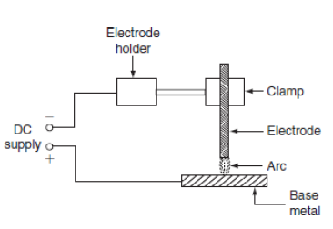
Fig.9. Carbon Arc Welding

In this process of welding, the electrodes are placed in an electrode holder used as negative electrode and the base metal being welded as positive. Unless, the electrode is negative relative to the work, due to high temperature, there is a tendency of the particles of carbon will fuse and mix up with the base metal, which causes brittleness; DC is preferred for carbon arc welding since there is no fixed polarity maintained in case of AC.
In the carbon arc welding, carbon or graphite rods are used as electrode. Due to longer life and low resistance, graphite electrodes are used, and thus capable of conducting more current. The arc produced between electrode and base metal; heat the metal to the melting temperature, on the negative electrode is 3,200°C and on the positive electrode is 3,900°C. This process of welding is normally employed where addition of filler metal is not required.
The carbon arc is easy to maintain, and also the length of the arc can be easily varied. One major problem with carbon arc is its instability which can be overcome by using an inductor in the electrode of 2.5-cm diameter and with the current of about of 500–800 A employed to deposit large amount of filler metal on the base metal. Filler metal and flux may not be used depending upon the type of joint and material to be welded.
Advantages:
- The heat developed during the welding can be easily controlled by adjusting the length of the arc.
- It is quite clean, simple, and less expensive when compared to other welding process.
- Easily adoptable for automation.
- Both the ferrous and the non-ferrous metals can be welded.
Disadvantages:
- Input current required in this welding, for the workpiece to rise its temperature to melting/welding temperature, is approximately double the metal arc welding.
- In case of the ferrous metal, there is a chance of disintegrating the carbon at high temperature and transfer to the weld, which causes harder weld deposit and brittlement.
- A separate filler rod has to be used if any filler metal is required.
Applications:
- It can be employed for the welding of stainless steel with thinner gauges.
- Useful for the welding of thin high-grade nickel alloys and for galvanized sheets using copper silicon manganese alloy filler metal.

2. Metal arc welding:
In metal arc welding, the electrodes used must be of the same metal as that of the work-piece to be welded. The electrode itself forms the filler metal. An electric arc is stuck by bringing the electrode connected to a suitable source of electric current, momentarily in contract with the workpieces to be welded and withdrawn apart. The circuit diagram for the metal arc welding is shown in Fig.
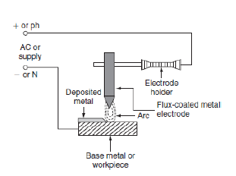
Fig.10. Metal Arc welding

The arc produced between the workpiece and the electrode results high temperature of the order of about 2,400°C at negative metal electrode and 2,600°C at positive base metal or workpiece.
This high temperature of the arc melts the metal as well as the tip of the electrode, then the electrode melts and deposited over the surface of the workpiece, forms complete weld. Both AC and DC can be used for the metal arc welding.
The voltage required for the DC metal arc welding is about 50–60 V and for the AC metal arc welding is about 80–90 V In order to maintain the voltage drop across the arc less than 13 V, the arc length should be kept as small as possible, otherwise the weld will be brittle. The current required for the welding varies from 10 to 500 A depending upon the type of work to be welded.
The main disadvantage in the DC metal arc welding is the presence of arc blow, i.e., distortion of arc stream from the intended path due to the magnetic forces of the non-uniform magnetic field with AC arc blow is considerably reduced.
For obtaining good weld, the flux-coated electrodes must be used, so the metal which is melted is covered with slag produces a non oxidizing gas or a molten slag to cover the weld, and also stabilizes the arc.

3. Atomic hydrogen arc welding:
In atomic hydrogen arc welding, shown in Fig, the heat for the welding process is produced from an electric arc struck between two tungsten electrodes in an atmosphere of hydrogen. Here, hydrogen serves mainly two functions; one acts as a protective screen for the arc and the other acts as a cooling agent for the glowing tungsten electrode tips. As the hydrogen gas passes through the arc, the hydrogen molecules are broken up into atoms, absorbs heat from the glowing tungsten electrodes so that these are cooled.
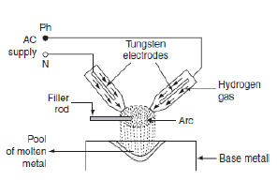
Fig.11. Atomic hydrogen arc welding

But, when the atoms of hydrogen recombine into molecules outside the arc, a large amount of heat is liberated. This extra heat is added to the intense heat of arc, which produces a temperature of about 4,000°C that is sufficient to melt the surfaces to be welded, together with the filler rod if used. Moreover hydrogen includes oxygen and some other gases that might combine with the molten metal and forms oxides and other impurities. Hydrogen also removes oxides from the surface of workpiece. Thus, this process is capable of producing strong, uniform, smooth, and ductile welds.
In the atomic hydrogen arc welding, the arc is maintained between the two non-consumable tungsten electrodes under a pressure of about 0.5 kg/cm2. In order to obtain equal consumption of electrodes, AC supply is used. Arc currents up to 150 A can be used. High voltage about 300 V is applied for this welding through a transformer. For striking the arc between the electrodes the open circuit voltage required varies from 80 to 100 V. As the atomic hydrogen welding is too expensive, it is usually employed for welding alloy steel, carbon steel, stainless steel, aluminum, etc.
4. Inert gas metal arc welding:
It is a gas-shielded metal arc welding, in which an electric arc is stuck between tungsten electrode and workpiece to be welded. Filler metal may be introduced separately into the arc if required.
A welding gun, which carries a nozzle, through this nozzle, inert gas such as beryllium or argon is blown around the arc and onto the weld, as shown in Fig. As both beryllium and argon are chemically inert, so the molten metal is protected from the action of the atmosphere by an envelope of chemically reducing or inert gas.
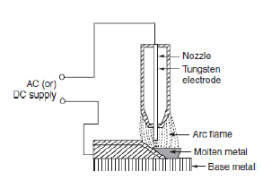
Fig.12. Inert gas metal arc welding
As molten metal has an affinity for oxygen and nitrogen, if exposed to the atmosphere, thereby forming their oxides and nitrides, which makes weld leaky and brittle. Thus, several methods of shielding have been employed. With the use of flux coating electrodes or by pumping, the inert gases around the arc produces a slag that floats on the top of molten metal and produces an envelope of inert gas around the arc and the weld.
Advantages:
- Flux is not required since inert gas envelope protects the molten metal without forming oxides and nitrates so the weld is smooth, uniform, and ductile.
- Distortion of the work is minimum because the concentration of heat is possible.
Applications:
- The welding is employed for light alloys, stainless steel, etc.
- The welding of non-ferrous metal such as copper, aluminum, etc.

ELECTRIC WELDING EQUIPMENT: Electric welding equipments fall into two natural sections. They are:
(a) D.C Welding Equipments.
(b) A.C Welding Equipments.
(a) D.C Welding Equipments:
It consists of mainly a motor generator set. The motor is a squirrel cage induction motor and generator is differentially compound to give drooping characteristics. In differential compound generator the terminal voltage falls automatically with the increase in load current.
If supply from existing system is used for welding, then a ballest resistance is putting series with equipments and control is obtained by variation of external resistance, this method is also suitable when a number of operators are working on the same supply system. In such cases each operator is provided with separate ballest.
(a) A.C Welding Equipments:
A transformer reduces the voltage from that of the supply drawn to about100v. To regulate the current and produce the dropping of characteristics required a resistance and a reactance may be used. When a reactance is used it must be designed to operate well below the saturation point of its magnetic circuit to prevent the introduction of harmonics which tends to length and the zero current period in each half cycle and allow cooling of the arc, a reactance with a air gap in the magnetic circuit is generally employed.
Electric welding accessories:
Electric welding accessories required to carry out proper welding operation are:
1. Electric welding power sets.
2. Electrode holder to hold the electrodes.
3. Welding cable for connecting electrode and workpiece to the supply.
4. Face screen with colored glass.
5. Chipping hammers to remove slag from molten weld.
6. Wire brush to clean the weld.
7. Earth clamp and protective clothing.
Coated Electrodes:
Depending upon the thickness of flux coating, the coated electrode may classify into
1. lightly coated electrodes and
2. heavily coated electrodes.
For obtaining good weld, the coated electrodes are always preferred.
- Lightly coated electrodes:
These electrodes are coated with thin layer of coating material up to less than 1 mm. This coating is usually consists of lime mixed with soluble glass which serves as a binder. These electrodes are considered as improvement over bare electrodes.
The main purpose of using the light coating layer on the electrode is to increase the arc stability, so they are also called as stabilizing electrodes. The mechanical strength of the weld increased because slag layer will not formed on the molten weld. For this reason, lightly coated electrodes may only be used for welding non-essential workpieces.
- Heavily coated electrodes:
These electrodes have coating layer with heavy thickness. The heavily coated electrodes sometimes referred to as the shielded arc electrodes. The materials commonly used for coating the electrodes are titanium oxide, ferromanganese, silica, flour, asbestos clay, calcium carbonate, etc.
This electrode coating helps in improving the quality of weld, as if the coating layer of the electrodes burns in the heat of the arc provides gaseous shield around the arc, which prevents the formation oxides and nitrites.
Advantages of Coated electrodes:
- Arc is stabilized due to the flux compounds of sodium and potassium.
- The weld metal can be protected from the oxidizing action of oxygen and the nitrifying action of nitrogen due to the gas shielded envelope.
- The impurities present on the surface being welded are fluxed away.
- The electrode coating increases deposition efficiency and weld metal deposition rate through iron powder and ferro alloy addition.
- In case of AC supply arc cools at zero current and there is a tendency of deionizing the arc path.
- Covering gases keep the arc space ionized.
- The welding operation becomes faster due to the increased melting rate.
- The coated electrodes help to deoxidize and refine the weld metal.

COMPARISON BETWEEN AC AND DC WELDING
AC welding:
- Motor generator set or rectifier is required in case of the availability of AC supply.
- The cost of the equipment is high.
- Arc stability is more.
- The heat produced is uniform.
- Both bare and coated electrodes can be used.
- The operating power factor is high.
- It is safer since no load voltage is low.
- The electric energy consumption is 5–10 kWh/kg of deposited metal.
- Arc blow occurs due to the presence of non-uniform magnetic field.
- The efficiency is low due to the rotating parts.

DC welding:
1. Only transformer is required.
2. The cost of the equipment is cheap.
3. Arc stability is less.
4. The heat produced is not uniform.
5. Only coated electrodes should be used.
6. The power factor is low. So, the capacitors are necessary to improve the power factor.
7. It is dangerous since no load voltage is high.
8. The electrical energy consumption is 3–4 kWh/kg of deposited metal.
9. Arc blow will not occur due to the uniform magnetic field.
10. The efficiency is high due to the absence of rotating parts.
Comparison between Resistance welding & Arc welding:
Resistance welding:
- The source of supply is AC only.
- The head developed is mainly due to the flow of contact resistance.
- The temperature attained by the workpiece is not so high.
- External pressure is required.
- Filler metal is not required to join two metal pieces.
- It cannot be used for repair work; it is suitable for mass production.
- The power consumption is low.
- The operating power factor is low.
- Bar, roller, or flat type electrodes are used (not consumable).
Arc welding:
- The source of supply is either AC (1-φ or 3-φ) or DC.
- The heat developed is mainly due to the striking of arc between electrodes or an electrode and the workpiece.
- The temperature of the arc is so high, so proper care should be taken during the welding.
- No external pressure is required hence the welding equipment is more simple and easy to control.
- Suitable filler electrodes are necessary to get proper welding strength.
- It is not suitable for mass production. It is most suitable for repair works and where more metal is to be deposited.
- The power consumption is high.
- The operating power factor is high.
- Bare or coated electrodes are used (consumable or non-consumable).

