UNIT 2:THREE PHASE CONTROLLED CONVERTERS

Three types of electric of speed control techniques:

motors generally used for drive purposes. DC, Induction and Synchronous motor
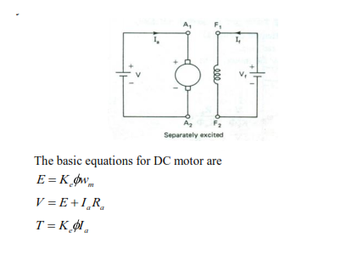 Where, E = back emf in volt;
φ= flux per pole in weber;
V = supply I = Armature
current in Amp;
R = Armature resistance in ohm;
w = speed of armature in rad/sec;
T = torque developed
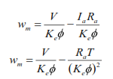 This equation can be applied to all series, shunt, compound and separately excited dc motor In the case of separately excited motors, if the field voltage is maintained constant,and assuming the flux as constant, then
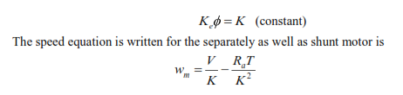 The speed increases from the zero upto the base speed. This method is called the constant torque method. Beyond the rated voltage, and rated armature current the voltage can not be increased further due to insulation problem. So, to control the speed the flux control can be done. By decreasing the flux, speed can be increased above the base speed w . This method is called constant power method where both voltage and armature current is kept constants. Further, in the below base speed region, the speed can be decreased from the no load speed w by increasing the load. When the load increased, the speed decreased from its no load speed. This motor is used where the speed regulation is good.
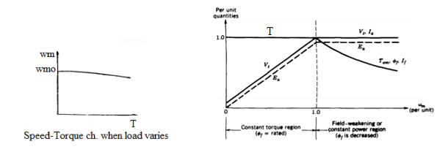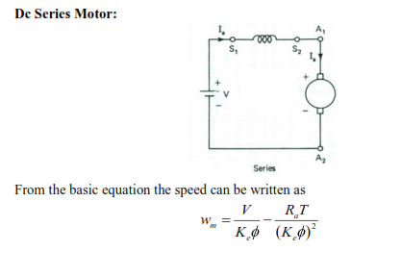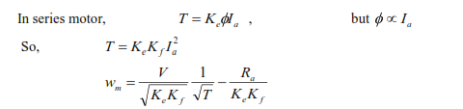 In the case of series motor, any increase in torque is accompanied by an increase in the armature current and therefore, an increase in flux. Because the flux increases with torque, the speed must drop to maintain a balance between the induced voltage and the supply voltage. The characteristic is therefore, highly drooping.
Methods of speed control :
From the speed-torque relation from the equation it is seen that, the speed can be controlled by any one of the following three methods.
1.Armature voltage control
2. Armature resistance control (Rheostatic control)
3. Field flux control
THREE PHASE CONVERTER FED DC MOTOR:
The three phase fully controlled bridge converter has been probably the most widely used power electronic converter in the medium to high power applications. The controlled rectifier can provide controllable output dc voltage in a single unit instead of a three phase autotransformer and a diode bridge rectifier. The controlled rectifier is obtained by replacing the diodes of the uncontrolled rectifier with thyristors. Control over the output dc voltage is obtained by controlling the conduction interval of each thyristor. In phase controlled rectifiers though the output voltage can be varied continuously the load harmonic voltage increase considerably as the average value goes down. Of course the magnitude of harmonic voltage is lower in three phase converter compared to the single phase circuit. Three phase converter is shown in fig.
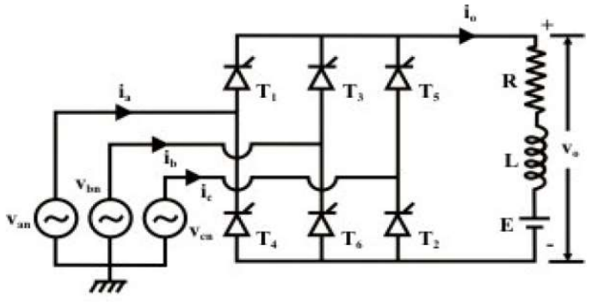 For any current to flow in the load at least one device from the top group (T1, T3, T5) and one from the bottom group (T2, T4, T6) must conduct. Then from symmetry consideration it can be argued that each thyristor conducts for 120° of the input cycle. Now the thyristors are fired in the sequence T1 → T2 → T3 → T4 → T5 → T6 → T1 with 60° interval between each firing. Therefore thyristors on the same phase leg are fired at an interval of 180° and hence cannot conduct simultaneously. This leaves only six possible conduction mode for the converter in the continuous conduction mode of operation. These are T1T2, T2T3, T3T4, T4T5, T5T6, T6T1. Each conduction mode is of 60° duration and appears in the sequence mentioned. Table.1 shows the firing sequence of SCRs.
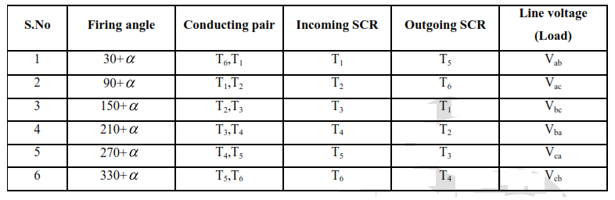 Fig. shows the waveforms of different variables. To arrive at the waveforms it is necessary to draw the firing sequence table which shows the interval of conduction for each thyristor. If the converter firing angle is “α” each thyristor is fired “α” angle after the positive going zero crossing of the line voltage with which it’s firing is associated. Once the conduction diagram is drawn all other voltage waveforms can be drawn from the line voltage waveforms. It is clear from the waveforms that output voltage and current waveforms are periodic over one sixth of the input cycle. Therefore this converter is also called the “six pulse” converter. The input current on the other hand contains only odds harmonics of the input frequency other than the triplex
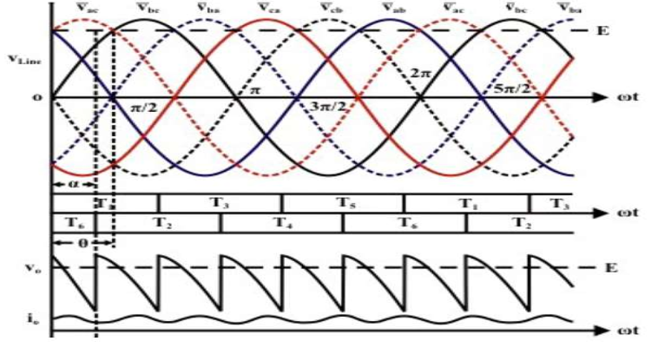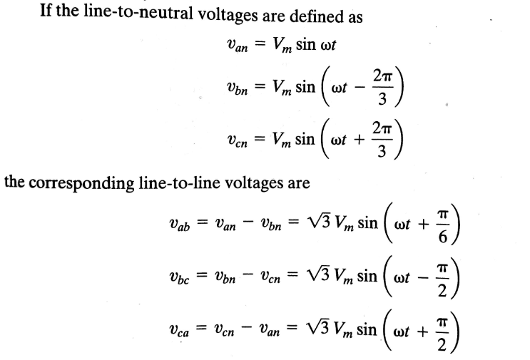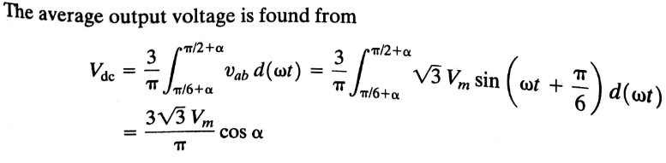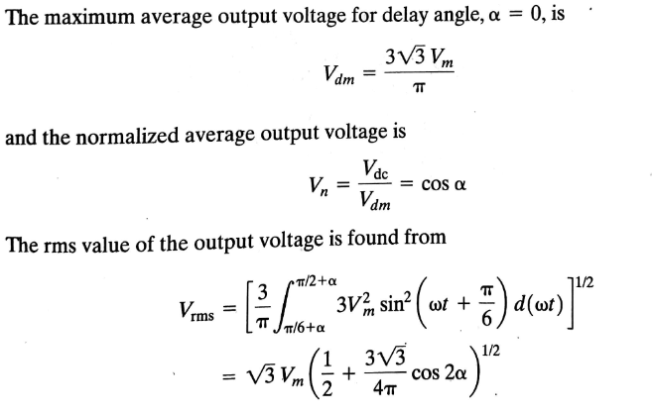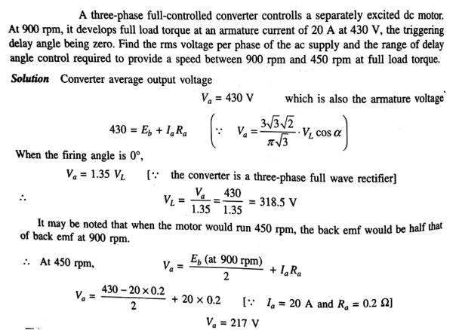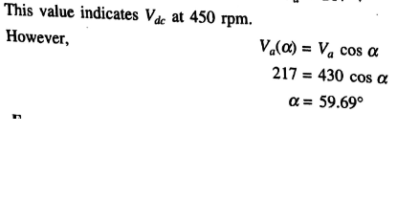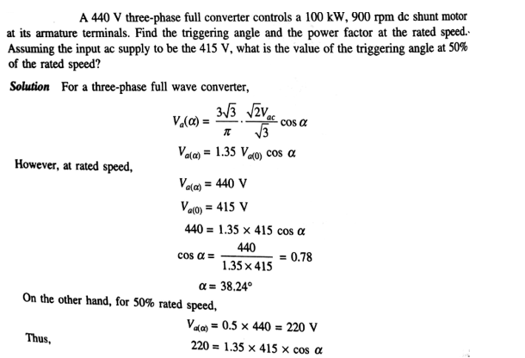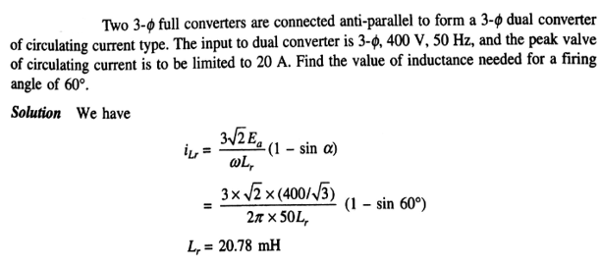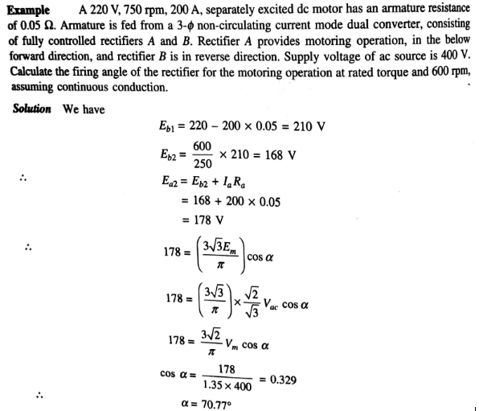

Three-Phase Fully-Controlled Dual-Converter Drives System:
Fig. shows a three-phase fully controlled dual-converter power circuit, the voltage and current waveforms, and firing sequence of thyristors. The three-phase six-pulse bridge can be operated in a converter or inverter mode depending upon the delay angle to be less than or above 90 Each SCR remains on for 120 duration and is turned off only when the next SCR of the same portion in sequence is gated. Once SCR each in upper and lower portions of the bridge conducts at a time for 120 duration and is turned off only when the next SCR of the same portion in sequence is turned on. SCRs are switched on in a sequence at every 60 angle thus the gate pulses should have a frequency six times higher than the source frequency. Moreover, to keep each SCR on for 120 duration either each SCR should be gated twice at the interval of 60 by short gate pulses or each gate pulse should be for more than 60.
Fig. shows a three-phase fully controlled dual-converter power circuit, the voltage and current waveforms, and firing sequence of thyristors. The three-phase six-pulse bridge can be operated in a converter or inverter mode depending upon the delay angle to be less than or above 90 Each SCR remains on for 120 duration and is turned off only when the next SCR of the same portion in sequence is gated. Once SCR each in upper and lower portions of the bridge conducts at a time for 120 duration and is turned off only when the next SCR of the same portion in sequence is turned on. SCRs are switched on in a sequence at every 60 angle thus the gate pulses should have a frequency six times higher than the source frequency. Moreover, to keep each SCR on for 120 duration either each SCR should be gated twice at the interval of 60 by short gate pulses or each gate pulse should be for more than 60.

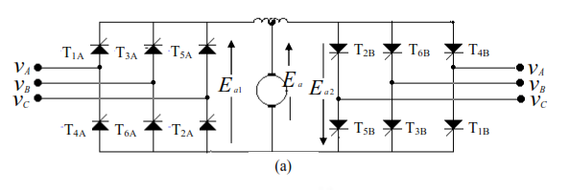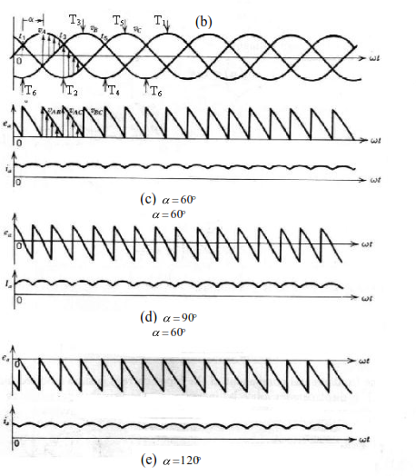 DUAL DUAL CONVERTER
Half-converter and fully-controlled converter are discussed in the previous section. All half-controlled converters provide single-quadrant operation only. They convert ac power to dc power which is controllable. The operation of all such converters is confined to the first quadrant in the I_{dc}-V_{de} plane, where V_{de} and I_{d}, represent average output voltage and average output current respectively. The average output voltage of all fully-controlled converters can be either positive or negative, they can operate in two quadrants, first and fourth in the I_{dc}-V_{de} plane. The first quadrant operation indicates the rectification mode with the power flow from ac to dc while the fourth quadrant operation indicates the inversion mode with the power flow from the dc circuit to the ac supply network.
In order to obtain the four-quadrant operation without the aid of any mechanical switch two converters are connected in anti-parallel across the load circuit. Such arrangement is known as a dual converter. Both voltage and current of either polarity are obtained with a dual converter. Figure show single-phase and three-phase dual converter
using bridge type converter circuits. The output terminals of each converter having the same potential are connected together through a reactor. If we assume ideal converters with a negligible ripple in the output voltage, the output voltage of each converter must be equal to the load voltage.
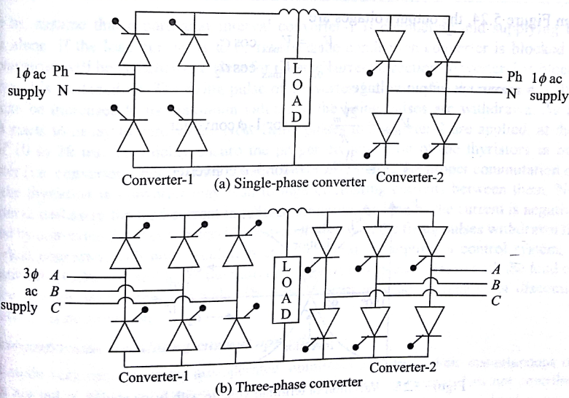

Ideal Dual Converter

The equivalent circuit of a dual converter is represented in Figure
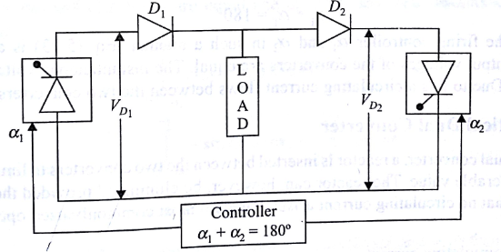
dual converter consists of two ideal converters labeled as converter-1 and converter-2 as Shown in Figure . Since converters are assumed to be ideal, their output voltage is ripple-free. V₀₁ and V₀₂ represent average output voltage magnitudes of converter-1 and converter-2, respectively. direction.
Two diodes D1 and D2 are connected in series with the output voltages of converter-1 and converter-2 respectively The connection of diodes indicates that each converter can conduct current In Only one direction. But the load current can flow in either
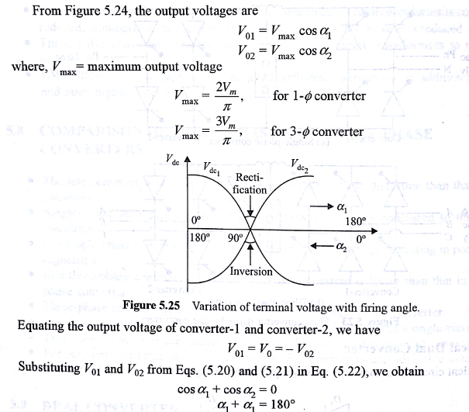 By changing the firing controller α_{l} and α₂ in such a manner, is always satisfied. The average output voltages of the converters are equal instantaneous voltages V₀₁ and V₀₂ are not equal. Due to this a circulating current flows between the converters.

