CHAPTER 1: FUNDAMENTALS OF ELECTRIC DRIVES

Whenever the term electric motor or electrical generator is used, we tend to think that the speed of rotation of these machines is totally controlled only by the applied voltage and frequency of the source current. But the speed of rotation of an electrical machine can be controlled precisely also by implementing the concept of drive. The main advantage of this concept is, the motion control is easily optimized with the help of drive. In very simple words, the systems which control the motion of the electrical machines, are known as electrical drives. A typical drive system is assembled with a electric motor (may be several) and a sophisticated control system that controls the rotation of the motor shaft. Now days, this control can be done easily with the help of software. So, the controlling becomes more and more accurate and this concept of drive also provides the ease of use.
This drive system is widely used in large number of industrial and domestic applications like factories, transportation systems, textile mills, fans, pumps, motors, robots etc. Drives are employed as prime movers for diesel or petrol engines, gas or steam turbines, hydraulic motors and electric motors.
Now coming to the history of electrical drives, this was first designed in Russia in the year 1838 by B.S.Iakobi, when he tested a DC electric motor supplied from a storage battery and propelled a boat. Even though the industrial adaptation occurred after many years as around 1870. Today almost everywhere the application of electric drivesis seen.
The very basic block diagram an electric drives is shown below. The load in the figure represents various types of equipments which consists of electric motor, like fans, pumps, washing machines etc.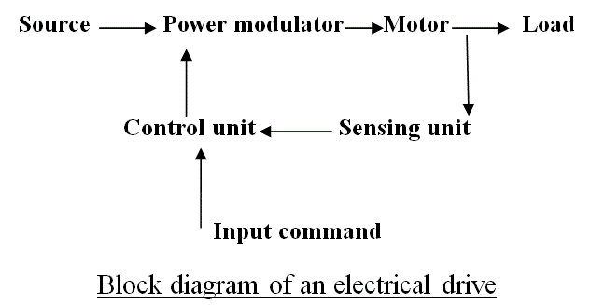

The classification of electrical drives can be done depending upon the various components of the drive system. Now according to the design, the drives can be classified into three types such as single-motor drive, group motor drive and multi motor drive. The single motor types are the very basic type of drive which are mainly used in simple metal working, house hold appliances etc. Group electric drives are used in modern industries because of various complexities. Multi motor drives are used in heavy industries or where multiple motoring units are required such as railway transport. If we divide from another point of view, these drives are of two types:

- Reversible types drives
- Non reversible types drives.
This depends mainly on the capability of the drive system to alter the direction of the flux generated. So, several classification of drive is discussed above.

Parts of Electrical Drives
The diagram which shows the basic circuit design and components of a drive, also shows that, drives have some fixed parts such as, load, motor, power modulator, control unit and source. These equipments are termed as parts of drive system. Now, loads can be of various types i.e they can have specific requirements and multiple conditions, which are discussed later, first of all we will discuss about the other four parts of electrical drives i.e motor, power modulator, source and control unit. Electric motors are of various types. The DC motors can be divided in four types – shunt wound DC motor, series wound DC motor, compound wound DC motor and permanent magnet DC motor. AC motors are of two types – induction motors and synchronous motors. Now synchronous motors are of two types – round field and permanent magnet. Induction motors are also of two types – squirrel cage and wound motor. Besides all of these, stepper motors and switched reluctance motors are also considered as the parts of drive system.
So, there are various types of electric motors, and they are used according to their specifications and uses. When the electrical drives were not so popular, induction and synchronous motors were usually implemented only where fixed or constant speed was the only requirement. For variable speed drive applications, DC motors were used. But as we know that, induction motors of same rating as a DC motors have various advantages like they have lighter weight, lower cost, lower volume and there is less restriction on maximum voltage, speed and power ratings. For these reasons, the induction motors are rapidly replaced the DC motors. Moreover induction motors are mechanically stronger and require less maintenance. When synchronous motors are considered, wound field and permanent magnet synchronous motors have higher full load efficiency and power factor than induction motors, but the size and cost of synchronous motors are higher than induction motors for the same rating. Brush less DC motors are similar to permanent magnet synchronous motors. They are used for servo applications and now a days used as an effcient alternative to DC servo motors because they don’t have the disadvantages like commentation problem. Beside of these, stepper motors are used for position control and switched reluctance motors are used for speed control.
Power Modulators - are the devices which alter the nature or frequency as well as changes the intensity of power to control electrical drives. Roughly, power modulators can be classified into three types,
- Converters,
- Variable impedance circuits,
- Switching circuits.
As the name suggests, converters are used to convert currents from one type to other type. Depending on the type of function, converters can be divided into 5 types -
- AC to DC converters
- AC regulators
- Choppers or DC - DC converters
- Inverters
- Cycloconverters
AC to DC converters are used to obtain fixed DC supply from the AC supply of fixed voltage. The very basic diagram of AC to DC converters is like.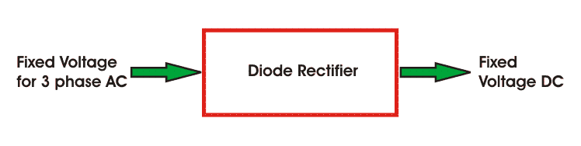AC Regulators are used to obtain the regulated AC voltage, mainly auto transformers or tap changer transformers are used in this regulators.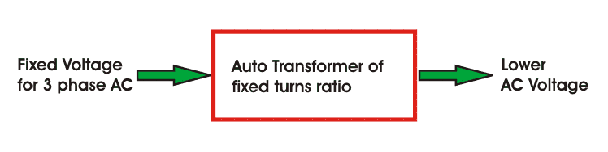Choppers or DC - DC converters are used to get a variable DC voltage. Power transistors, IGBT's, GPO's, power MOSFET's are mainly used for this purpose.
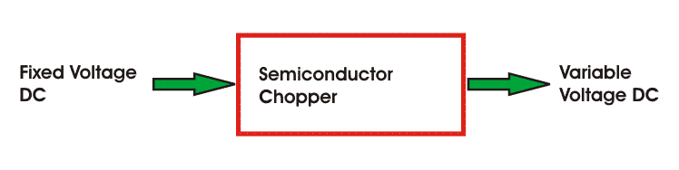Inverters are used to get AC from DC, the operation is just opposite to that of AC to DC converters. PWM semiconductors are used to invert the current.
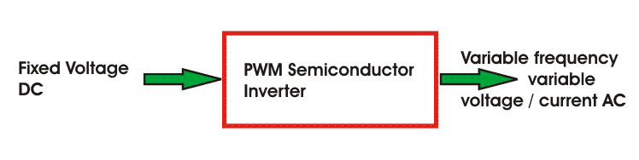Cycloconverters are used to convert the fixed frequency and fixed voltage AC into variable frequency and variable voltage AC. Thyristors are used in these converters to control the firing signals.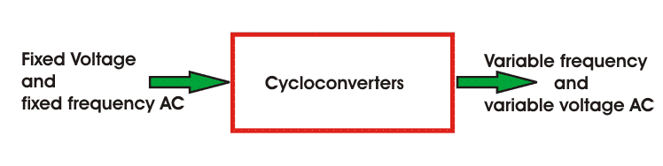
Variable Impedance circuits are used to controlling speed by varying the resistance or impedance of the circuit. But these controlling methods are used in low cost DC and ac drives. There can be two or more steps which can be controlled manually or automatically with the help of contactors. To limit the starting current inductors are used in AC motors.
Switching circuits in motors and electrical drives are used for running the motor smoothly and they also protects the machine during faults. These circuits are used for changing the quadrant of operations during the running condition of a motor. And these circuits are implemented to operate the motor and drives according to predetermined sequence, to provide interlocking, to disconnect the motor from the main circuit during any abnormal condition or faults.
Sources may be of 1 phase and 3 phase. 50 Hz AC supply is the most common type of electricity supplied in India, both for domestic and commercial purpose. Synchronous motors which are fed 50 Hz supply have maximum speed up to 3000 rpm, and for getting higher speeds higher frequency supply is needed. Motors of low and medium powers are fed from 400 V supply, and higher ratings like 3.3kv, 6.6kv, 11kv etc are provided also.
ControlUnit -
Choice of control unit depends upon the type of power modulator that is used. These are of many types, like when semiconductor converters are used, then the control unit consists of firing circuits, which employ linear devices and microprocessors.
So, the above discussion provides us a simple concept about the several parts of electrical drive.

Advantages of Electrical Drives
Electrical drives are readily used these days for controlling purpose but this is not the only the advantage of Electrical drives. There are several other advantages which are listed below -
- These drives are available in wide range torque, speed and power.
- The control characteristics of these drives are flexible. According to load requirements these can be shaped to steady state and dynamic characteristics. As well as speed control, electric braking, gearing, starting many things can be accomplished.
- The are adaptable to any type of operating conditions, no matter how much vigorous or rough it is.
- They can operate in all the four quadrants of speed torque plane, which is not applicable for other prime movers.
- They do not pollute the environment.
- They do not need refueling or preheating, they can be started instantly and can be loaded immediately.
- They are powered by electrical energy which is atmosphere friendly and cheap source of power.
Because of the above mentioned advantages of electrical drives, they are getting more and more popular and are used in a wider range of applications.

Now a days, in almost every applications, electric motors are used, and to control them electrical drives are employed. But the operating time for all motors are not the same. Some of the motors runs all the time, and some of the motor's run time is shorter than the rest period. Depending on this, concept of motor duty class is introduced and on the basis of this duty cycles of the motor can be divided in eight categories such as
- Continuous duty
- Short time duty
- Intermittent periodic duty
- Intermittent periodic duty with starting
- Intermittent periodic duty with starting and braking
- Continuous duty with intermittent periodic loading
- Continuous duty with starting and braking
- Continuous duty with periodic speed changes
Continuous Duty
This duty denotes that, the motor is running long enough AND the electric motor temperature reaches the steady state value. These motors are used in paper mill drives, compressors, conveyors etc. 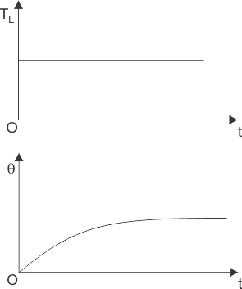
Short Time Duty
In these motors, the time of operation is very low and the heating time is much lower than the cooling time. So, the motor cooks off to ambient temperature before operating again. These motors are used in crane drives, drives for house hold appliances, valve drives etc.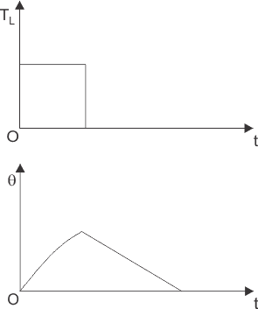
Intermittent Periodic Duty
Here the motor operates for some time and then there is rest period. In both cases, the time is insufficient to raise the temperature to steady state value or cool it off to ambient temperature. This is seen at press and drilling machine drives.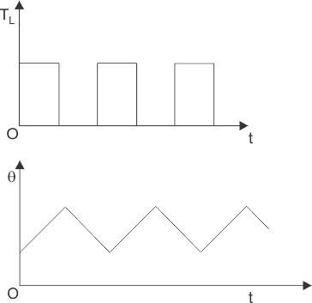
Intermittent Period Duty with Starting
In this type of duty, there is a period of starting, which cannot be ignored and there is a heat loss at that time. After that there is running period and rest period which are not adequate to attain the steady state temperatures. This motor duty class is widely used in metal cutting and drilling tool drives, mine hoist etc.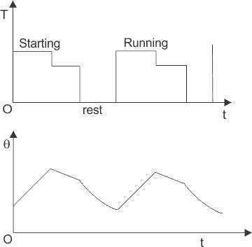
Intermittent Periodic Duty with Starting and Braking
In this type of drives, heat loss during starting and braking cannot be ignored. So, the corresponding periods are starting period, operating period, braking period and resting period, but all the periods are too short to attain the respective steady state temperatures, these techniques are used in billet mill drive, manipulator drive, mine hoist etc.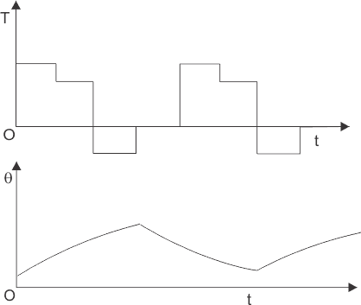
Continuous Duty with Intermittent Periodic Loading
In this type of motor duty, everything is same as the periodic duty but here a no load running period occurs instead of the rest period. Pressing, cutting are the examples of this system.
Continuous Duty with Starting and Braking
It is also a period of starting, running and braking and there is no resting period. The main drive of a blooming mill is an example.
Continuous Duty with Periodic Speed Changes
In this type of motor duty, there are different running periods at different loads and speeds. But there is no rest period and all the periods are too short to attain the steady state temperatures.

We know that when an electrical motor and drive operates, there is a generation of heat inside the motor. The amount of heat generated inside the motor should be known as accurately as possible. That’s why thermal modeling of motor is necessary. The material of the motors and the shapes and size of the motors are not unique but the generation of heat does not alter very much depending on these characteristics. So, a simple thermal model of any motor can be obtained assuming it to be a homogeneous body. The main aim of this modeling is to choose the appropriate rating of a motor so that the electric motor does not exceed its safe limit during operation.
At time ‘t’,
Let the motor has following parameters
p₁ = Heat developed, Joules/sec or watts
p₂ = Heat dissipated to the cooling medium, watts -
W = Weight of the active parts of the machine.
h = Specific heat, Joules per Kg per ºC.
A = Cooling Surface, m²
d = Co-efficient of heat transfer, Joules/Sec/m²/ºC
θ = Mean temperature rise ºC
Now, if time dt, let the temperature rise of the machine be dθ,
Therefore, heat absorbed in the machine = (Heat generated inside the machine – Heat dissipated to the surrounding cooling medicine)
Where, dθ=p₁dt-p₂dt................(i)
Since, p₂=θdA................(ii)
Substituting (ii) in (i), we get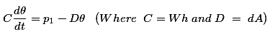Here, C is called the thermal capacity of the machine in watts/ºC and D is the heat dissipation constant in watts/ºC.
When we acquire the first order differential equation of the equation -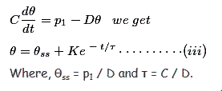We obtain the value of K by putting t = 0 in equation (iii) and get the solution as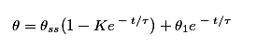So, from the above equation we can find out the rise in temperature inside a working machine, which is very near to being accurate and if we plot a graph for the variation of temperature risk with time during heating and cooling and thus the thermal modeling of a motor gets completed.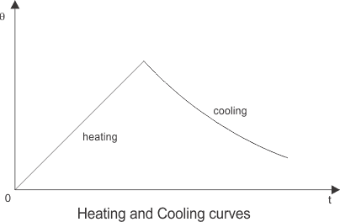

Multiquadrant Operation – Operation of Hoist in Four Quadrant
Multiquadrant Operation
* A motor operate in 2 modes – Motoring and braking
* Motoring - electrical energy to mechanical energy, support its motion.
* (generator) braking – mech energy to electrical energy, oppose the motion.
* Motor can provide motoring & braking for both forward & reverse direction.
* Power developed by a motor is given by the product of speed & torque.
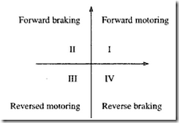
* Quadrant I – Power +ve, m/c working as a motor, supplying mech energy. So called “forward motoring”
* Quadrant II – Power –ve, m/c works under braking opposing the motion. So called “forward braking”
* Quadrant III & IV – reverse motoring and braking.
Operation of hoist in four quadrants
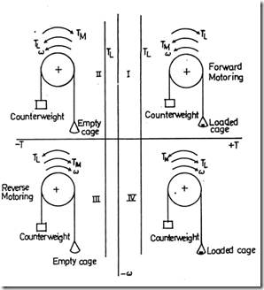
* Direction of motor & load torques and direction of speed are marked by arrows.
* A hoist consists of a rope wound on a drum coupled to a motor shaft. One end of a rope is tied to a cage which is used for transporting material. Other end of the rope has a counter weight.
* Weight of the counter weight chosen higher than the weight of an empty case but lower than a fully loaded cage.
* Load torque TL2 in quadrants I & IV represent speed torque charal of the loaded hoist. This torque is the diff. of torques due to loaded hoist & counter weight.
* Load torque TL2 in quadrants II & III is the speed-torque charal of an empty hoist. This torque is due to the diff in torque of counter weight & empty hoist. This is –ve because the counter weight is always higher than the empty cage.
* The quadrant I operation – hoist requires the movement of the cage upward, which corresponds to the +ve motor speed which is in CCW (counter clockwise) direction. It will be obtained if motor produce +ve torque in CCW direction equal to TL. Since developed power is +ve, this is forward motoring operation.
* Quadrant IV operation is obtained when a loaded cage is lowered. Since the weight of the loaded cage is > the counter weight. In order to limit the speed of the cage within a safe value, motor must produce a +ve torque T = TL2 in anti clockwise direction. Both power & speed are –ve, drive is in reverse braking.
* Quadrant II is obtained when an empty cage is moved up since a counter weight is heavier than a empty cage, it is able to pull it up. In order to limit the speed to safety value, motor must produce braking torque = TL2 in clockwise direction. Since speed is +ve, developed power is, -ve. It is forward breaking operation.
Quadrant III – empty cage is lowered since empty cage weight is < counter weight motor produce a torque in clockwise direction. Since speed is –ve & developed power is +ve, this is reverse motoring operation.
braking
The term braking comes from the term brake. We know that brake is an equipment to reduce the speed of any moving or rotating equipment, like vehicles, locomotives. The process of applying brakes can be termed as braking. Now coming to the term or question what is braking. First of all we can classify the term braking in two parts
- Mechanical Braking
- Electrical Braking
Mechanical braking is left out here because as it is an electrical engineering site, we should only focus on electrical braking here. In mechanical braking the speed of the machine is reduced solely by mechanical process but electrical braking is far more interesting than that because the whole process is depended on the flux and torque directions. We will further see through the various types of braking but the main idea behind each type of barking is the reversal of the direction of the flux.
So, we can understand that when it is asked that what is braking? We can say that it is the process of reducing speed of any rotating machine. The application of braking is seen at almost every possible area, be it inside the motor used in factories, industrial areas or be it in locomotives or vehicles. Everywhere the use of mechanical and electrical brakes is inevitable.

Types of Braking
Brakes are used to reduce or cease the speed of motors. We know that there are various types of motors available (DC motors, induction motors, synchronous motors, single phase motors etc.) and the specialty and properties of these motors are different from each other, hence this braking methods also differs from each other. But we can divide braking in to three parts mainly, which are applicable for almost every type of motors.
- Regenerative Braking.
- Plugging type braking.
- Dynamic braking.

Regenerative Braking
Regenerative braking takes place whenever the speed of the motor exceeds the synchronous speed. This baking method is called regenerative baking because here the motor works as generator and supply itself is given power from the load, i.e. motors. The main criteria for regenerative braking is that the rotor has to rotate at a speed higher than synchronous speed, only then the motor will act as a generator and the direction of current flow through the circuit and direction of the torque reverses and braking takes place. The only disadvantage of this type of brakingis that the motor has to run at super synchronous speed which may damage the motor mechanically and electrically, but regenerative braking can be done at sub synchronous speed if the variable frequency source is available.

Plugging Type Braking
Another type of braking is Plugging type braking. In this method the terminals of supply are reversed, as a result the generator torque also reverses which resists the normal rotation of the motor and as a result the speed decreases. During plugging external resistance is also introduced into the circuit to limit the flowing current. The main disadvantage of this method is that here power is wasted.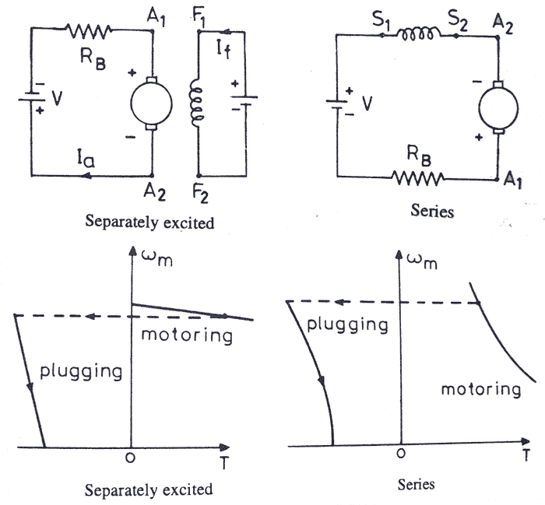

Dynamic Braking
Another method of reversing the direction of torque and braking the motor is dynamic braking. In this method of braking the motor which is at a running condition is disconnected from the source and connected across a resistance. When the motor is disconnected from the source, the rotor keeps rotating due to inertia and it works as a self-excited generator. When the motor works as a generator the flow of the current and torque reverses. During braking to maintain the steady torque sectional resistances are cut out one by one.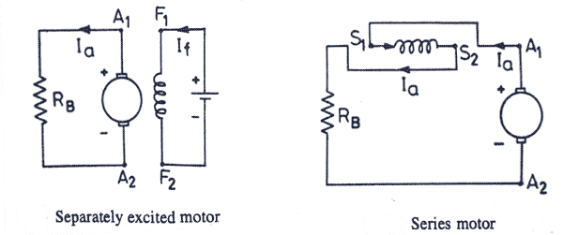
Basically, there are three types of electrical braking done in a DC Motor:-
- Regenerative Braking
- Dynamic Braking
- Plugging

Regenerative Braking
It is a form of braking in which the kinetic energy of the motor is returned to the power supply system. This type of braking is possible when the driven load forces the motor to run at a speed higher than its no-load speed with a constant excitation.
The motor back emf E_{b} is greater than the supply voltage V, which reverses the direction of the motor armature current. The motor begins to operate as an electric generator.
It is very interesting to note that regenerative braking cannot be used to stop a motor but to control its speed above the no-load speed of the motor driving the descending loads.

Dynamic Braking
It is also known as Rheostatic braking. In this type of braking, the DC motor is disconnected from the supply and a braking resistor R_{b} is immediately connected across the armature. The motor will now work as a generator, and produces the braking torque.
During electric braking when the motor works as a generator, the kinetic energy stored in the rotating parts of the motor and a connected load is converted into electrical energy. It is dissipated as heat in the braking resistance R_{b}and armature circuit resistance R_{a}.
Dynamic Braking is an inefficient method of braking as all the generated energy is dissipated as heat in resistances.

Plugging
It is also known as reverse current braking. The armature terminals or supply polarity of a separately excited DC motor or shunt DC motor when running are reversed. Therefore, the supply voltage V and the induced voltage E_{b}i.e. back emf will act in the same direction. The effective voltage across the armature will be V + E_{b} which is almost twice the supply voltage.
Thus, the armature current is reversed and a high braking torque is produced. Plugging is a highly inefficient method of braking because, in addition to the power supplied by the load, power supplied by the source is wasted in resistances.
It is used in elevators, printing press etc.
These were the main three types of braking techniques preferred to stop a DC motor and used widely in industrial applications.

Load Equalisation in Electrical Drives
Definition: Load equalisation is the process of smoothing the fluctuating load. The fluctuate load draws heavy current from the supply during the peak interval and also cause a large voltage drop in the system due to which the equipment may get damage. In load equalisation, the energy is stored at light load, and this energy is utilised when the peak load occurs. Thus, the electrical power from the supply remains constant.
The load fluctuation mostly occurs in some of the drives. For example, in a pressing machine, a large torque is required for a short duration. Otherwise, the torque is zero. Some of the other examples are a rolling mill, reciprocating pump, planning machines, electrical hammer, etc.
In electrical drives, the load fluctuation occurs in the wide range. For supplying the peak torque demand to electrical drives the motor should have high ratings, and also the motor will draw pulse current from the supply. The amplitude of pulse current gives rise to a line voltage fluctuation which affected the other load connected to the line.

Method of Load Equalisation
The problem of load fluctuation can be overcome by using the flywheel.The flying wheel is mounted on a motor shaft in non-reversible drives. In variable speed and reversible drive, a flywheel cannot be mounted on the motor shaft as it will increase the transient time of the drive. If the motor is fed from the motor generator set, then flywheel mounted on the motor generator shaft and hence equalises the load on the source but not load on the motor.
When the load is light, the flywheel accelerated and stored the excess energy drawn from the supply. During the peak load, the flying wheel decelerates and supply the stored energy to the load along with the supply energy. Hence the power remains constant, and the load demand is reduced.
Moment of inertia of the flying wheel required for load equalisation is calculated as follows. Consider the linear motor speed torque curve as shown in the figure below.
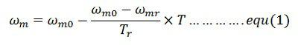Assumed the response of the motor is slow due to large inertia and hence applicable for transient operation. Differentiate the equation (1) and multiply both sides by J (moment of inertia).
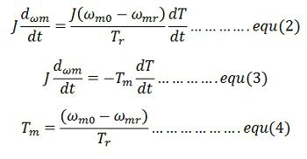Where Τ_{m} is the mechanical time constant of the motor. It is the time required for the motor speed to change by (ω_{m0} – ω_{m}) when motor torque is maintained constant at rated value ᴛ_{r}. From equation(2) and (3)
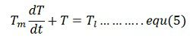Consider a periodic load torque a cycle which consists of one high load period with torque T_{lh} and duration the, and one light load period with torque T_{ll} and duration t_{l}
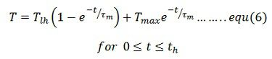Where T_{min} is the motor torque at t = 0 which is also the instant when heavy load T_{lh} is applied. If motor torque at the end of heavy load period is T_{max}, then from the equation (6)
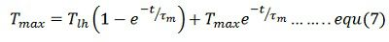Solution of equation (5) for the light load period with the initial motor torque equal to T_{max} is
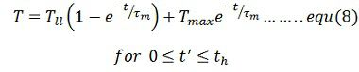where t‘ = t – t_{h}
When operating at steady state the motor torque at the end of a cycle will be the same as at the beginning of a cycle.Hence at t’ = t_{l}, T = t_{min}. Substituting in equation (8) give
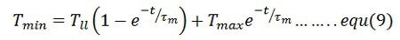From equation (7)
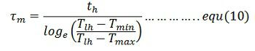From equation (4) and (10)
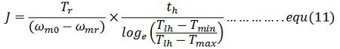Also from equation (9)
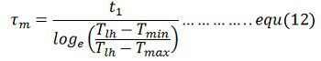From equation (4) and (11)
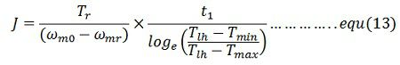Moment of inertia of the flywheel required can be calculated either from equation(11) and (12)
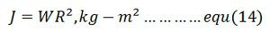Where W is the weight of the wheel (Kg), and R is the radius (m).
Note: The moment of inertia is the angular obstruction of the rotating body. It is the product of the mass and a square of a distance from the axis of rotation.

