UNIT-I

Static Electric fields

In this chapter we will discuss on the followings:

• Coulomb's Law

• Electric Field & Electric Flux Density

• Gauss's Law with Application

• Electrostatic Potential, Equipotential Surfaces

• Boundary Conditions for Static Electric Fields

• Capacitance and Capacitors

• Electrostatic Energy

• Laplace's and Poisson's Equations

• Uniqueness of Electrostatic Solutions

• Method of Images

• Solution of Boundary Value Problems in Different Coordinate Systems.
INTRODUCTION:

In the previous chapter we have covered the essential mathematical tools needed to study EM fields. We have already mentioned in the previous chapter that electric charge is a fundamental property of matter and charge exist in integral multiple of electronic charge. Electrostatics can be defined as the study of electric charges at rest. Electric fields have their sources in electric charges.
( Note: Almost all real electric fields vary to some extent with time. However, for many problems, the field variation is slow and the field may be considered as static. For some other cases spatial distribution is nearly same as for the static case even though the actual field may vary with time. Such cases are termed as quasi-static.)
In this chapter we first study two fundamental laws governing the electrostatic fields, viz, (1) Coulomb's Law and (2) Gauss's Law. Both these law have experimental basis. Coulomb's law is applicable in finding electric field due to any charge distribution, Gauss's law is easier to use when the distribution is symmetrical.
COULOMB'S LAW:

Coulomb's Law states that the force between two point charges Q1and Q2 is directly proportional to the product of the charges and inversely proportional to the square of the distance between them.
Point charge is a hypothetical charge located at a single point in space. It is an idealized model of a particle having an electric charge.
Mathematically, 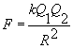 , where k is the proportionality constant.

In SI units, Q1 and Q2 are expressed in Coulombs(C) and R is in meters.

Force F is in Newtons (N) and 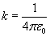, is called the permittivity of free space.

(We are assuming the charges are in free space. If the charges are any other dielectric

medium, we will use instead where is called the relative permittivity or the dielectric constant of the medium).

Therefore 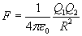 ....................... (1)

As shown in the Figure 1 let the position vectors of the point charges Q1and Q2 are given by

and . Let represent the force on Q1 due to charge Q2.

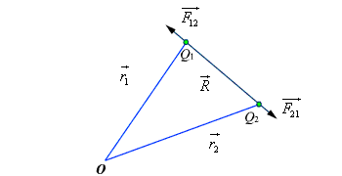

Fig 1: Coulomb's Law

The charges are separated by a distance of 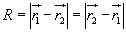. We define the unit vectors as

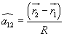 and 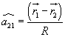 ..................................(2)

can be defined as 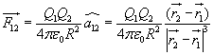 .

Similarly the force on Q1 due to charge Q2 can be calculated and if represents this force then we can write

When we have a number of point charges, to determine the force on a particular charge
due to all other charges, we apply principle of superposition. If we have N number of charges Q1,Q2,.........QN located respectively at the points represented by the position vectors , ,...... , the force experienced by a charge Q located at is given by,
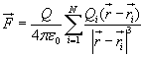 .................................(3)

ELECTRIC FIELD :

The electric field intensity or the electric field strength at a point is defined as the force per unit charge. That is

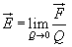 or, 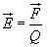 .......................................(4)

The electric field intensity E at a point r (observation point) due a point charge Q located at (source point) is given by:
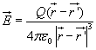 ..........................................(5)

For a collection of N point charges Q1 ,Q2 ,.........QN located at , ,...... , the electric field intensity at point is obtained as

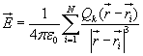 ........................................(6)

The expression (6) can be modified suitably to compute the electric filed due to a continuous distribution of charges.
In figure 2 we consider a continuous volume distribution of charge (t) in the region denoted as the source region.

For an elementary charge , i.e. considering this charge as point charge,

we can write the field expression as:

.............(7)
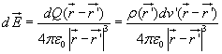

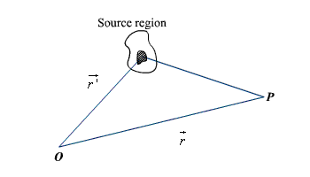

Fig 2: Continuous Volume Distribution of Charge

When this expression is integrated over the source region, we get the electric field at the point P due to this distribution of charges. Thus the expression for the electric field at P can be written as:

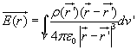 ..........................................(8)

Similar technique can be adopted when the charge distribution is in the form of a line charge density or a surface charge density.
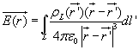 ........................................(9) 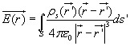 ........................................(10)
ELECTRIC FLUX DENSITY:

As stated earlier electric field intensity or simply ‘Electric field' gives the strength of the field at a particular point. The electric field depends on the material media in which the field is being considered. The flux density vector is defined to be independent of the

material media (as we'll see that it relates to the charge that is producing it).For a linear isotropic medium under consideration; the flux density vector is defined as:

................................................(11)

We define the electric flux as

.....................................(12)
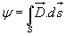

GAUSS'S LAW: Gauss's law is one of the fundamental laws of electromagnetism and it states that the total electric flux through a closed surface is equal to the total charge enclosed by the surface.

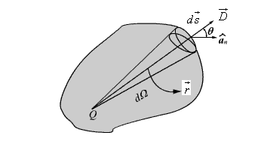

Fig 3: Gauss's Law

Let us consider a point charge Q located in an isotropic homogeneous medium of dielectric constant . The flux density at a distance r on a surface enclosing the charge is given by

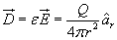 ...............................................(13)

If we consider an elementary area ds, the amount of flux passing through the elementary area is given by

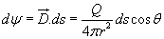 .....................................(14)

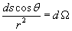

But , is the elementary solid angle subtended by the area at the location of Q. Therefore we can write 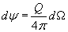

For a closed surface enclosing the charge, we can write 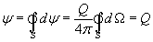

which can seen to be same as what we have stated in the definition of Gauss's Law.

APPLICATION OF GAUSS'S LAW:

Gauss's law is particularly useful in computing or where the charge distribution has some symmetry. We shall illustrate the application of Gauss's Law with some examples.

1. An infinite line charge

As the first example of illustration of use of Gauss's law, let consider the problem of determination of the electric field produced by an infinite line charge of density LC/m. Let us consider a line charge positioned along the z-axis as shown in Fig. 4(a) (next slide). Since the line charge is assumed to be infinitely long, the electric field will be of the form as shown in Fig. 4(b) (next slide).

If we consider a close cylindrical surface as shown in Fig. 2.4(a), using Gauss's theorm we can write,

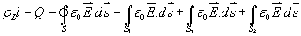 .....................................(15)

Considering the fact that the unit normal vector to areas S1 and S3 are perpendicular to the electric field, the surface integrals for the top and bottom surfaces evaluates to zero.
Hence we can write,
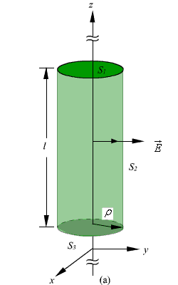

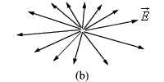

Fig 4: Infinite Line Charge

.....................................(16)
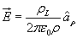

2. Infinite Sheet of Charge

As a second example of application of Gauss's theorem, we consider an infinite charged sheet covering the x-z plane as shown in figure 5. Assuming a surface charge density of
for the infinite surface charge, if we consider a cylindrical volume having sides placed symmetrically as shown in figure 5, we can write:

..............(17)
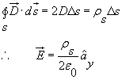

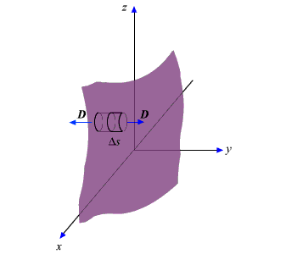

Fig 5: Infinite Sheet of Charge

It may be noted that the electric field strength is independent of distance. This is true for the infinite plane of charge; electric lines of force on either side of the charge will be perpendicular to the sheet and extend to infinity as parallel lines. As number of lines of force per unit area gives the strength of the field, the field becomes independent of distance. For a finite charge sheet, the field will be a function of distance.
3. Uniformly Charged Sphere

Let us consider a sphere of radius r0 having a uniform volume charge density of rv

C/m3. To determine everywhere, inside and outside the sphere, we construct

Gaussian surfaces of radius r < r0 and r > r0 as shown in Fig. 6 (a) and Fig. 6(b). For the region ; the total enclosed charge will be
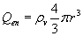 .........................(18)
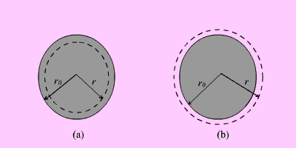

Fig 6: Uniformly Charged Sphere

By applying Gauss's theorem,

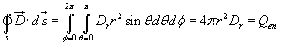 ............... (19)

Therefore

.............................................. (20)
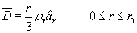

For the region ; the total enclosed charge will be

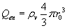 ........................................................... (21)

By applying Gauss's theorem,

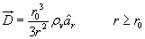 ....................................... (22)

Electrostatic Potential and Equipotential Surfaces

In the previous sections we have seen how the electric field intensity due to a charge or a charge distribution can be found using Coulomb's law or Gauss's law. Since a charge placed in the vicinity of another charge (or in other words in the field of other charge) experiences a force, the movement of the charge represents energy exchange. Electrostatic potential is related to the work done in carrying a charge from one point to the other in the presence of an electric field. Let us suppose that we wish to move a

positive test charge from a point P to another point Q as shown in the Fig. 8.The force at any point along its path would cause the particle to accelerate and move it out of the region if unconstrained. Since we are dealing with an electrostatic case, a force

equal to the negative of that acting on the charge is to be applied while moves from P to Q. The work done by this external agent in moving the charge by a distance is given by:

............................. (23)

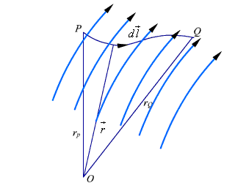

Fig 8: Movement of Test Charge in Electric Field

The negative sign accounts for the fact that work is done on the system by the external agent.
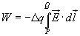 ..................................... (24)

The potential difference between two points P and Q , VPQ, is defined as the work done per unit charge, i.e.
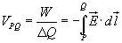 ............................... (25)

It may be noted that in moving a charge from the initial point to the final point if the potential difference is positive, there is a gain in potential energy in the movement, external agent performs the work against the field. If the sign of the potential difference is negative, work is done by the field.

We will see that the electrostatic system is conservative in that no net energy is exchanged if the test charge is moved about a closed path, i.e. returning to its initial position. Further, the potential difference between two points in an electrostatic field is a point function; it is independent of the path taken. The potential difference is measured in Joules/Coulomb which is referred to as Volts.
Let us consider a point charge Q as shown in the Fig. 9.

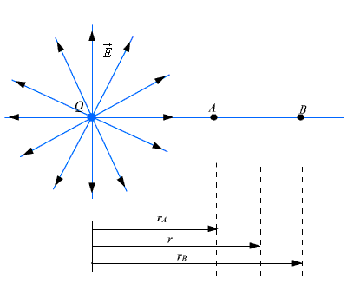

Fig 9: Electrostatic Potential calculation for a point charge

Further consider the two points A and B as shown in the Fig. 9. Considering the movement of a unit positive test charge from B to A , we can write an expression for the potential difference as:
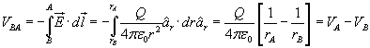 ...................(26)

It is customary to choose the potential to be zero at infinity. Thus potential at any point ( rA = r) due to a point charge Q can be written as the amount of work done in bringing a unit positive charge from infinity to that point (i.e. rB = 0).
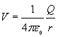 .................................. (27)

Or, in other words,

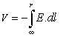 ..................................(28)

Let us now consider a situation where the point charge Q is not located at the origin as shown in Fig. 10.
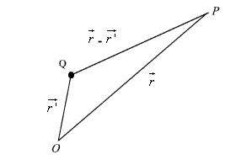

Fig 10: Electrostatic Potential due a Displaced Charge

The potential at a point P becomes

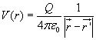 .................................. (29)

So far we have considered the potential due to point charges only. As any other type of charge distribution can be considered to be consisting of point charges, the same basic ideas now can be extended to other types of charge distribution also. Let us first
consider N point charges Q1, Q2 ,..... QN located at points with position vectors , ,

....... . The potential at a point having position vector can be written as:

.................................. (30a) OR
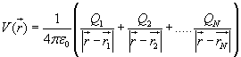

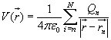 ...................................(30b)

For continuous charge distribution, we replace point charges Qn by corresponding

charge elements or or depending on whether the charge distribution is linear, surface or a volume charge distribution and the summation is replaced by an
integral. With these modifications we can write:

For line charge, 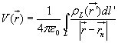…………………(31)
For surface charge, 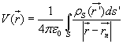 ................................. (32) For volume charge, 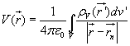 ................................. (33)

It may be noted here that the primed coordinates represent the source coordinates and the unprimed coordinates represent field point.
Further, in our discussion so far we have used the reference or zero potential at infinity. If any other point is chosen as reference, we can write:

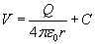 .................................(34)

where C is a constant. In the same manner when potential is computed from a known electric field we can write:
……………….. (35)

The potential difference is however independent of the choice of reference.

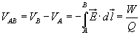 .......................(36)
We have mentioned that electrostatic field is a conservative field; the work done in moving a charge from one point to the other is independent of the path. Let us consider moving a charge from point P1 to P2 in one path and then from point P2 back to P1 over a different path. If the work done on the two paths were different, a net positive or negative amount of work would have been done when the body returns to its original position P1. In a conservative field there is no mechanism for dissipating energy corresponding to any positive work neither any source is present from which energy
could be absorbed in the case of negative work. Hence the question of different works in two paths is untenable, the work must have to be independent of path and depends on the initial and final positions.
Since the potential difference is independent of the paths taken, VAB = - VBA , and over a closed path,
.................................(37) Applying Stokes's theorem, we can write:

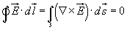 ............................ (38)

from which it follows that for electrostatic field,

......................(39)
Any vector field that satisfies is called an irrotational field. From our definition of potential, we can write

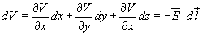

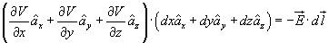

from which we obtain,
.................................(40)

.......................................... (41)

From the foregoing discussions we observe that the electric field strength at any point is the negative of the potential gradient at any point, negative sign shows that is
directed from higher to lower values of . This gives us another method of computing

the electric field , i. e. if we know the potential function, the electric field may be

computed. We may note here that that one scalar function contain all the
information that three components of carry, the same is possible because of the fact that three components of are interrelated by the relation .

Equipotential Surfaces

An equipotential surface refers to a surface where the potential is constant. The intersection of an equipotential surface with an plane surface results into a path called an equipotential line. No work is done in moving a charge from one point to the other along an equipotential line or surface.
In figure 12, the dashes lines show the equipotential lines for a positive point charge. By symmetry, the equipotential surfaces are spherical surfaces and the equipotential lines
are circles. The solid lines show the flux lines or electric lines of force.

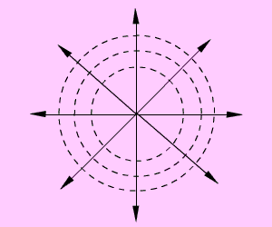

Fig 12: Equipotential Lines for a Positive Point Charge

Michael Faraday as a way of visualizing electric fields introduced flux lines. It may be seen that the electric flux lines and the equipotential lines are normal to each other. In
order to plot the equipotential lines for an electric dipole, we observe that for a given Q

and d, a constant V requires that 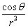 is a constant. From this we can write

to be the equation for an equipotential surface and a family of surfaces can be generated for various values of cv.When plotted in 2-D this would give equipotential
lines.

To determine the equation for the electric field lines, we note that field lines represent the direction of in space. Therefore,
, k is a constant .............................................(42)

.................(43)

For the dipole under consideration =0 , and therefore we can write,

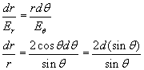 .................................. (44)

Electrostatic Energy and Energy Density:

We have stated that the electric potential at a point in an electric field is the amount of work required to bring a unit positive charge from infinity (reference of zero potential) to that point. To determine the energy that is present in an assembly of charges, let us first determine the amount of work required to assemble them. Let us consider a number of discrete charges Q1, Q2,......., QN are brought from infinity to their present position one by one. Since initially there is no field present, the amount of work done in bring Q1 is zero. Q2 is brought in the presence of the field of Q1, the work done W1= Q2V21 where V21 is the potential at the location of Q2 due to Q1. Proceeding in this manner, we can
write, the total work done

....................(45)

Had the charges been brought in the reverse order,

................(46)

Therefore,

............(47)
....

Here VIJ represent voltage at the Ith charge location due to Jth charge. Therefore,

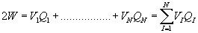 Or, 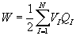................(48)

If instead of discrete charges, we now have a distribution of charges over a volume v

then we can write, 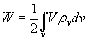 ................(49)

where is the volume charge density and V represents the potential function.

Since, , we can write

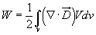 .......................................(50)

, we can write
Using the vector identity,

................(51)
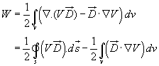

In the expression , for point charges, since V varies as and D varies as

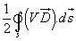

, the term V varies as while the area varies as r2. Hence the integral term

varies at least as and the as surface becomes large (i.e. ) the integral term tends to zero.

Thus the equation for W reduces to

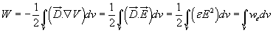 ................(52) 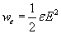 , is called the energy density in the electrostatic field. Poisson’s and Laplace’s Equations
For electrostatic field, we have seen that

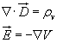 ................................................................(53) Form the above two equations we can write

................................................(54)

Using vector identity we can write, ................(55)

For a simple homogeneous medium, is constant and . Therefore,

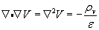 ................(56)

This equation is known as Poisson’s equation. Here we have introduced a new operator

, ( del square), called the Laplacian operator. In Cartesian coordinates,

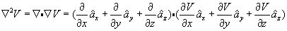 ...............(57) Therefore, in Cartesian coordinates, Poisson equation can be written as:

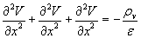 ...............(58) In cylindrical coordinates,

...............(59)
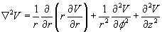

In spherical polar coordinate system,

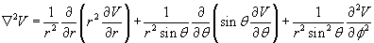 ...............(60)

At points in simple media, where no free charge is present, Poisson’s equation reduces to

which is known as Laplace’s equation.
...................................(61)

Laplace’s and Poisson’s equation are very useful for solving many practical electrostatic field problems where only the electrostatic conditions (potential and charge) at some boundaries are known and solution of electric field and potential is to be found hroughout the volume. We shall consider such applications in the section where we deal with boundary value problems.

Convention and conduction current:
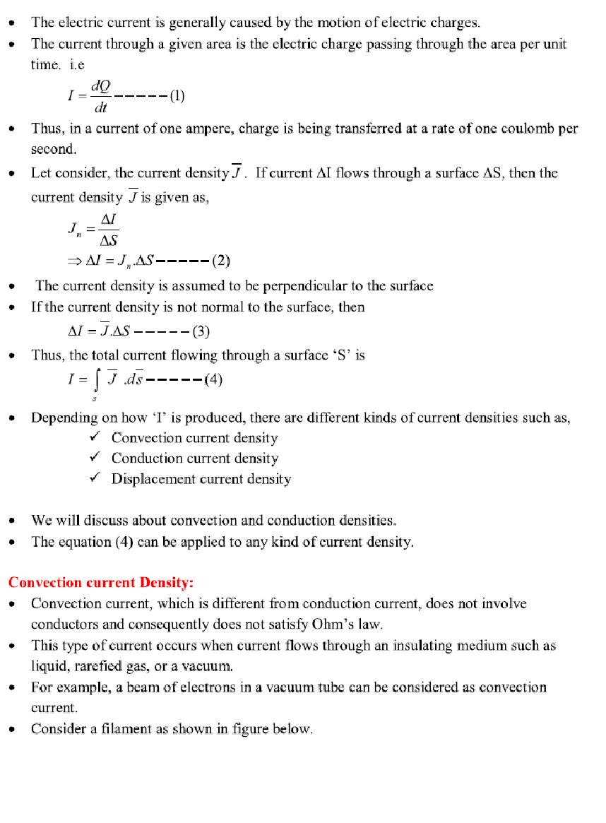
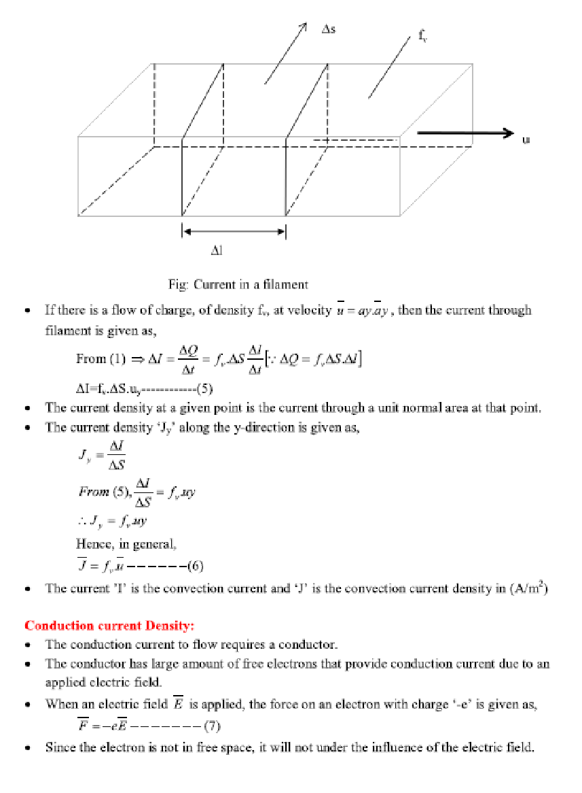
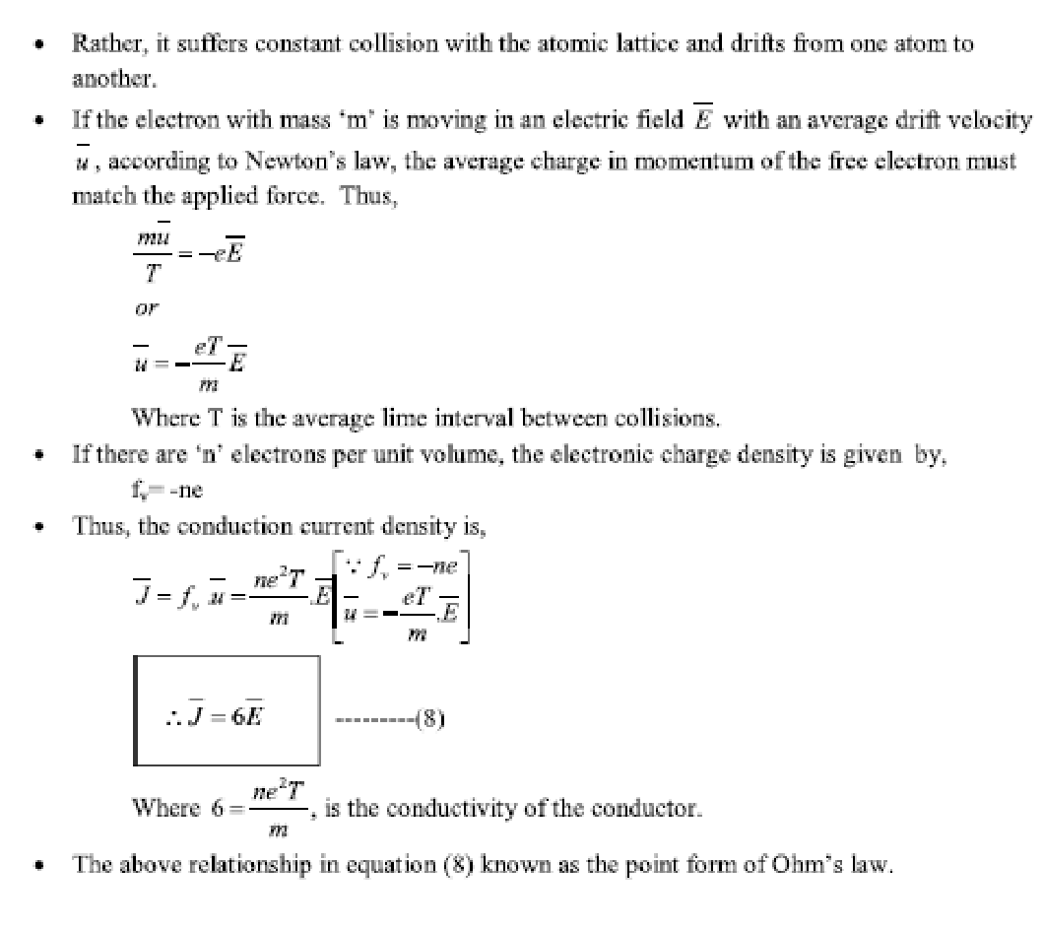
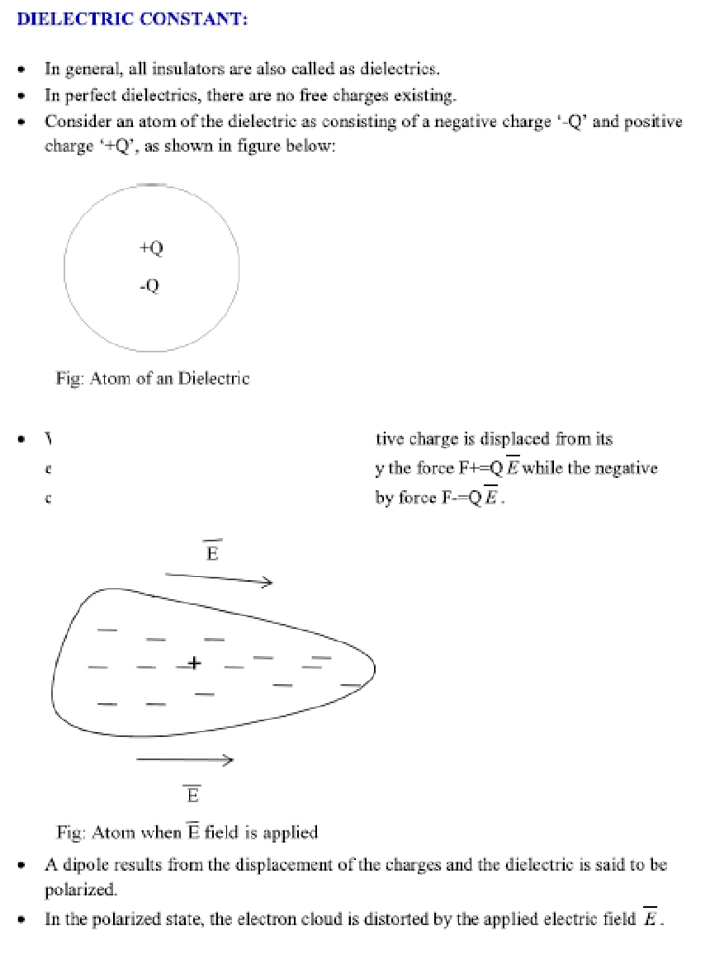
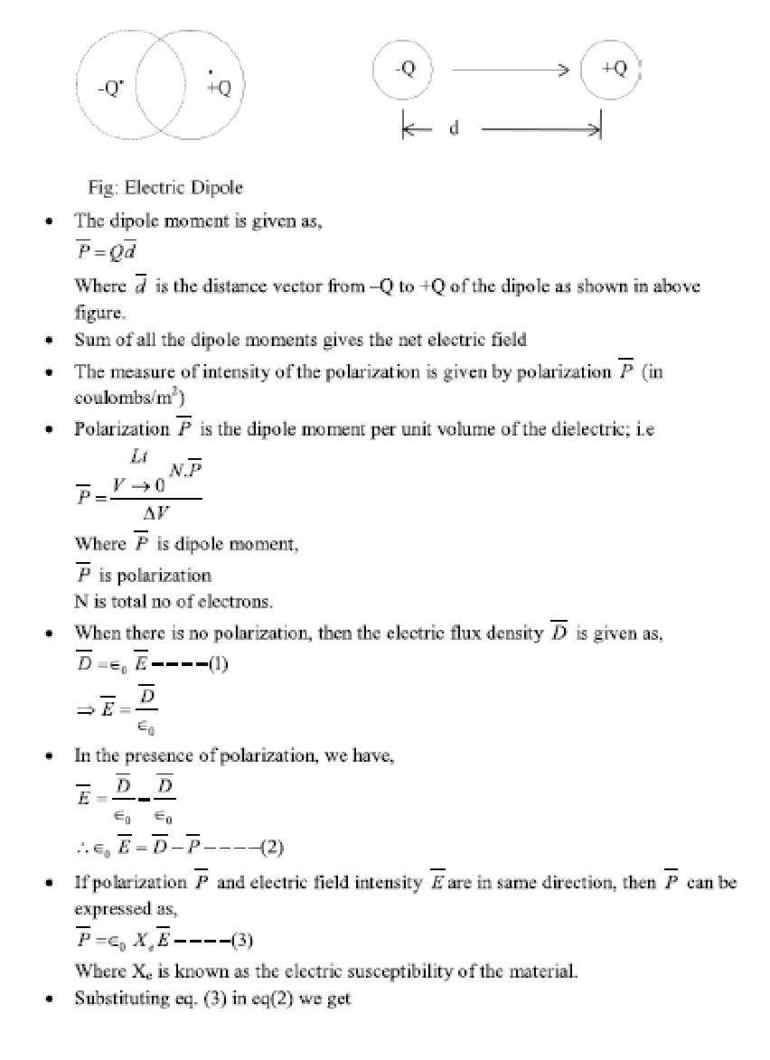
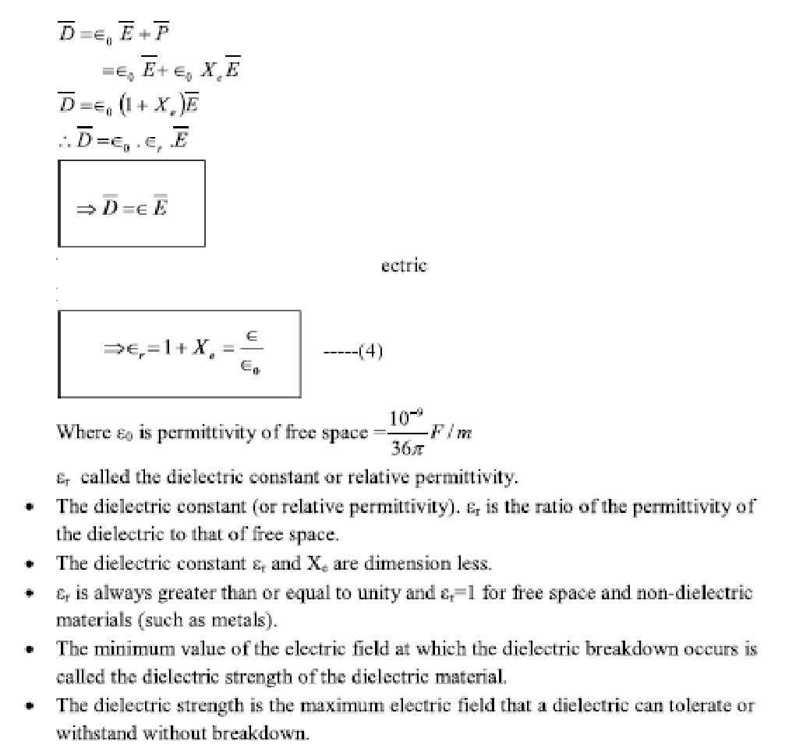
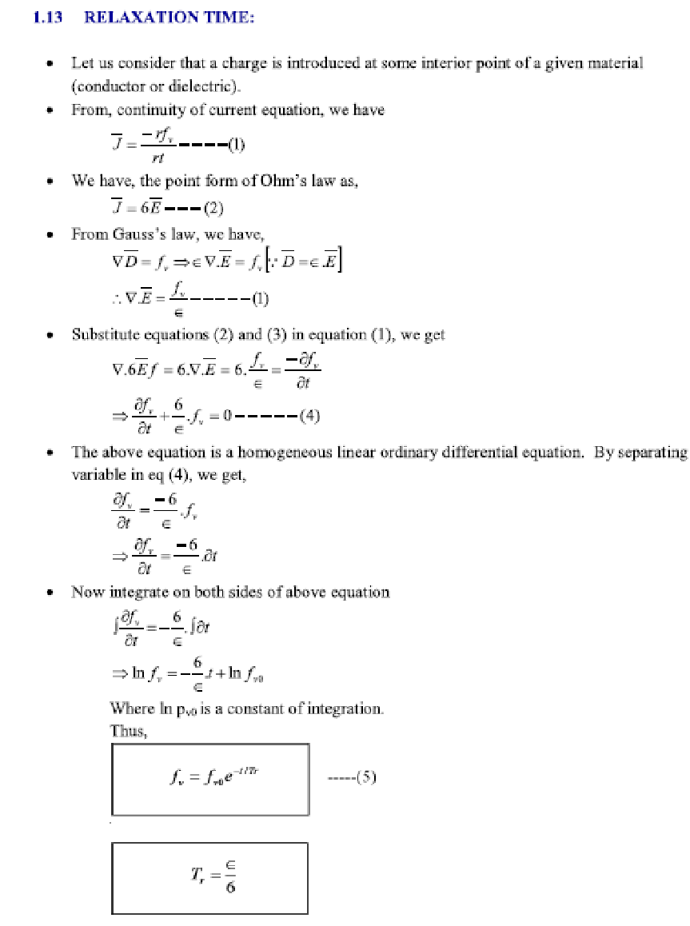
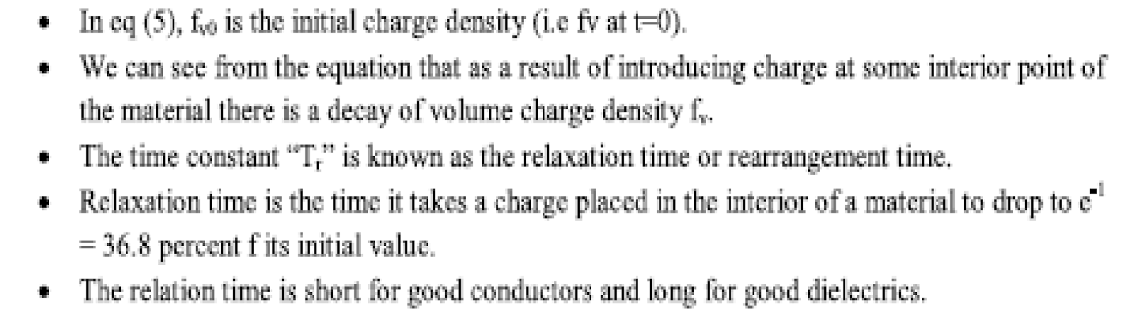

CAPACITANCE AND CAPACITORS

We have already stated that a conductor in an electrostatic field is an Equipotential body and any charge given to such conductor will distribute themselves in such a manner that electric field inside the conductor vanishes. If an additional amount of charge is supplied to an isolated conductor at a given potential, this additional charge will increase the surface charge density
. Since the potential of the conductor is given by 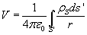 , the potential of conductor will also increase maintaining the ratio same . Thus we can write 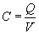 where the constant of proportionality C is called the capacitance of the isolated conductor. SI unit of

capacitance is Coulomb/ Volt also called Farad denoted by F. It can It can be seen that if V=1, C

= Q. Thus capacity of an isolated conductor can also be defined as the amount of charge in

Coulomb required to raise the potential of the conductor by 1 Volt.
Of considerable interest in practice is a capacitor that consists of two (or more) conductors carrying equal and opposite charges and separated by some dielectric media or free space. The conductors may have arbitrary shapes. A two-conductor capacitor is shown in figure below.

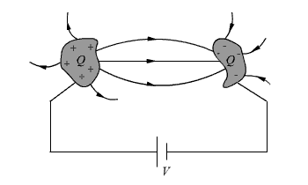

Fig : Capacitance and Capacitors
When a d-c voltage source is connected between the conductors, a charge transfer occurs which results into a positive charge on one conductor and negative charge on the other conductor. The conductors are equipotential surfaces and the field lines are perpendicular to the conductor surface. If V is the mean potential difference between the conductors, the capacitance is given by
. Capacitance of a capacitor depends on the geometry of the conductor and the permittivity of the medium between them and does not depend on the charge or potential

difference between conductors. The capacitance can be computed by assuming Q(at the same time -Q on the other conductor), first determining using Gauss’s theorem and then
determining . We illustrate this procedure by taking the example of a parallel plate capacitor.

Example: Parallel plate capacitor

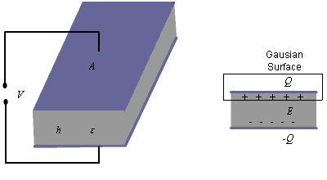 Fig : Parallel Plate Capacitor

For the parallel plate capacitor shown in the figure about, let each plate has area A and a distance h separates the plates. A dielectric of permittivity fills the region between the plates. The electric field lines are confined between the plates. We ignore the flux fringing at the edges of the plates and charges are assumed to be uniformly distributed over the conducting plates with
densities and - , 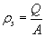 .

By Gauss’s theorem we can write, 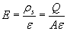 .......................(1)

As we have assumed to be uniform and fringing of field is neglected, we see that E is

constant in the region between the plates and therefore, we can write . Thus, for a
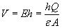

parallel plate capacitor we have, 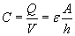

........................(2)

Series and parallel Connection of capacitors

Capacitors are connected in various manners in electrical circuits; series and parallel connections are the two basic ways of connecting capacitors. We compute the equivalent capacitance for such connections.
Series Case: Series connection of two capacitors is shown in the figure 1. For this case we can write,
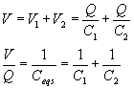 .......................(1)

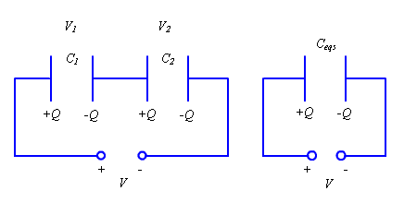

Fig 1.: Series Connection of Capacitors
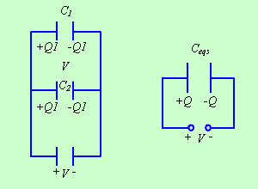

Fig 2: Parallel Connection of Capacitors

The same approach may be extended to more than two capacitors connected in series. Parallel Case: For the parallel case, the voltages across the capacitors are the same. The total charge
Therefore, 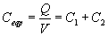 .......................(2)

Continuity Equation and Kirchhoff’s Current Law

Let us consider a volume V bounded by a surface S. A net charge Q exists within this region. If a net current I flows across the surface out of this region, from the principle of conservation of charge this current can be equated to the time rate of decrease of charge within this volume. Similarly, if a net current flows into the region, the charge in the volume must increase at a rate equal to the current. Thus we can write,
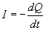 .....................................(3)

or, 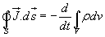......................(4) Applying divergence theorem we can write,

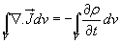 .....................(5)

It may be noted that, since in general may be a function of space and time, partial derivatives are used. Further, the equation holds regardless of the choice of volume V , the integrands must
be equal.

Therefore we can write,

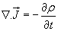 ................(6)

The equation (6) is called the continuity equation, which relates the divergence of current density vector to the rate of change of charge density at a point.
For steady current flowing in a region, we have

......................(7)

Considering a region bounded by a closed surface,

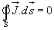 ..................(8)

which can be written as,

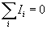 ......................(9)

when we consider the close surface essentially encloses a junction of an electrical circuit.

The above equation is the Kirchhoff’s current law of circuit theory, which states that algebraic sum of all the currents flowing out of a junction in an electric circuit, is zero.

