**Introduction:**

Electronic circuit analysis subject teaches about the basic knowledge required to design an amplifier circuit, oscillators etc .It provides a clear and easily understandable discussion of designing of different types of amplifier circuits and their analysis using hybrid model, to find out their parameters. Fundamental concepts are illustrated by using small examples which are easy to understand. It also covers the concepts of MOS amplifiers, oscillators and large signal amplifiers.

**Two port devices & Network Parameters:**

A transistor can be treated as a two-part network. The terminal behavior of any two-part network can be specified by the terminal voltages V1& V2at parts 1 & 2 respectively and current i1and i2, entering parts 1 & 2, respectively, as shown in figure.

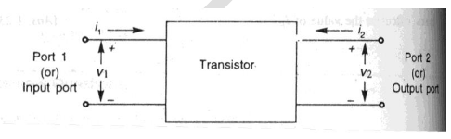

Of these four variables V1, V2, i1and i2, two can be selected as independent variables and the remaining two can be expressed in terms of these independent variables. This leads to various two part parameters out of which the following three are more important.

1. Z –Parameters (or) Impedance parameters
2. Y –Parameters (or) Admittance parameters
3. H –Parameters (or) Hybrid parameters

**Hybrid parameters (or) h –parameters:**

The equivalent circuit of a transistor can be dram using simple approximation by retaining its essential features. These equivalent circuits will aid in analyzing transistor circuits easily and rapidly.

If the input current i1 and output Voltage V2 are takes as independent variables, the input voltage V1 and output current i2 can be written as

**V1 = h11 i1 + h12 V2**

**i2 = h21 i1 + h22 V2**

The four hybrid parameters h11, h12, h21and h22 are defined as follows:

h11= [V1/ i1] with V2= 0 Input Impedance with output part short circuited.

h22= [i2/ V2] with i1= 0 Output admittance with input part open circuited.

h12= [V1/ V2] with i1= 0 reverse voltage transfer ratio with input part open circuited.

h21= [i2/ i1] with V2= 0 Forward current gain with output part short circuited

**The dimensions of h–parameters are as follows:**

h11-Ω

h22–mhos

h12, h21 –dimension less.

As the dimensions are not alike, (i.e.) they are hybrid in nature, and these parameters are called as hybrid parameters.

h11 = input; h 22 = output;

h21= forward transfer; h22 = Reverse transfer.

**Notations used in transistor circuits: -**

hie= h11e= Short circuit input impedance

hoe= h22e= Open circuit output admittance

hre = h12e= Open circuit reverse voltage transfer ratio

hfe= h21e= Short circuit forward current Gain.

**The Hybrid Model for Two-port Network: -**

V1= h11 i1+ h12V2

I2= h21i1+ h22V2

V1= h1i1+ hrV2

I2 = hfi1+ h0V2

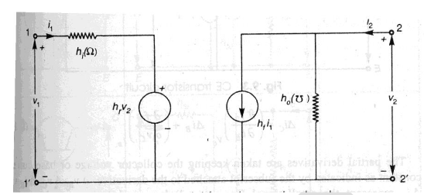

**Common Emitter Amplifier**

Common Emitter Circuit is as shown in the Fig. The DC supply, biasing resistors and coupling capacitors are not shown since we are performing an AC analysis.



Esis the input signal source and Rs is its resistance. The h-parameter equivalent for the above circuit is as shown in Fig.





The typical values of the h-parameter for a transistor in Common Emitter configuration are,



























**Common Base Amplifier**

Common Base Circuit is as shown in the Fig. The DC supply, biasing resistors and coupling capacitors are not shown since we are performing an AC analysis.

















**Common Collector Amplifier**

Common Collector Circuit is as shown in the Fig. The DC supply, biasing resistors and coupling capacitors are not shown since we are performing an AC analysis



The h-parameter model is shown below







**Transistors at High Frequencies**

At low frequencies it is assumed that transistor responds instantaneously to changes in the input voltage or current i.e., if you give AC signal between the base and emitter of a Transistor amplifier in Common Emitter configuraii6n and if the input signal frequency is low, the output at the collector will exactly follow the change in the input (amplitude etc.,). If '1' of the input is high (MHz) and the amplitude of the input signal is changing the Transistor amplifier will not be able to respond.

It is because; the carriers from the emitter side will have to be injected into the collector side. These take definite amount of time to travel from Emitter to Base, however small it may be. But if the input signal is varying at much higher speed than the actual time taken by the carries to respond, then the Transistor amplifier will not respond instantaneously. Thus, the junction capacitances of the transistor, puts a limit to the highest frequency signal which the transistor can handle. Thus depending upon doping area of the junction etc, we have transistors which can respond in AF range and also RF range.

To study and analyze the behavior of the transistor to high frequency signals an equivalent model based upon transmission line equations will be accurate. But this model will be very complicated to analyze. So some approximations are made and the equivalent circuit is simplified. If the circuit is simplified to a great extent, it will be easy to analyze, but the results will not be accurate. If no approximations are made, the results will be accurate, but it will be difficult to analyze. The desirable features of an equivalent circuit for analysis are simplicity and accuracy. Such a circuit which is fairly simple and reasonably accurate is the Hybrid-pi or Hybrid-π model, so called because the circuit is in the form of π.

**Hybrid - π Common Emitter Transconductance Model**

For Transconductance amplifier circuits Common Emitter configuration is preferred. Why? Because for Common Collector (hrc< 1). For Common Collector Configuration, voltage gain Av < 1. So even by cascading you can't increase voltage gain. For Common Base, current gain is hib< 1. Overall voltage gain is less than 1. For Common Emitter, hre>>1. Therefore Voltage gain can be increased by cascading Common Emitter stage. So Common Emitter configuration is widely used. The Hybrid-x or Giacoletto Model for the Common Emitter amplifier circuit (single stage) is as shown below

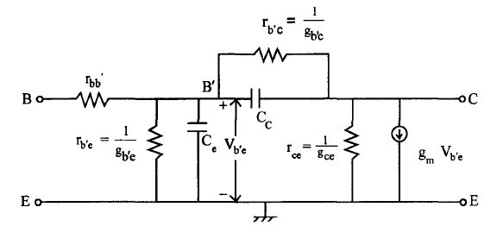

Analysis of this circuit gives satisfactory results at all frequencies not only at high frequencies but also at low frequencies. All the parameters are assumed to be independent of frequency.

Where B’ = internal node in base

rbb’ = Base spreading resistance

rb’e = Internal base node to emitter resistance

rce = collector to emitter resistance

Ce = Diffusion capacitance of emitter base junction

rb’c = Feedback resistance from internal base node to collector node

gm = Transconductance

CC= transition or space charge capacitance of base collector junction

**Circuit Components**

B' is the internal node of base of the Transconductance amplifier. It is not physically accessible. The base spreading resistance rbb is represented as a lumped parameter between base B and internal node B'. gmVb'e is a current generator. Vb'e is the input voltage across the emitter junction. If Vb'e increases, more carriers are injected into the base of the transistor. So the increase in the number of carriers is proportional to Vb'e. This results in small signal current since we are taking into account changes in Vb'e. This effect is represented by the current generator gmVb'e. This represents the current that results because of the changes in Vb'e' when C is shorted to E.

When the number of carriers injected into the base increase, base recombination also increases. So this effect is taken care of by gb'e. As recombination increases, base current increases. Minority carrier storage in the base is represented by Ce the diffusion capacitance.

According to Early Effect, the change in voltage between Collector and Emitter changes the base width. Base width will be modulated according to the voltage variations between Collector and Emitter. When base width changes, the minority carrier concentration in base changes. Hence the current which is proportional to carrier concentration also changes. IE changes and IC changes. This feedback effect [IE on input side, IC on output side] is taken into account by connecting gb'e between B', and C. The conductance between Collector and Base is gce.Cc represents the collector junction barrier capacitance.

**Hybrid - *n* Parameter Values**

Typical values of the hybrid-n parameter at IC = 1.3 rnA are as follows:

gm= 50 mA/v

rbb' = 100 Ω

rb'e = 1 kΩ

ree = 80 kΩ

Cc = 3 pf

Ce = 100 pf

rb'c = 4 MΩ

These values depend upon:

1. Temperature 2. Value of IC

**Determination of Hybrid-x Conductances**

1. **Transconductance or Mutual Conductance (gm)**

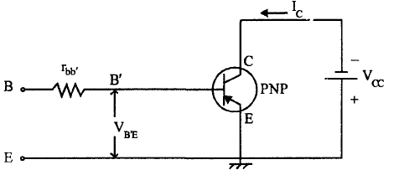

The above figure shows PNP transistor amplifier in Common Emitter configuration for AC purpose, Collector is shorted to Emitter.



ICO opposes IE. IE is negative. Hence IC = ICO – α0IE α0 is the normal value of α at roomtemperature.

In the hybrid - π equivalent circuit, the short circuit current = gmVb' e

Here only transistor is considered, and other circuit elements like resistors, capacitors etc,are not considered.

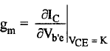

Differentiate (l) with respect to Vb'e partially. ICO is constant

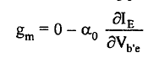

For a PNP transistor, Vb'e = -VESince, for PNP transistor, base is n-type. So negative voltage is given

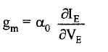

If the emitter diode resistance is re then

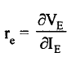

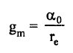

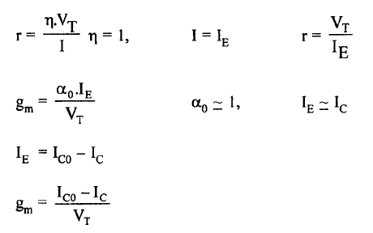

Neglect IC0

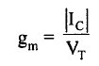

gm is directly proportiortal to IC is also inversely proportiortal to T. For PNP transistor, IC is negative

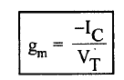

At room temperature i.e. T=3000K

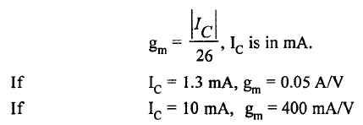

**Input Conductance (gb'e):**

At low frequencies, capacitive reactance will be very large and can be considered as Open circuit. Soin the hybrid-π equivalent circuit which is valid at low frequencies, all the capacitances can be neglected.

The equivalent circuit is as shown in Fig.

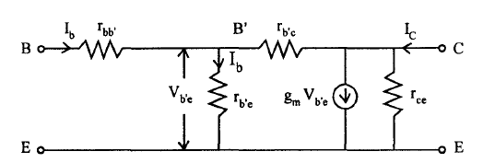

The value of rb'c» rb'e (Since Collector Base junction is Reverse Biased)So Ib flows into rb'e only. [This is lb' (IE - Ib)will go to collector junction]



The short circuit collector current,

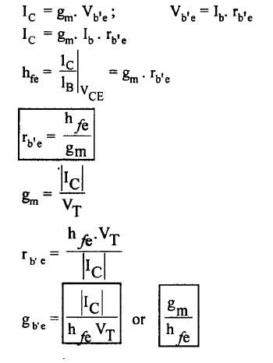

**Feedback Conductance (gb' c)**

hre = reverse voltage gain, with input open or Ib = 0

hre =Vb'e/Vce = Input voltage/Output voltage

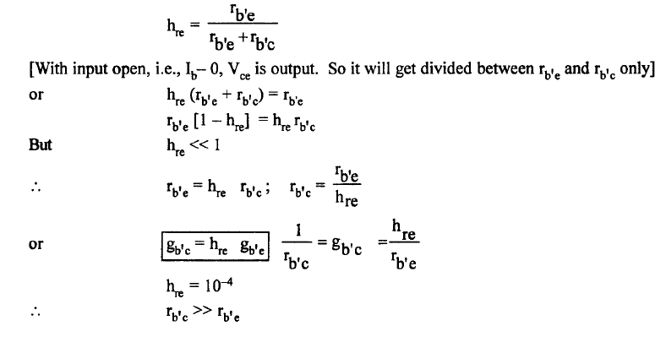

**Base Spreading Resistance (r bb')**

The input resistance with the output shorted is hie. If output is shorted, i.e., Collector and Emitter arejoined; rb'e is in parallel with rb’c.

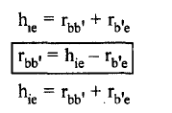 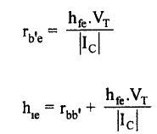

**Output Conductance (gce)**

This is the conductance with input open circuited. In h-parameters it is represented as hoe. For Ib= 0, we have,

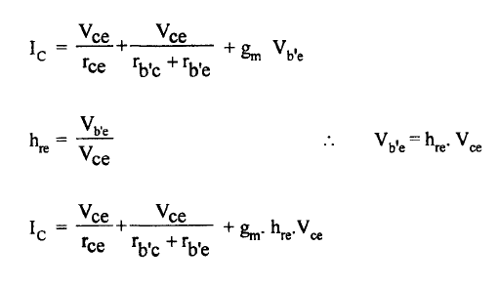

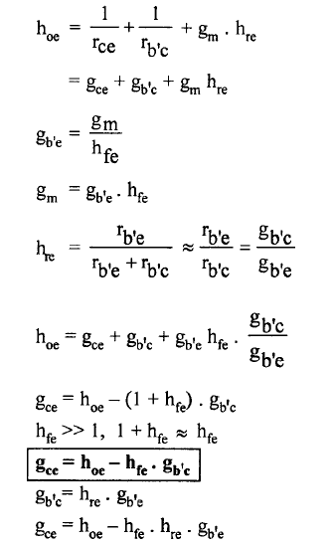

**Hybrid - π Capacitances**

In the hybrid - **π** equivalent circuit, there are two capacitances, the capacitance between the Collector Base junction is the Cc or Cb'e'. This is measured with input open i.e., IE = 0, and is specified by the manufacturers as COb. 0 indicates that input is open. Collector junction is reverse biased.

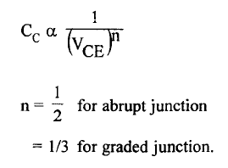

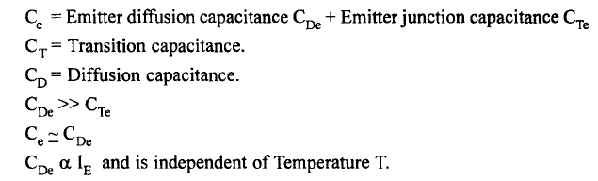

**Validity of hybrid-π model**

**The high frequency hybrid Pi or Giacoletto model of BJT is valid for frequencies less than the unit gain frequency.**

**High frequency model parameters of a BJT in terms of low frequency hybrid parameters**

The main advantage of high frequency model is that this model can be simplified to obtain low frequency model of BJT. This is done by eliminating capacitance’s from the high frequency model so that the BJT responds without any significant delay (instantaneously) to the input signal. In practice there will be some delay between the input signal and output signal of BJT which will be very small compared to signal period (1/frequency of input signal) and hence can be neglected. The high frequency model of BJT is simplified at low frequencies and redrawn as shown in the figure below along with the small signal low frequency hybrid model of BJT.



Fig. high frequency model of BJT at low frequencies

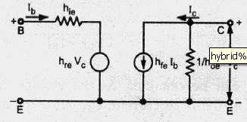

Fig hybrid model of BJT at low frequencies

The High frequency model parameters of a BJT in terms of low frequency hybrid parameters is given below:

Transconductance gm = Ic/Vt

Internal Base node to emitter resistance rb’e = hfe/ gm = (hfe* Vt )/ Ic

Internal Base node to collector resistance rb’e = (hre* rb’c) / (1- hre) assuming hre << 1 it reduces to rb’e = (hre* rb’c)

Base spreading resistance rbb’ = hie – rb’e = hie – (hfe* Vt )/ Ic

Collector to emitter resistance rce = 1 / ( hoe – (1+ hfe)/rb’c)

**Collector Emitter Short Circuit Current Gain**

Consider a single stage Common Emitter transistor amplifier circuit. The hybrid-1t equivalent circuit is as shown:

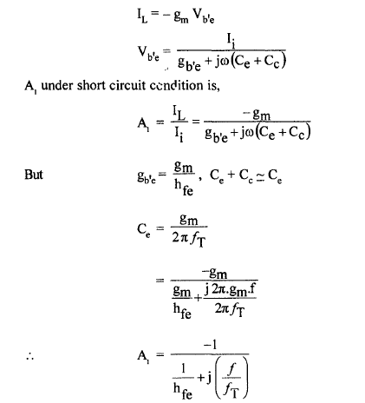

If the output is shorted i.e. RL = 0, what will be the flow response of this circuit? WhenRL = 0, Vo = 0. Hence Av = 0. So the gain that we consider here is the current gain IL/Ic. The simplified equivalent circuit with output shorted is,

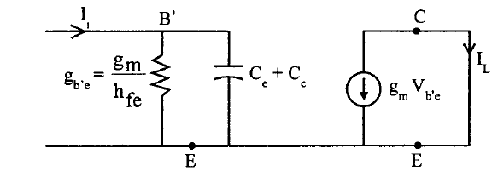

A current source gives sinusoidal current Ic. Output current or load current is IL· gb'c isneglected since gb'c « gb'e, gce is in shunt with short circuit R = 0. Therefore gce disappears. The current is delivered to the output directly through Ce and gb'c is also neglected since this will be very small.



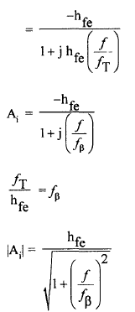

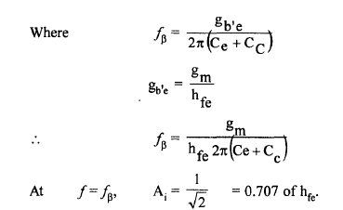

**Current Gain with Resistance Load:**

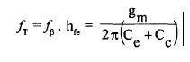

Considering the load resistance RL

V b'e is the input voltage and is equal to V1

Vce is the output voltage and is equal to V 2



This circuit is still complicated for analysis. Because, there are two time constants associated with the input and the other associated with the output. The output time constant will be much smaller than the input time constant. So it can be neglected.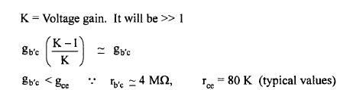

So gb'c can be neglected in the equivalent circuit. In a wide band amplifier RL will not exceed 2KΩ. If RL is small fH is large.



Thereforegce can be neglected compared with RL. Therefore the output circuit consists of current generator gm V b'e feeding the load RL so the Circuit simplifies as shown in Fig.

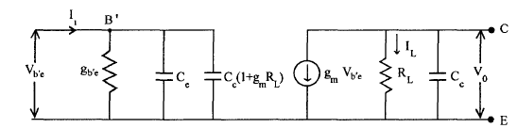

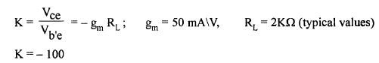

**Miller's Theorem**

It states that if an impedance Z is connected between the input and output terminals, of a network, between which there is voltage gain, K, the same effect can be had by removing Z and connecting an impedance Zi at the input =Z/(1-K) and Zo across the output = ZK/(K-1)

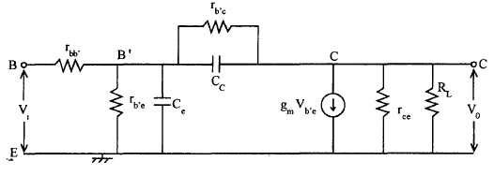

Fig. High frequency equivalent circuit with resistive load RL

Therefore high frequency equivalent circuit using Miller's theorem reduces to

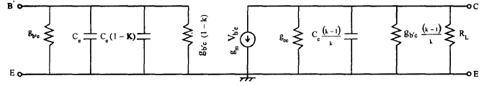

Fig. Circuit after applying Millers' Theorem



Vce = - Ic . RL

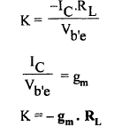

**The Parameters f*T***

*fT*is the frequency at which the short circuit Common Emitter current gain becomes unity.

**The Parameters f*β***

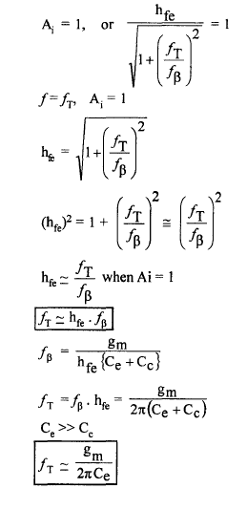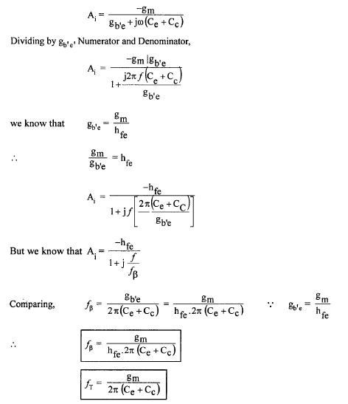

**Gain - Bandwidth (B.W) Product**

This is a measure to denote the performance of an amplifier circuit. Gain - B. W product is also referred as Figure of Merit of an amplifier. Any amplifier circuit must have large gain and large bandwidth. For certain amplifier circuits, the midband gain Am maybe large, but not Band width or Vice - Versa. Different amplifier circuits can be compared with thus parameter.

**FET: Analysis of common Source and common drain Amplifier circuits at high frequencies.**

Just like for the BJT, we could use the original small signal model for low frequency analysis–the only difference was that external capacitances had to be kept in the circuit. Also just like the BJT, for high frequency operation, the internal capacitances between each of the device’s terminals can no longer be ignored and the small signal model must be modified. Recall that for high frequency operation, we’re stating that external capacitances are so large (in relation to the internal capacitances) that they may be considered short circuits.

**High frequency response of Common source amplifier**

The JFET implementation of the common-source amplifier is given to the left below, and the small signal circuit in corporating the high frequency FET model is given to the right below. As stated above, the external coupling and bypass capacitors are large enough that we can model them as short circuits for high frequencies.

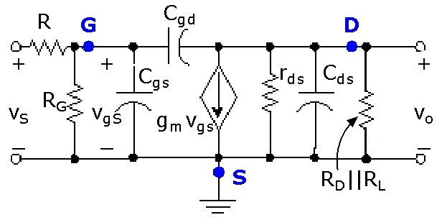

We may simplify the small signal circuit by making the following approximations and observations:

1. Rds is usually larger than RD||RL, so that the parallel combination is dominated by RD||RLand rds may be neglected. If this is not the case, a single equivalent resistance, rds||RD||RLmay be defined.
2. The Miller effect transforms Cgd into separate capacitances seen in the input and output circuits as

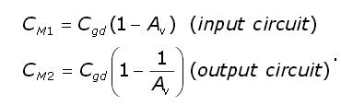

1. Cds is very small, so the impedance contribution of this capacitance may be considered to be an open circuit and may be ignored.



1. The parallel capacitances in the input circuit, Cgsand CM1, may be combined to a single equivalent capacitance of value
2. Similarly, the parallel capacitances in the output circuit, Cds and CM2,may be combined to a single equivalent capacitance of value

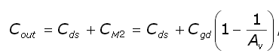

Where Av=-gm(RD||RL)for a common-source amplifier.

Setting the input source, vS, equal to zero allows us to define the equivalent resistances seen by Cin and Cout(the Method of Open Circuit Time Constants).Note that, with vS=0, the dependent current source also goes to zero (opens) and the input and output circuits are separated.

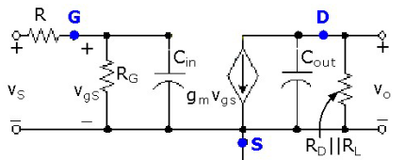









Generally, the input is going to provide the dominant pole, so the high frequency cut off is given by******

**High frequency response of Common source amplifier**



**Characteristics ofCDAmplifier:**

* Voltagegain ≈1
* Highinputresistance
* Lowoutputresistance
* Goodvoltage buffer

**High frequency small signal model**













If RSis not too high, bandwidth can be rather high and approach ωT

