Hashing

1

Overview

- Hashing

  - Technique supporting insertion, deletion and search in average-case constant time

  - Operations requiring elements to be sorted (e.g., FindMin) are not efficiently supported

- Hash table ADT

  - Implementations

  - Analysis

  - Applications

2

Hash Table
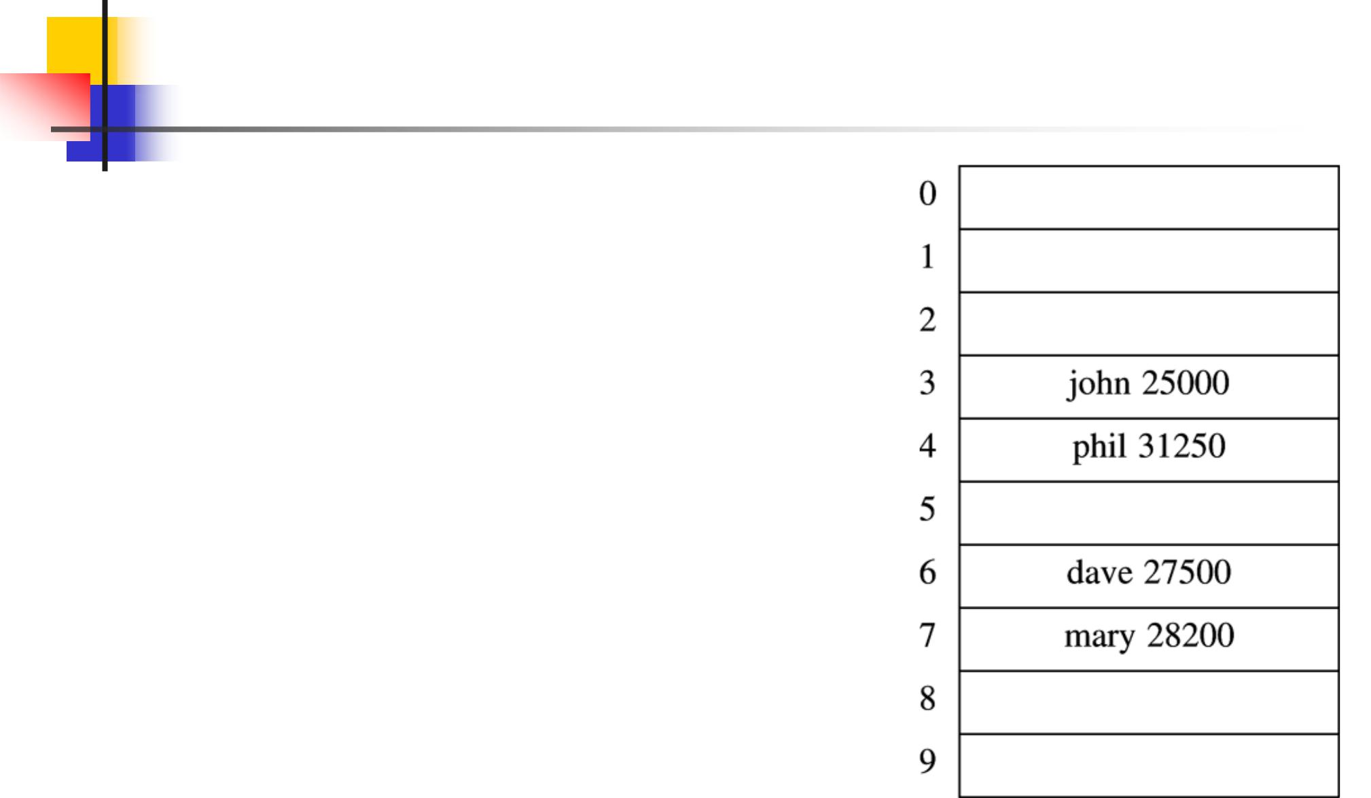

- One approach

  - Hash table is an array of fixed size TableSize

  - Array elements indexed by a key, which is mapped to an array index (0…TableSize-1)

  - Mapping (hash function) h from key to index

  - E.g., h(“john”) = 3

3

Hash Table

- Insert

  - T [h(“john”] = <“john”,25000>

- Delete

  - T [h(“john”)] = NULL

- Search

  - Return T [h(“john”)]

- What if h(“john”) = h(“joe”) ?

4

Hash Function

- Mapping from key to array index is called a hash function

  - Typically, many-to-one mapping

  - Different keys map to different indices

  - Distributes keys evenly over table

- Collision occurs when hash function maps two keys to same array index

5

Hash Function

- Simple hash function

  - h(Key) = Key mod TableSize

  - Assumes integer keys

- For random keys, h() distributes keys evenly over table

- What if TableSize = 100 and keys are multiples of 10?

- Better if TableSize is a prime number

  - Not too close to powers of 2 or 10

6

Hash Function for String Keys

- Approach 1

  - Add up character ASCII values (0-127) to produce integer keys

  - Small strings may not use all of table

    - Strlen(S) * 127 < TableSize

- Approach 2

  - Treat first 3 characters of string as base-27 integer (26 letters plus space)

  - Key = S[0] + (27 * S[1]) + (27² * S[2])
  - Assumes first 3 characters randomly distributed

    - Not true of English

7

Hash Function for String Keys
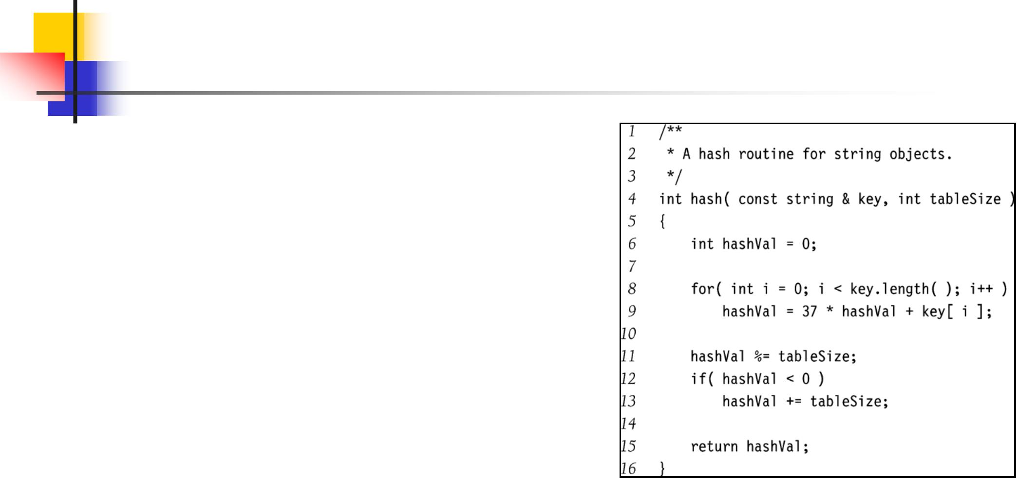

- Approach 3

  - Use all N characters of string as an N-digit base-K integer

  - Choose K to be prime number larger than number of different digits (characters)

    - I.e., K = 29, 31, 37

  - If L = length of string S, then

L−1
h(S ) = ∑ S[L − i −1]∗ 37^{i} | modTableSize
i=0
- Use Horner’s rule to compute h(S)

- Limit L for long strings

8

Collision Resolution

- What happens when h(k₁) = h(k₂)?

- Collision resolution strategies

  - Chaining

    - Store colliding keys in a linked list

  - Open addressing

    - Store colliding keys elsewhere in the table

9

Collision Resolution by Chaining

- Hash table T is a vector of lists

  - Only singly-linked lists needed if memory is tight

- Key k is stored in list at T[h(k)]

- E.g., TableSize = 10

  - h(k) = k mod 10

  - Insert first 10 perfect squares
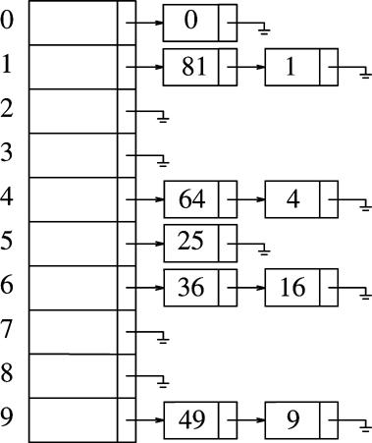

10

Implementation of Chaining Hash Table
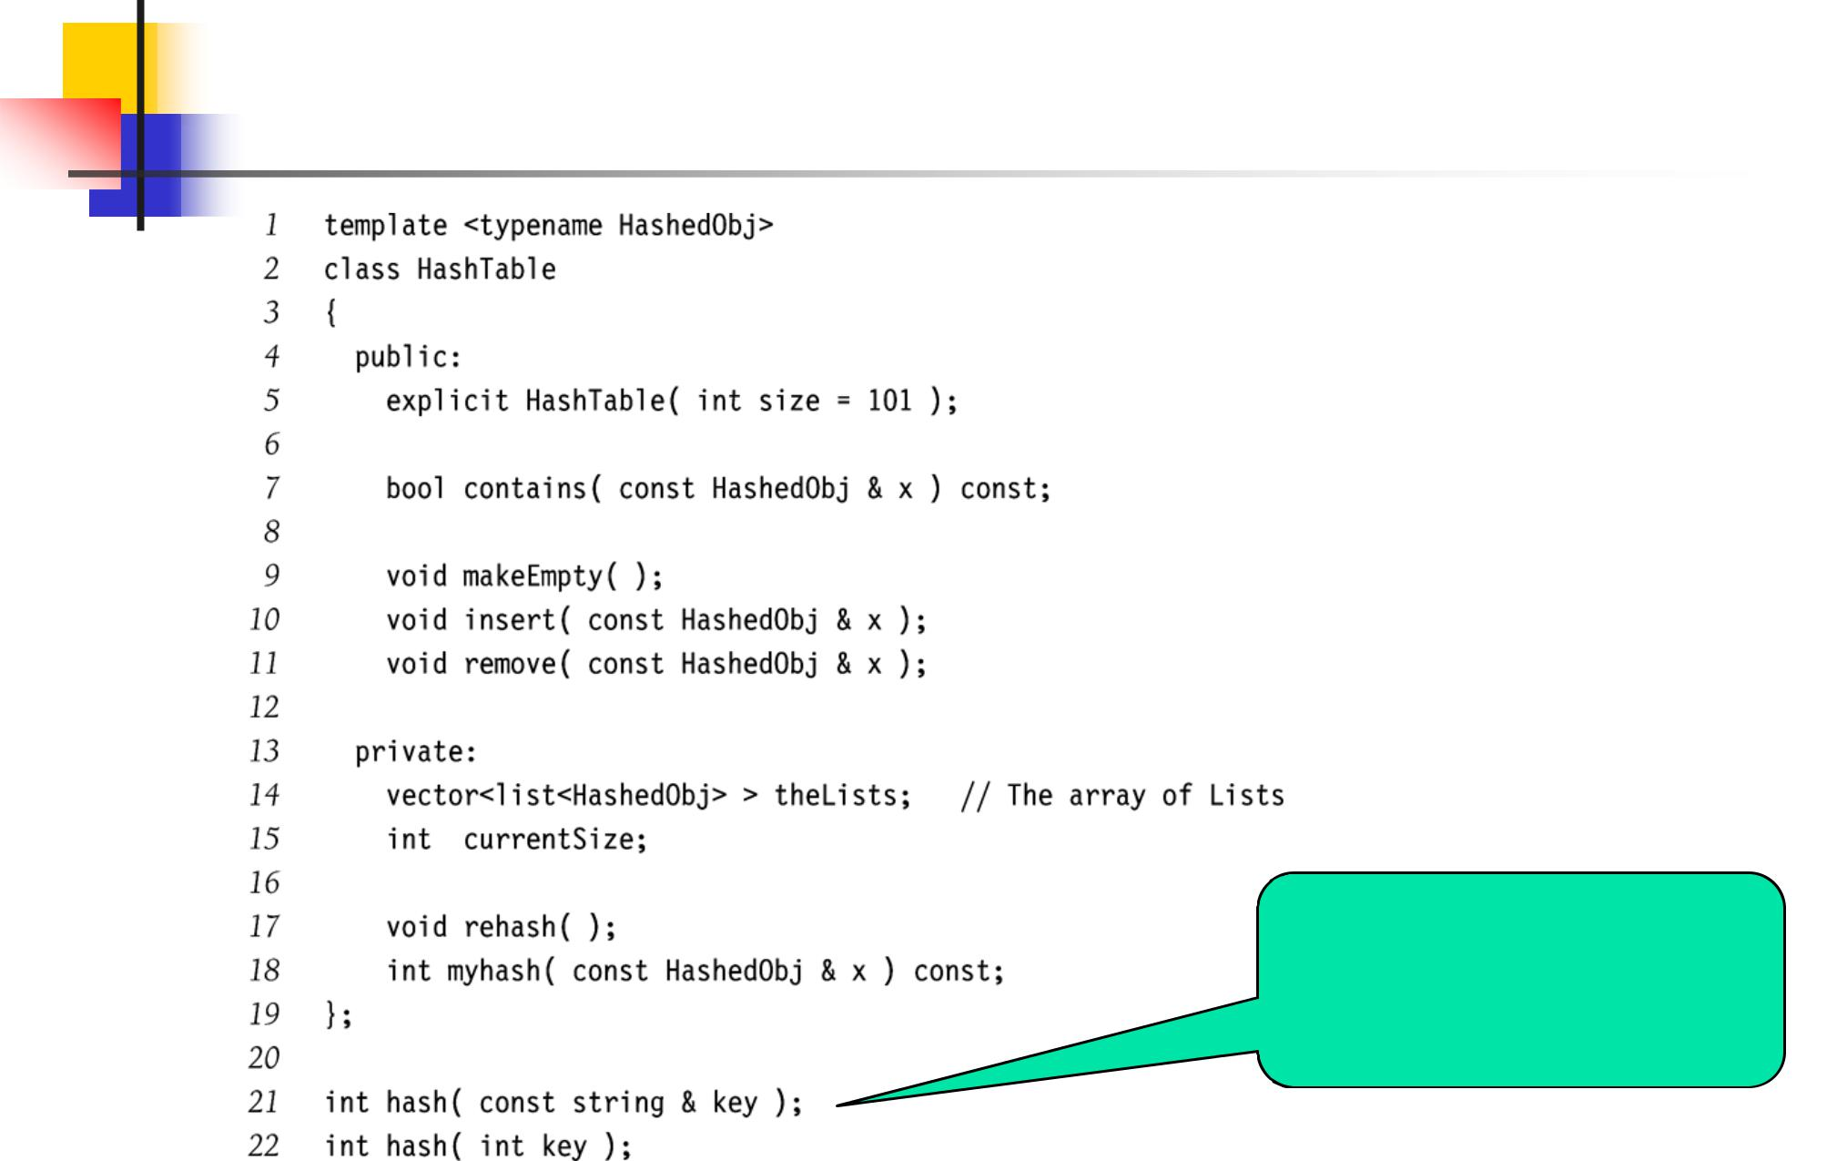

Generic hash functions for integers and keys

11

Implementation of Chaining Hash Table
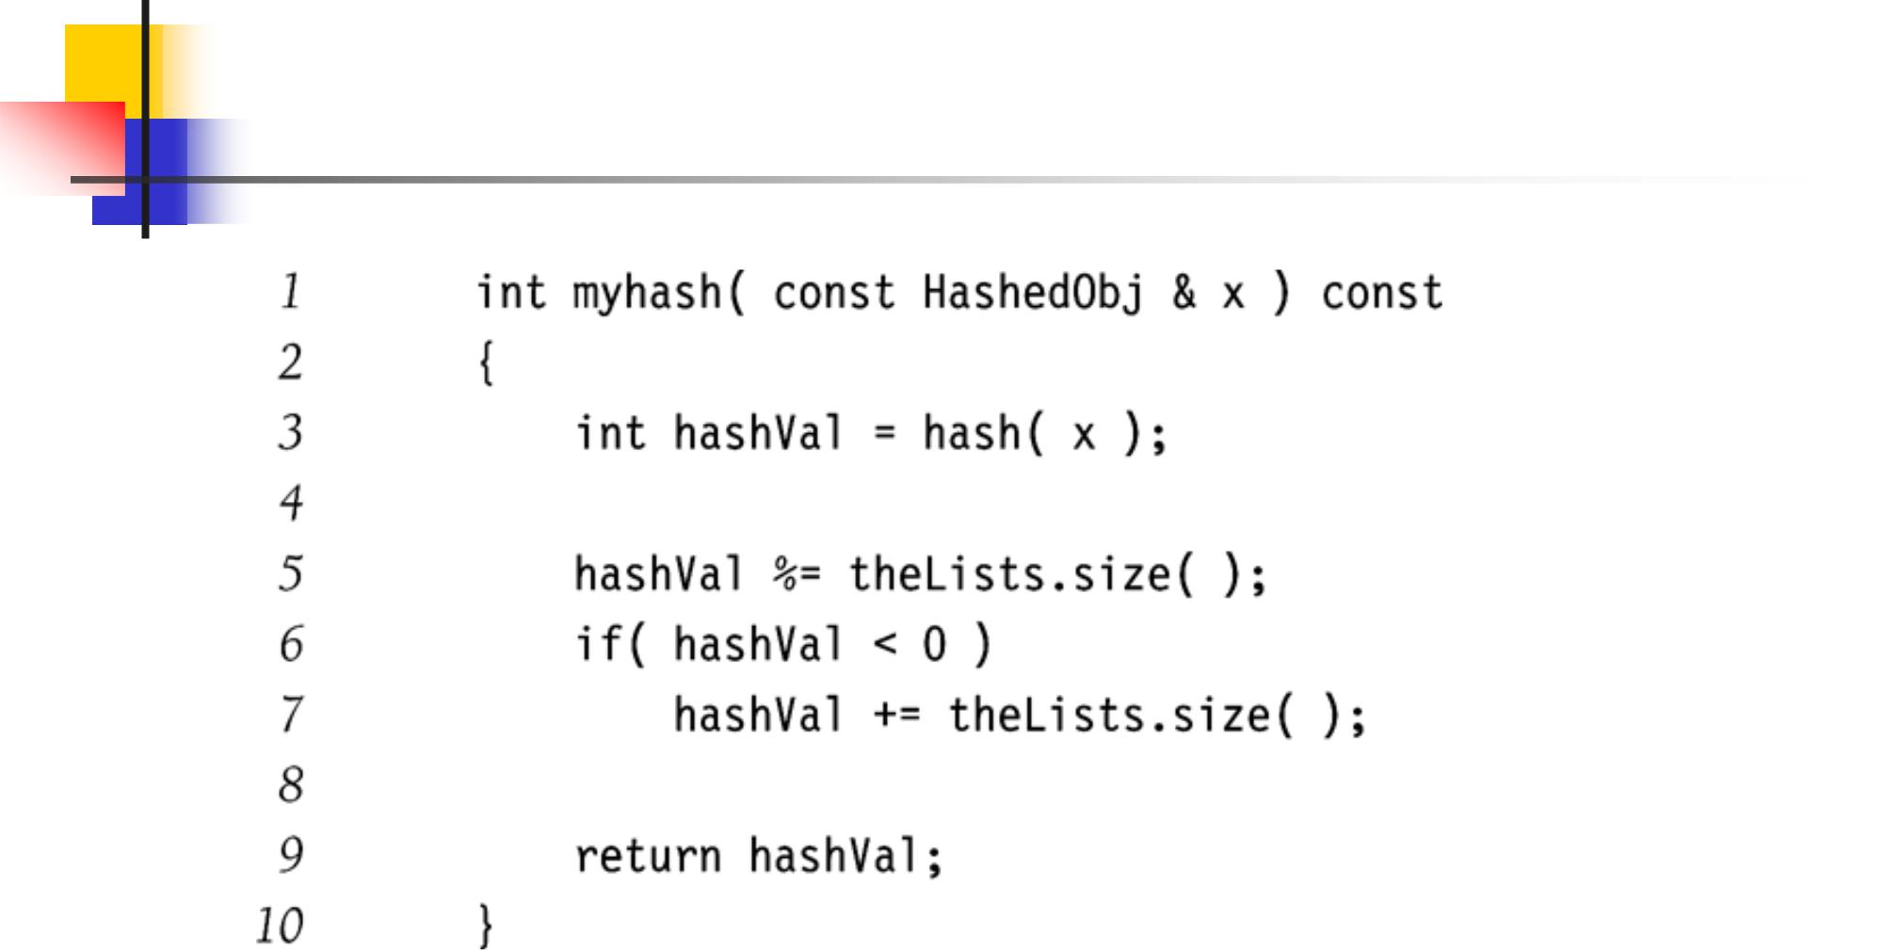

12

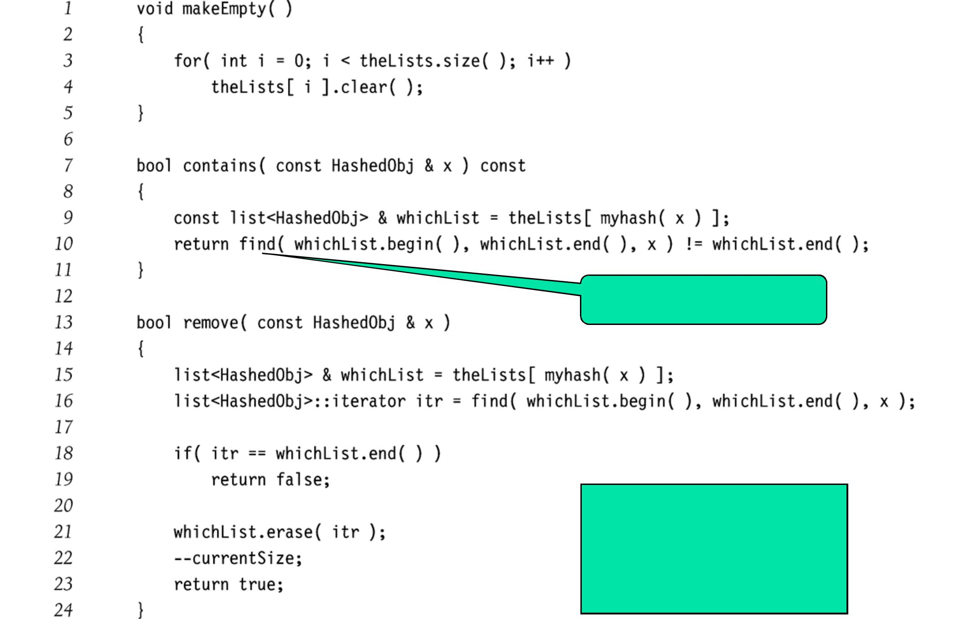

STL algorithm: find

Each of these

operations takes time

linear in the length of

the list.

13

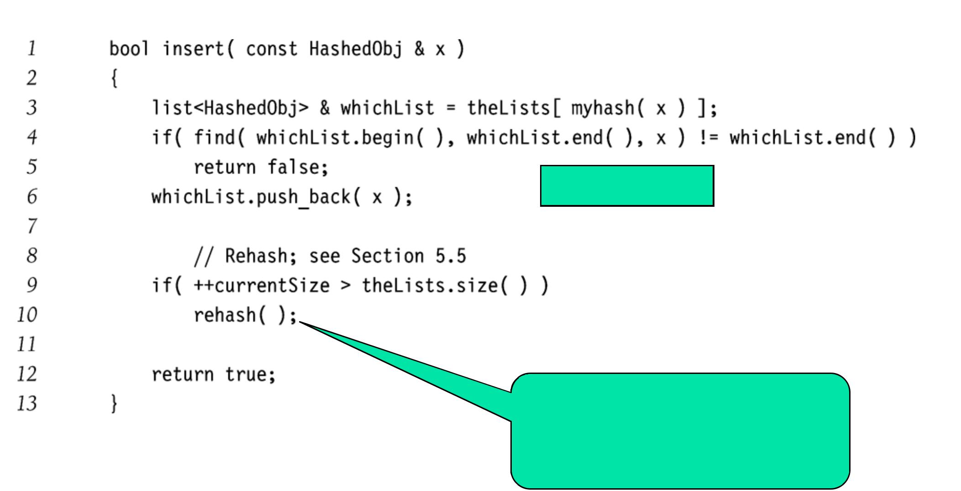

No duplicates

Later, but essentially

doubles size of table and

reinserts current elements.

14

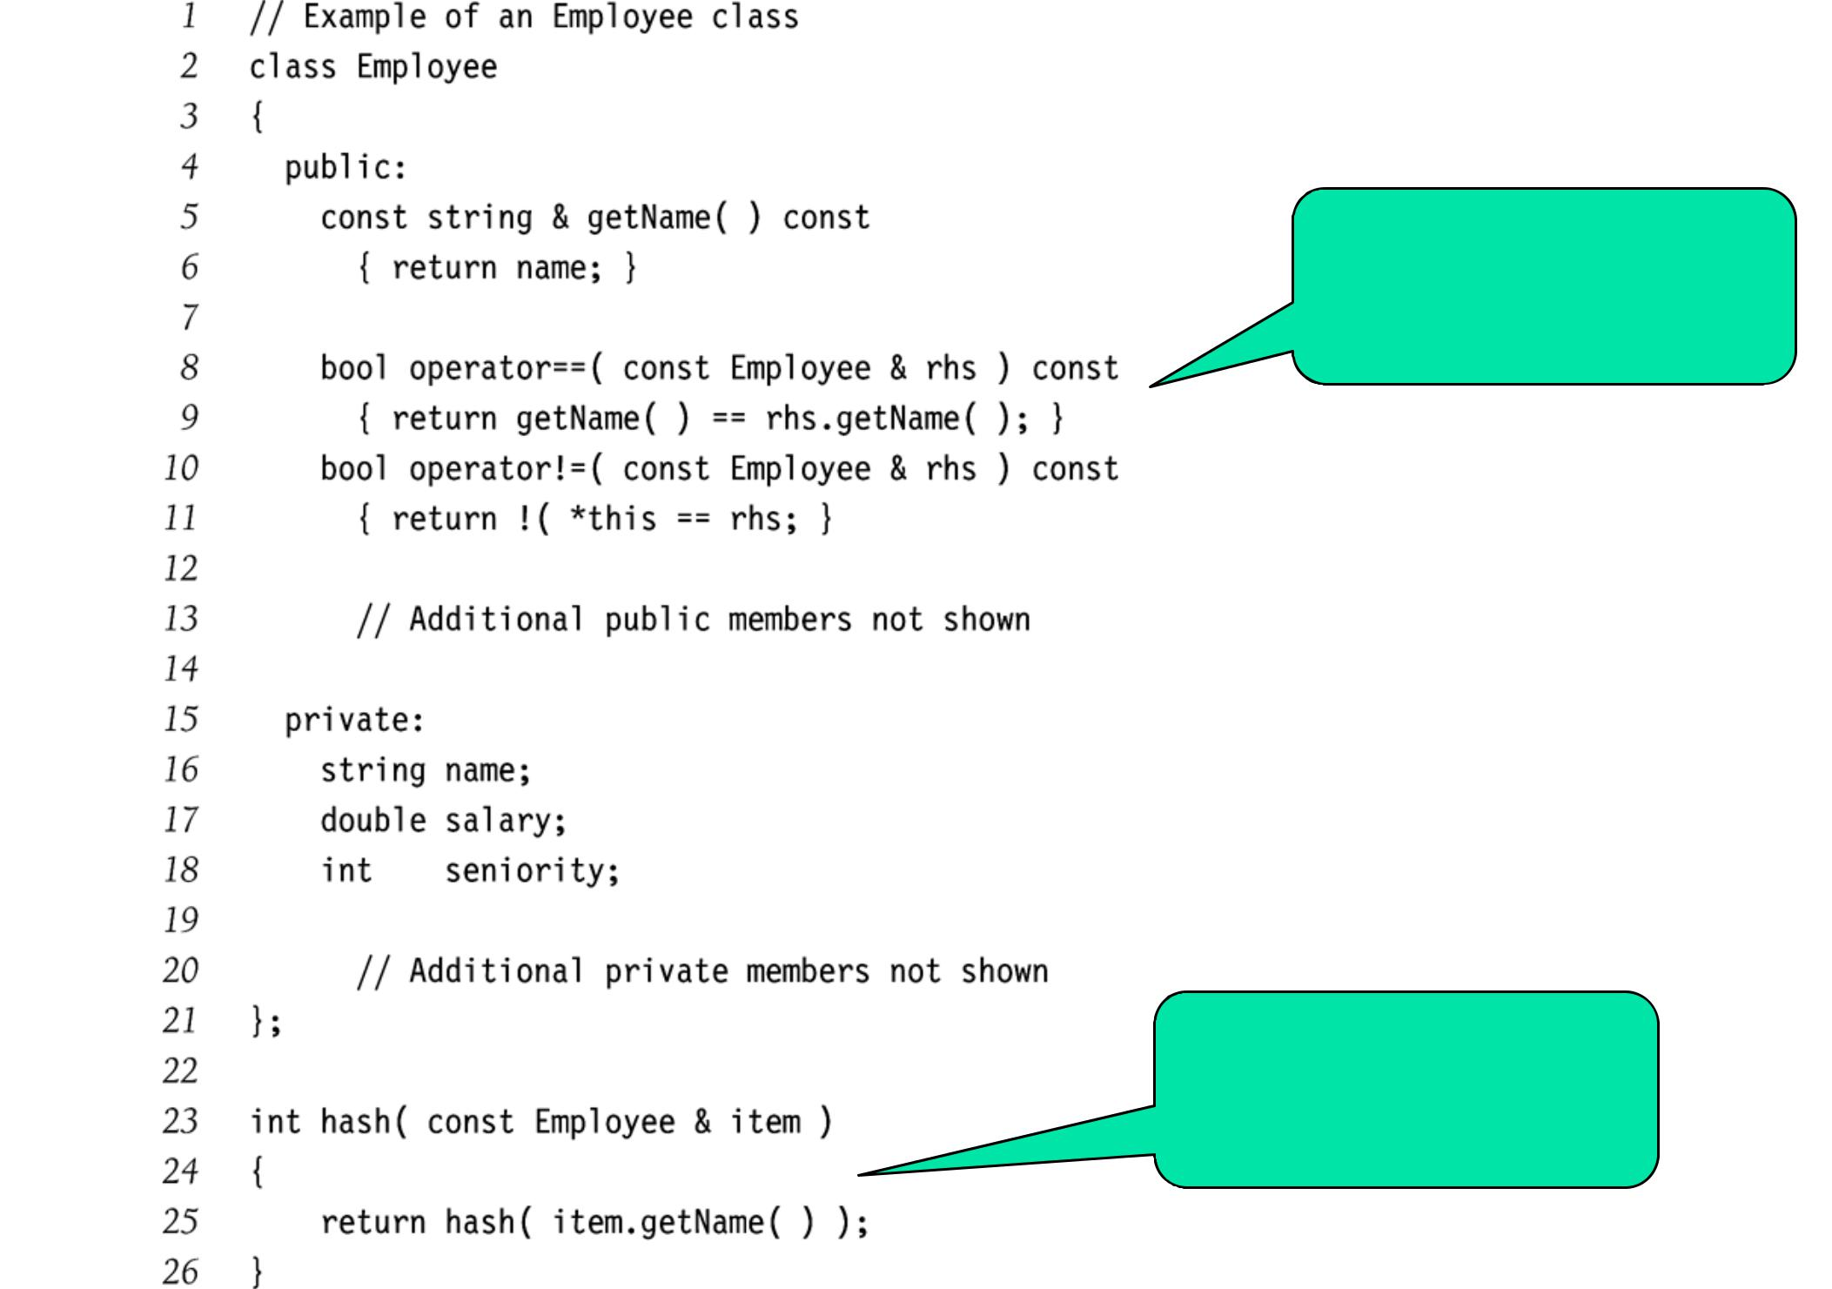
All hash objects must define == and != operators.

Hash function to handle Employee object type

15

Collision Resolution by Chaining: Analysis

- Load factor λ of a hash table T

  - N = number of elements in T

  - M = size of T

  - λ = N/M

- Average length of a chain is λ

- Unsuccessful search O(λ)

- Successful search O(λ/2)

- Ideally, want λ ≈ 1 (not a function of N)

  - I.e., TableSize = number of elements you expect to store in the table

16

Collision Resolution by Open Addressing

- When a collision occurs, look elsewhere in the table for an empty slot

- Advantages over chaining

  - No need for addition list structures

  - No need to allocate/deallocate memory during insertion/deletion (slow)

- Disadvantages

  - Slower insertion – May need several attempts to find an empty slot

  - Table needs to be bigger (than chaining-based table) to achieve average-case constant-time performance

    - Load factor λ ≈ 0.5

17

Collision Resolution by Open Addressing

- Probe sequence

  - Sequence of slots in hash table to search

  - h₀(x), h₁(x), h₂(x), …

  - Needs to visit each slot exactly once

  - Needs to be repeatable (so we can find/delete what we’ve inserted)

- Hash function

  - h_{i}(x) = (h(x) + f(i)) mod TableSize

  - f(0) = 0

18

Linear Probing

- f(i) is a linear function of i

  - E.g., f(i) = i

- Example: h(x) = x mod TableSize

  - h₀(89) = (h(89)+f(0)) mod 10 = 9

  - h₀(18) = (h(18)+f(0)) mod 10 = 8

  - h₀(49) = (h(49)+f(0)) mod 10 = 9 (X)

  - h₁(49) = (h(49)+f(1)) mod 10 = 0

19

Linear Probing Example
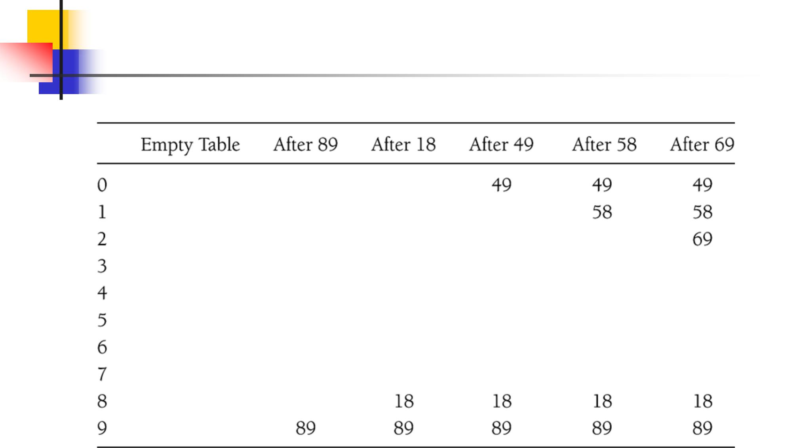

20

Linear Probing: Analysis

- Probe sequences can get long

- Primary clustering

  - Keys tend to cluster in one part of table

  - Keys that hash into cluster will be added to the end of the cluster (making it even bigger)

21

Linear Probing: Analysis

- Expected number of probes for insertion or unsuccessful search

1 |  |  | 1
 |  | +
 |  |  |  | 2
2 | 1 |  | (1− λ)
- Expected number of probes for successful search

1 |  |  | 1
 |  | +
2 | ¹
 |  |  | (1− λ)

- Example (λ = 0.5)

  - Insert / unsuccessful search

    - 2.5 probes

  - Successful search

    - 1.5 probes

- Example (λ = 0.9)

  - Insert / unsuccessful search

    - 50.5 probes

  - Successful search

    - 5.5 probes

22

Random Probing: Analysis

- Random probing does not suffer from clustering

- Expected number of probes for insertion or

unsuccessful search: |  | 1 | ln |  | 1
 |  |  |  | 1− λ
 Example |  | λ
 | λ = 0.5: 1.4 probes
 | λ = 0.9: 2.6 probes

23

Linear vs. Random Probing
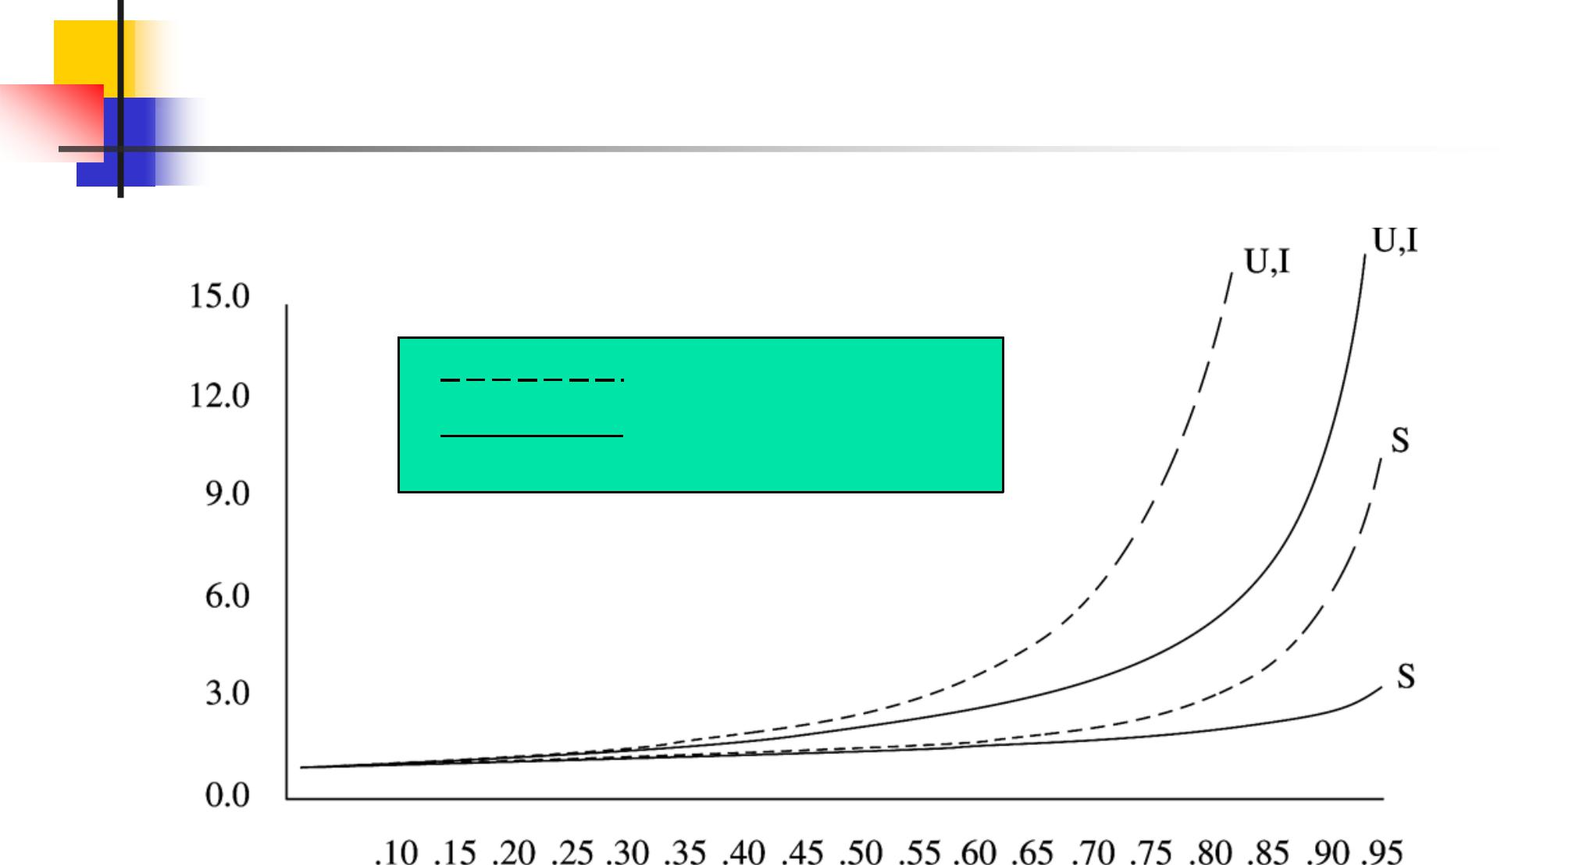

# probes

Linear probing

Random probing

Load factor λ

24

Quadratic Probing

- Avoids primary clustering

- f(i) is quadratic in i

  - E.g., f(i) = i²
- Example
  - h₀(58) = (h(58)+f(0)) mod 10 = 8 (X)

  - h₁(58) = (h(58)+f(1)) mod 10 = 9 (X)

  - h₂(58) = (h(58)+f(2)) mod 10 = 2

25

Quadratic Probing Example
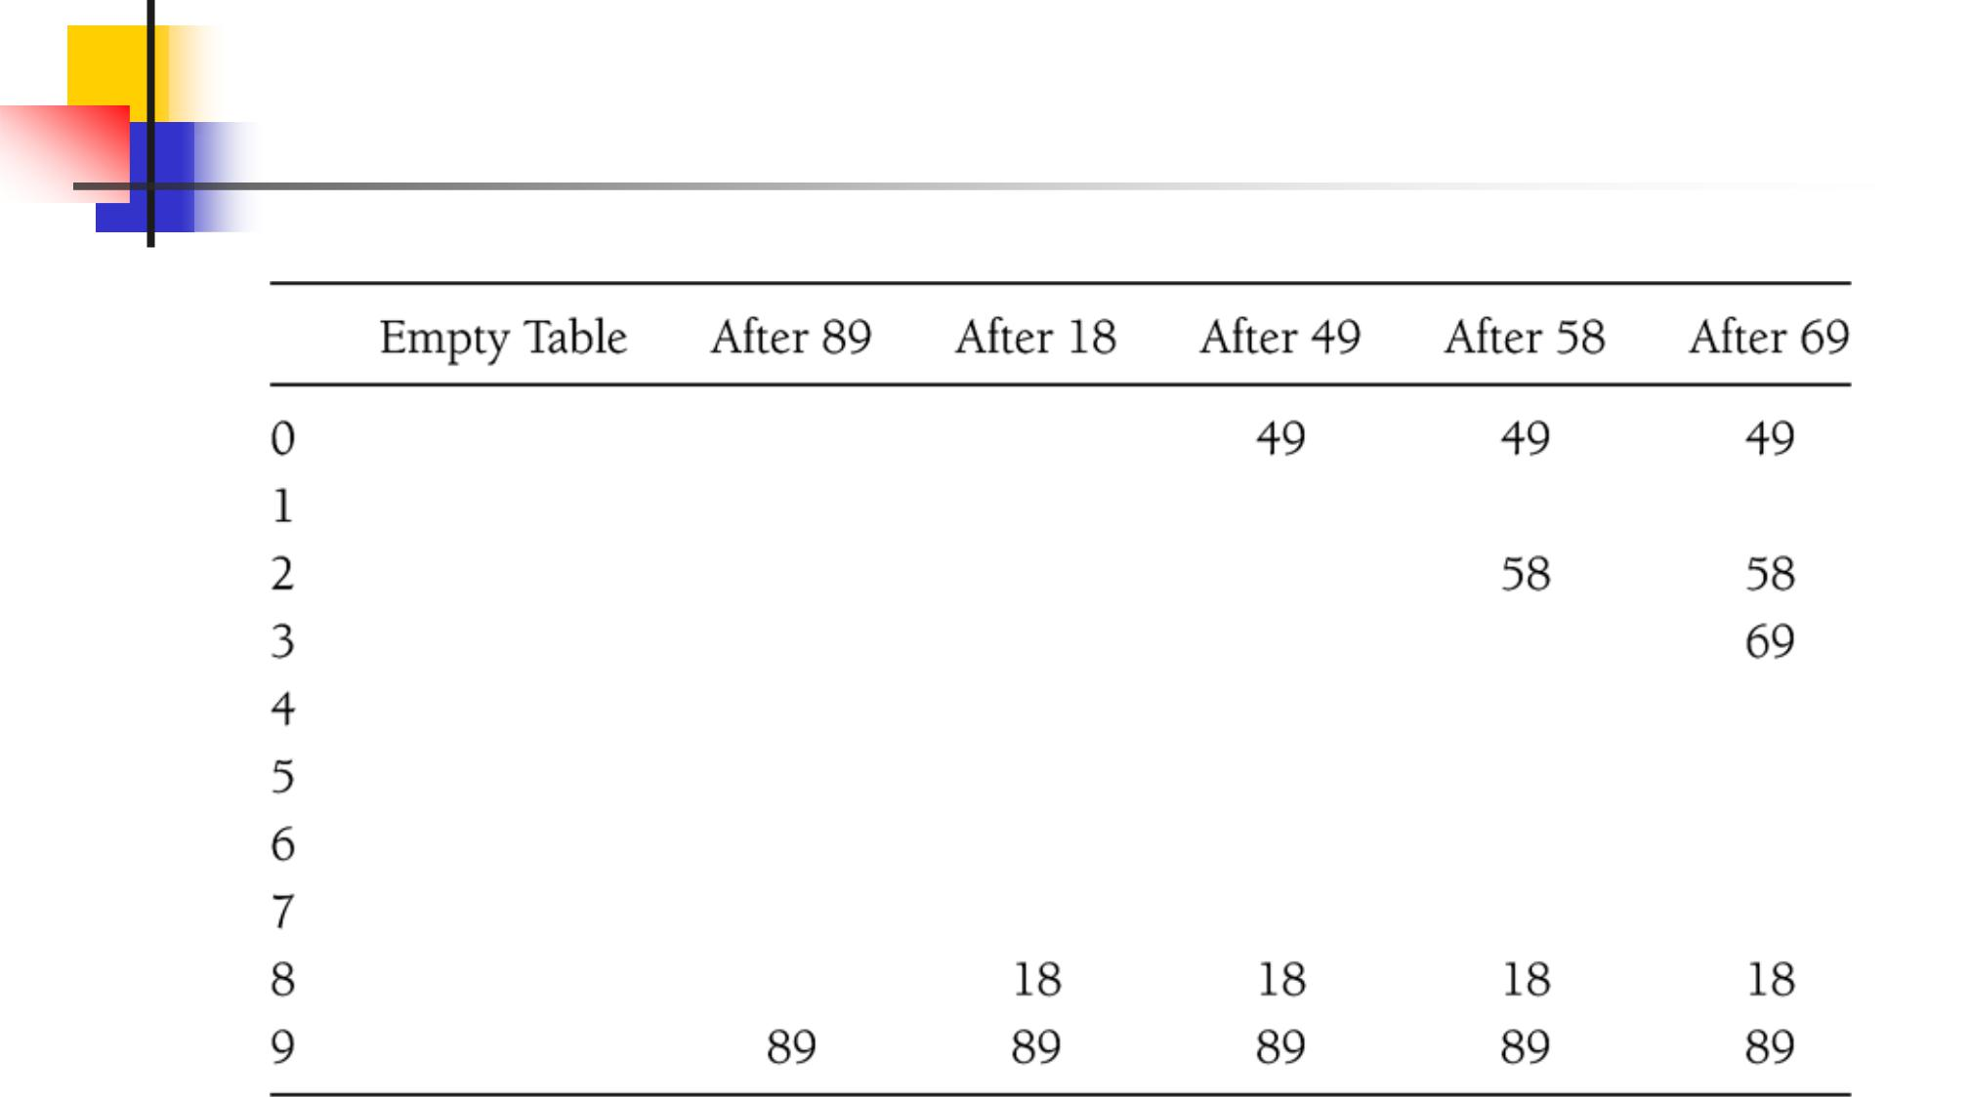

26

Quadratic Probing: Analysis

- Difficult to analyze

- Theorem 5.1

  - New element can always be inserted into a table that is at least half empty and TableSize is prime

- Otherwise, may never find an empty slot, even is one exists

- Ensure table never gets half full

  - If close, then expand it

27

Quadratic Probing

- Only M (TableSize) different probe sequences

  - May cause “secondary clustering”

- Deletion

  - Emptying slots can break probe sequence

  - Lazy deletion

    - Differentiate between empty and deleted slot

    - Skip deleted slots

    - Slows operations (effectively increases λ)

28

Quadratic Probing:

Implementation
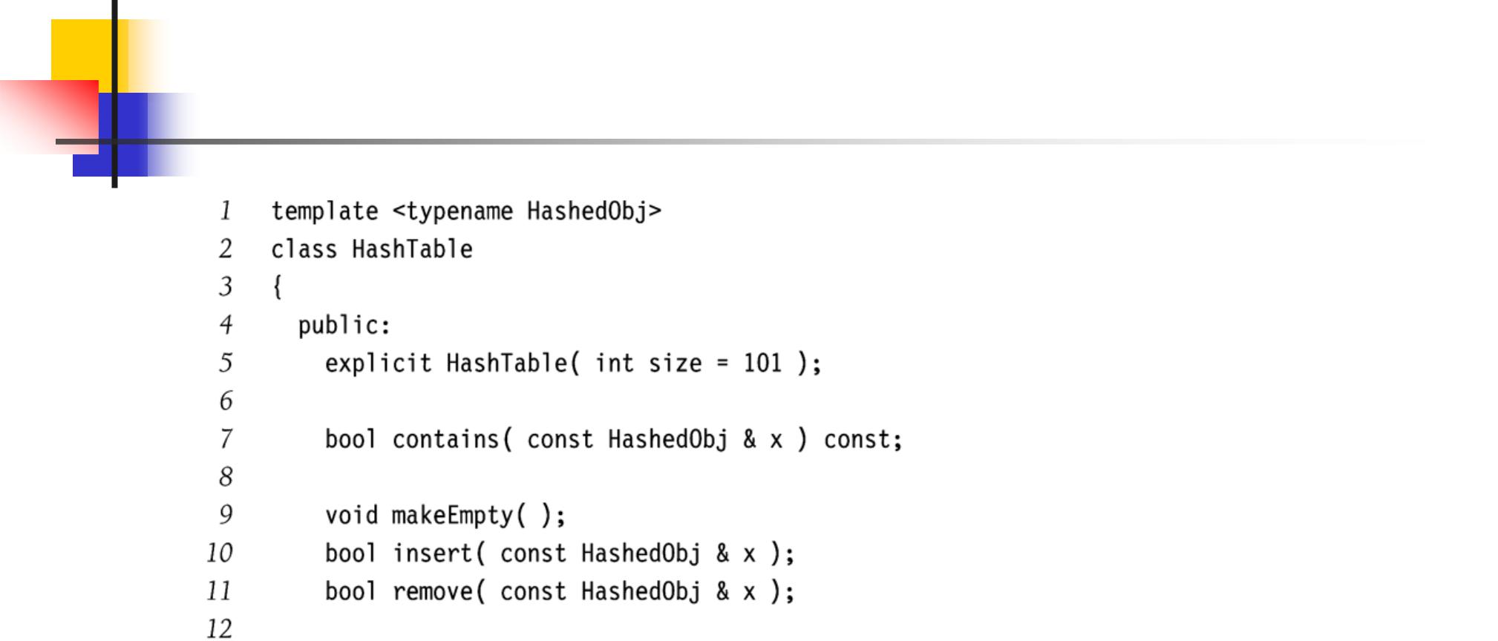

29

Quadratic Probing:

Implementation
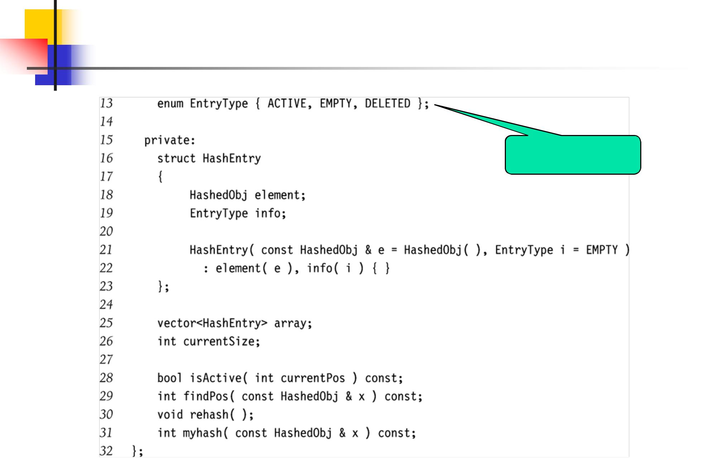

Lazy deletion

30

Quadratic Probing:

Implementation
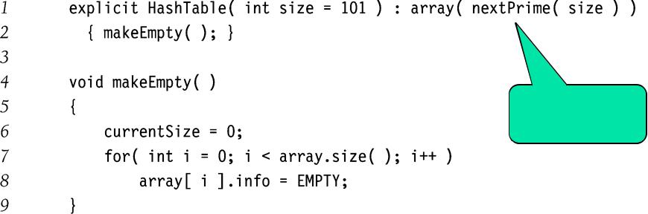

Ensure table

size is prime

31

Quadratic Probing:

Implementation
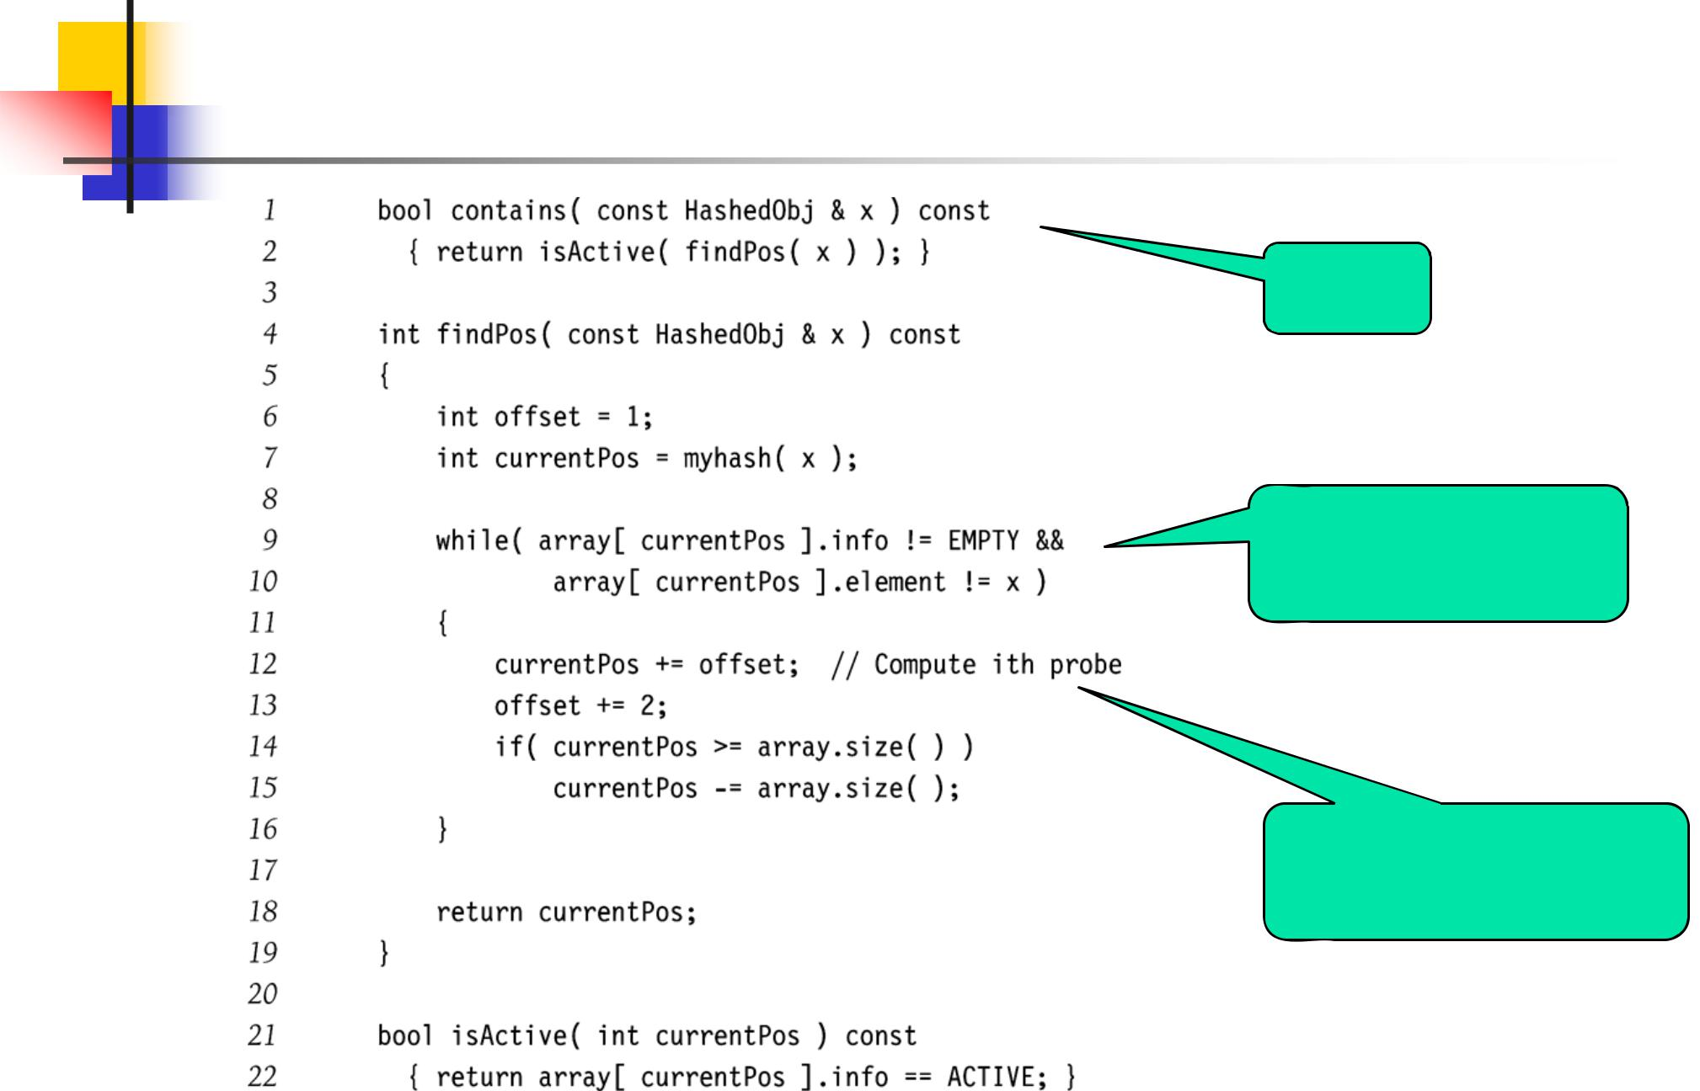

Find

Skip DELETED; No duplicates

Quadratic probe sequence (really)

32

Quadratic Probing:

Implementation
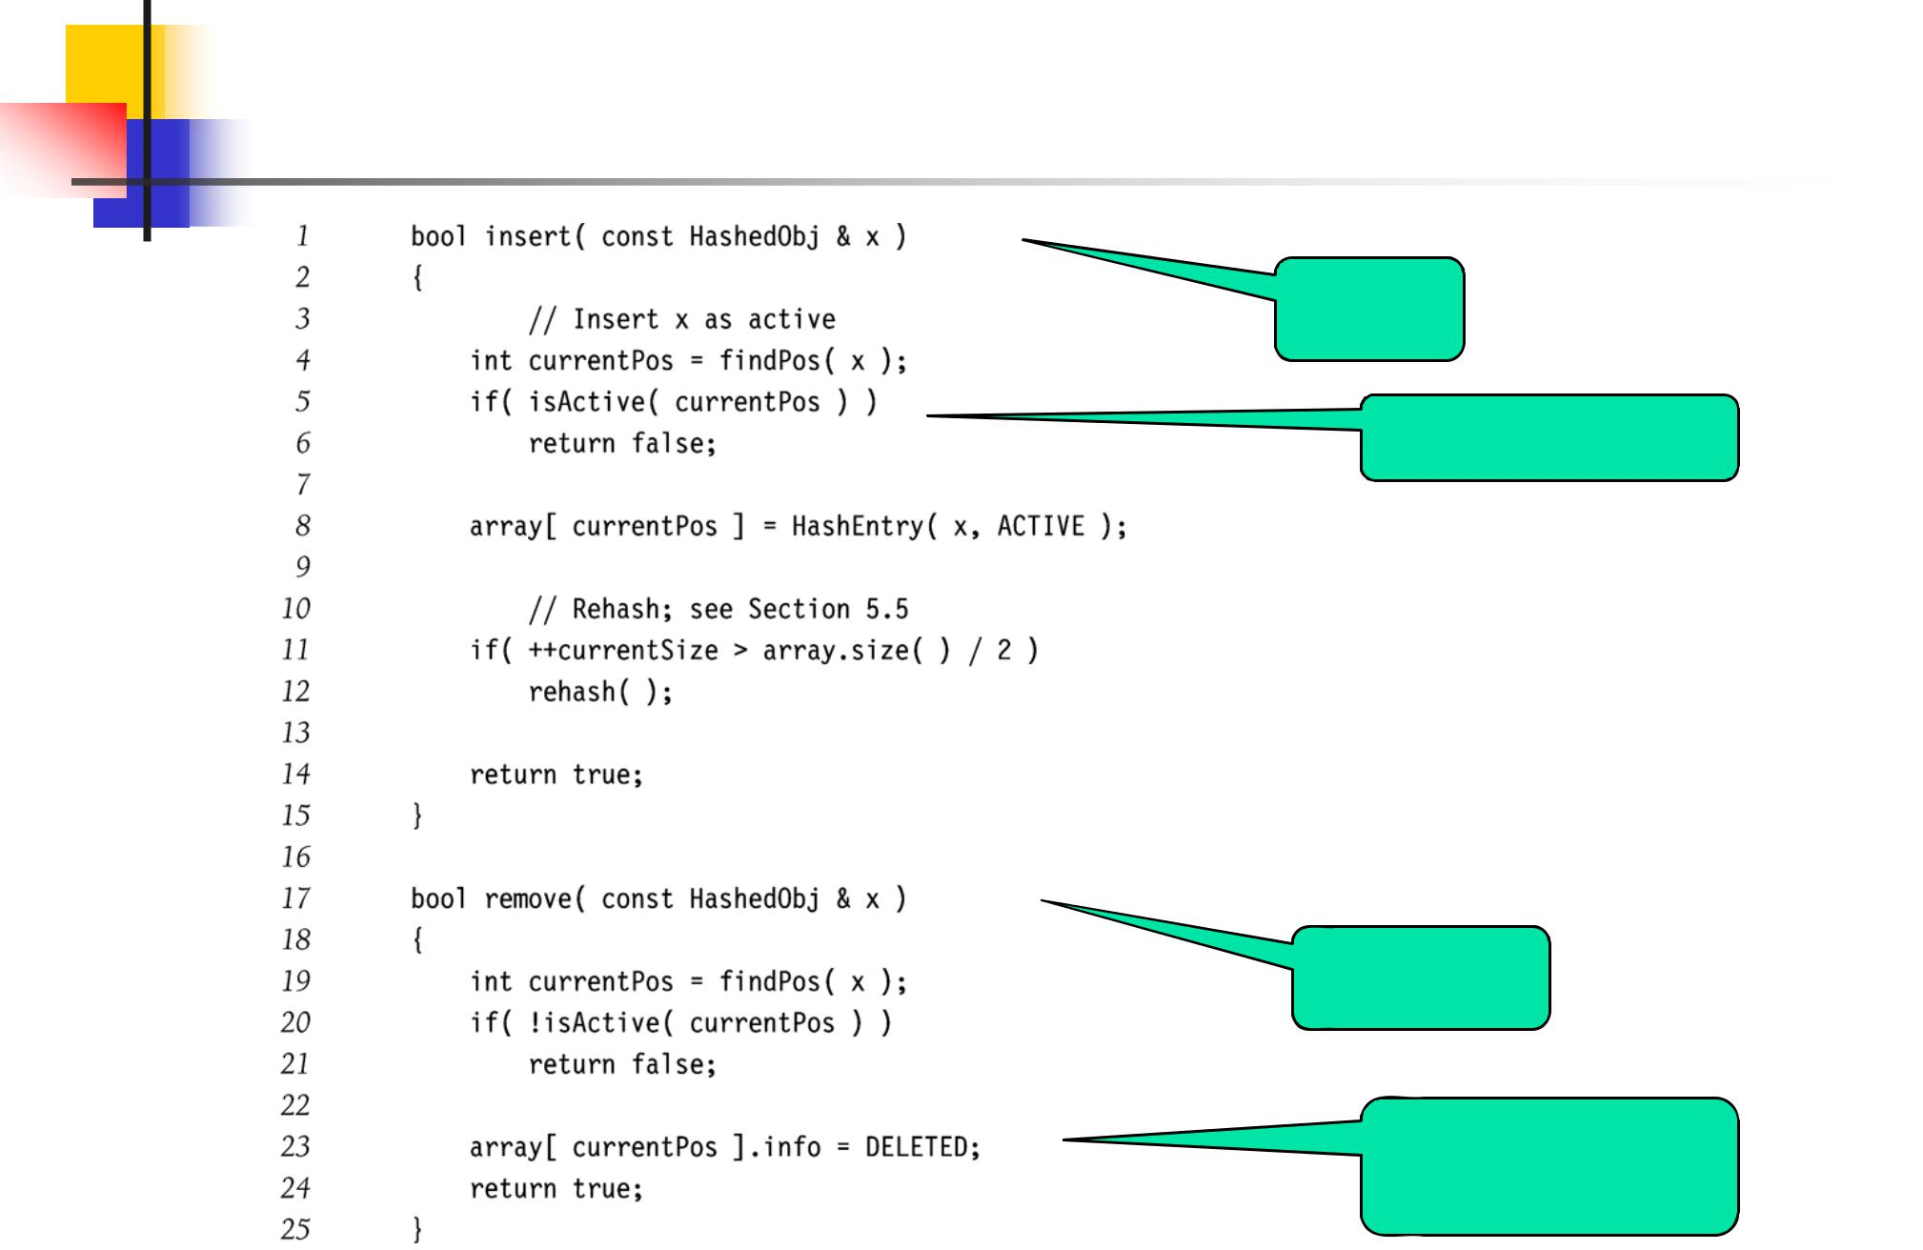

Insert

No duplicates

Remove

No deallocation

needed

33

Double Hashing

- Combine two different hash functions

- f(i) = i * h₂(x)

- Good choices for h₂(x) ?

  - Should never evaluate to 0

  - h₂(x) = R – (x mod R)

    - R is prime number less than TableSize

- Previous example with R=7

  - h₀(49) = (h(49)+f(0)) mod 10 = 9 (X)

  - h₁(49) = (h(49)+(7 – 49 mod 7)) mod 10 = 6

34

Double Hashing Example
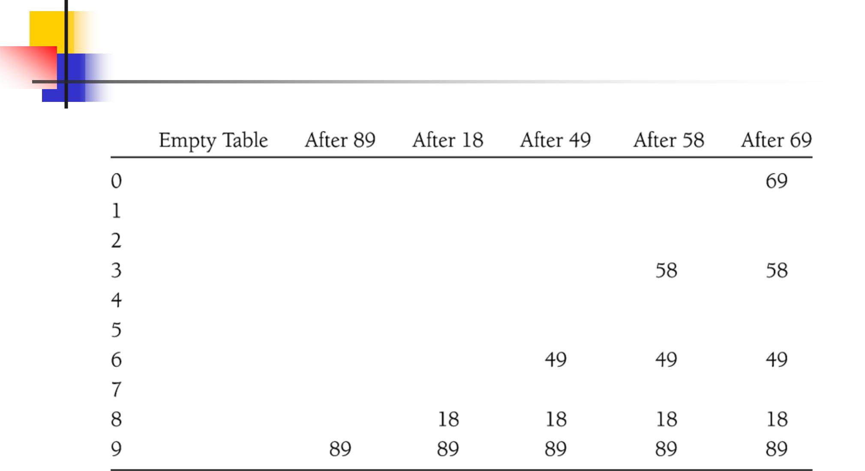

35

Double Hashing: Analysis

- Imperative that TableSize is prime

  - E.g., insert 23 into previous table

- Empirical tests show double hashing close to random hashing

- Extra hash function takes extra time to compute

36

Rehashing

- Increase the size of the hash table when load factor too high

- Typically expand the table to twice its size (but still prime)

- Reinsert existing elements into new hash table

37

Rehashing Example
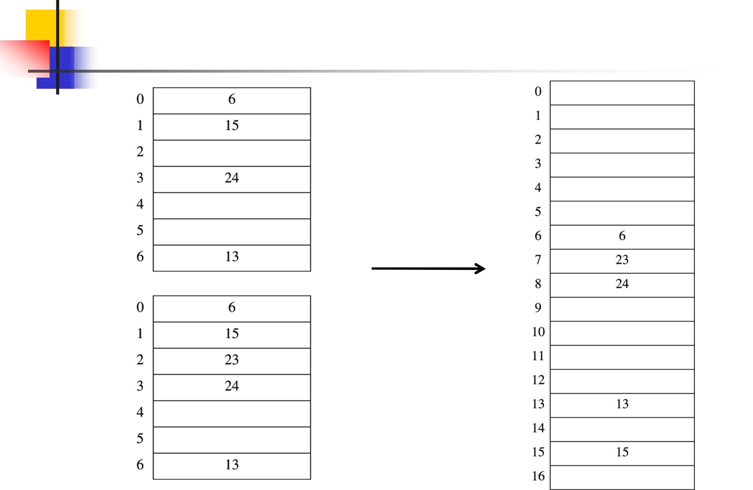

h(x) = x mod 7 h(x) = x mod 17

λ = 0.57 λ = 0.29

Rehashing

Insert 23

- = 0.71

38

Rehashing Analysis

- Rehashing takes O(N) time

- But happens infrequently

- Specifically

  - Must have been N/2 insertions since last rehash

  - Amortizing the O(N) cost over the N/2 prior insertions yields only constant additional time per insertion

39

Rehashing Implementation

- When to rehash

  - When table is half full (λ = 0.5)

  - When an insertion fails

  - When load factor reaches some threshold

- Works for chaining and open addressing

40

Rehashing for Chaining
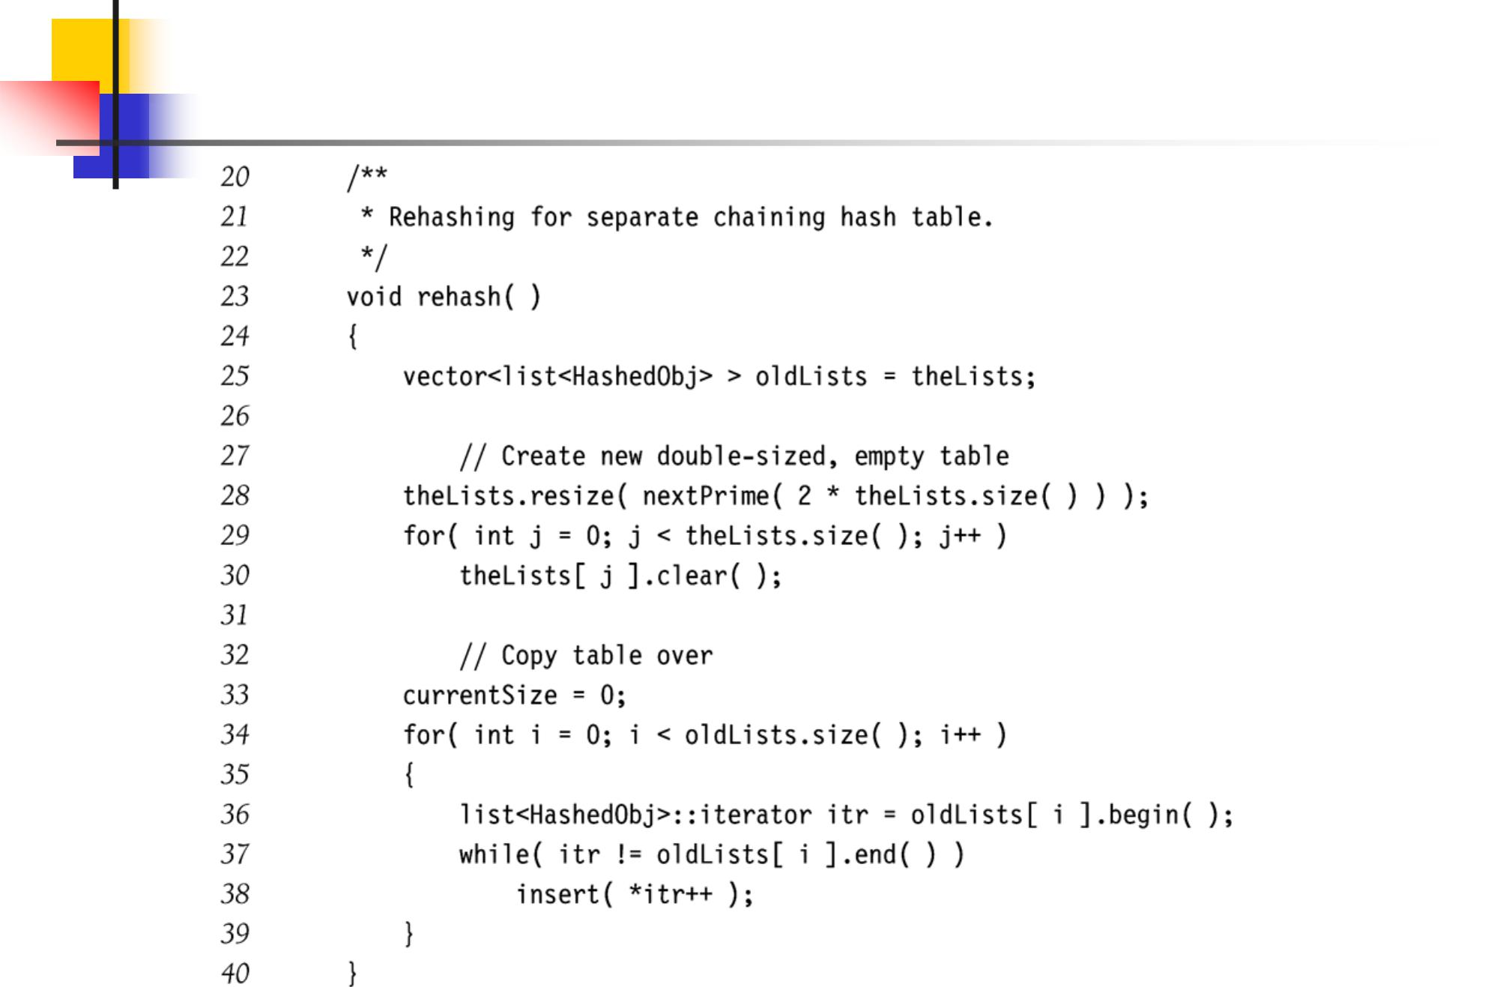

41

Rehashing for Quadratic Probing
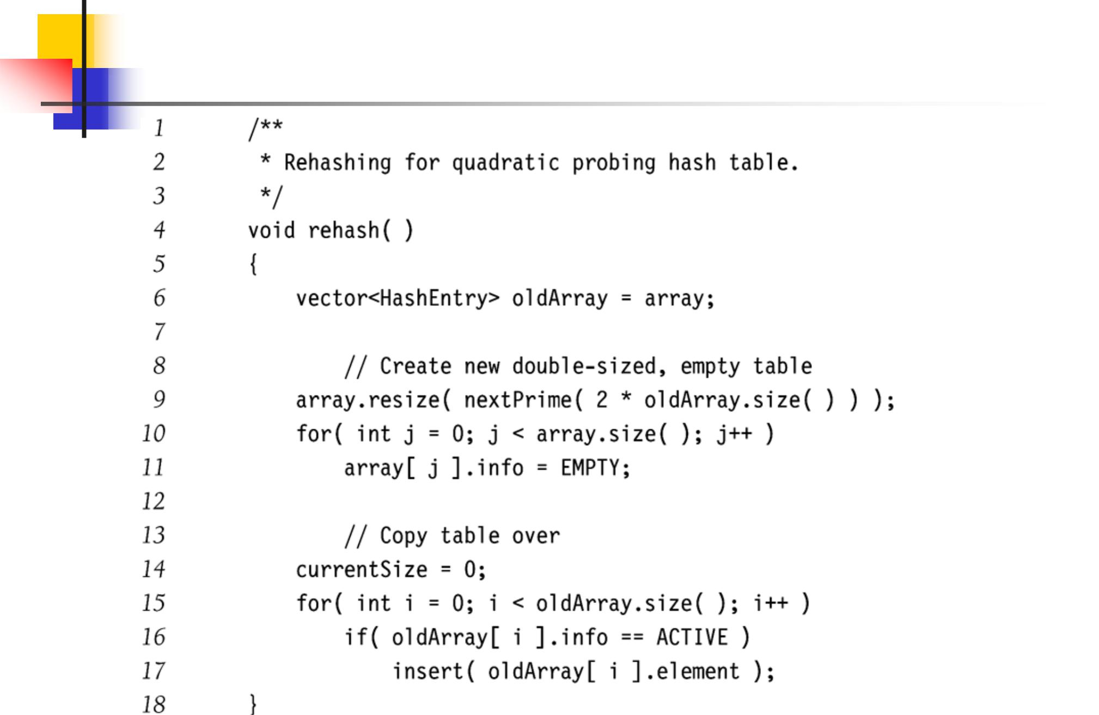

42

Hash Tables in C++ STL

- Hash tables not part of the C++ Standard Library

- Some implementations of STL have hash tables (e.g., SGI’s STL)

  - hash_set

  - hash_map

43

Hash Set in SGI’s STL

#include <hash_set>

struct eqstr

{

bool operator()(const char* s1, const char* s2) const {

return strcmp(s1, s2) == 0;

}

};

void lookup(const hash_ set<const char*, hash<const char*>, eqstr>& Set, const char* word)

{

hash_set<const char*, hash<const char*>, eqstr>::const_iterator it

- Set.find(word); cout << word << ": "
  - (it != Set.end() ? "present" : "not present")

  - endl;
}
Key Hash fn Key equality test

int main()

{

hash_set<const char*, hash<const char*>, eqstr> Set;

Set.insert("kiwi");
lookup(Set, “kiwi");

} | 44

Hash Map in SGI’s STL

#include <hash_map>

struct eqstr

{

bool operator() (const char* s1, const char* s2) const {

return strcmp(s1, s2) == 0;

}

};

int main()

{

Key Data Hash fn Key equality test

hash_map<const char*, int, hash<const char*>, eqstr> months;

months["january"] = 31;

months["february"] = 28;

…

months["december"] = 31;

cout << “january -> " << months[“january"] << endl;

}

45

Problem with Large Tables

- What if hash table is too large to store in main memory?

- Solution: Store hash table on disk

  - Minimize disk accesses

- But…

  - Collisions require disk accesses

  - Rehashing requires a lot of disk accesses

46

Extendible Hashing

- Store hash table in a depth-1 tree

  - Every search takes 2 disk accesses

  - Insertions require few disk accesses

- Hash the keys to a long integer (“extendible”)

- Use first few bits of extended keys as the keys in the root node (“directory”)

- Leaf nodes contain all extended keys starting with the bits in the associated root node key

47

Extendible Hashing Example

- Extendible hash table

- Contains N = 12 data elements

- First D = 2 bits of key used by root node keys

  - 2^{D} entries in directory
- Each leaf contains up to M = 4 data elements

  - As determined by disk page size

- Each leaf stores number of common starting bits (d_{L})
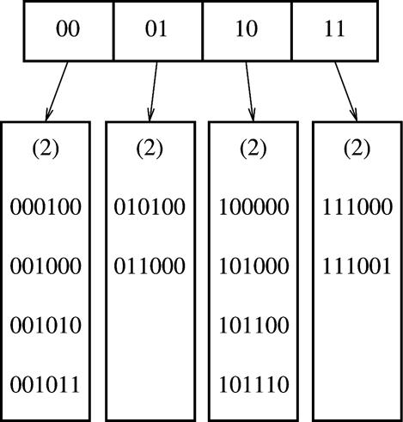

48

Extendible Hashing Example
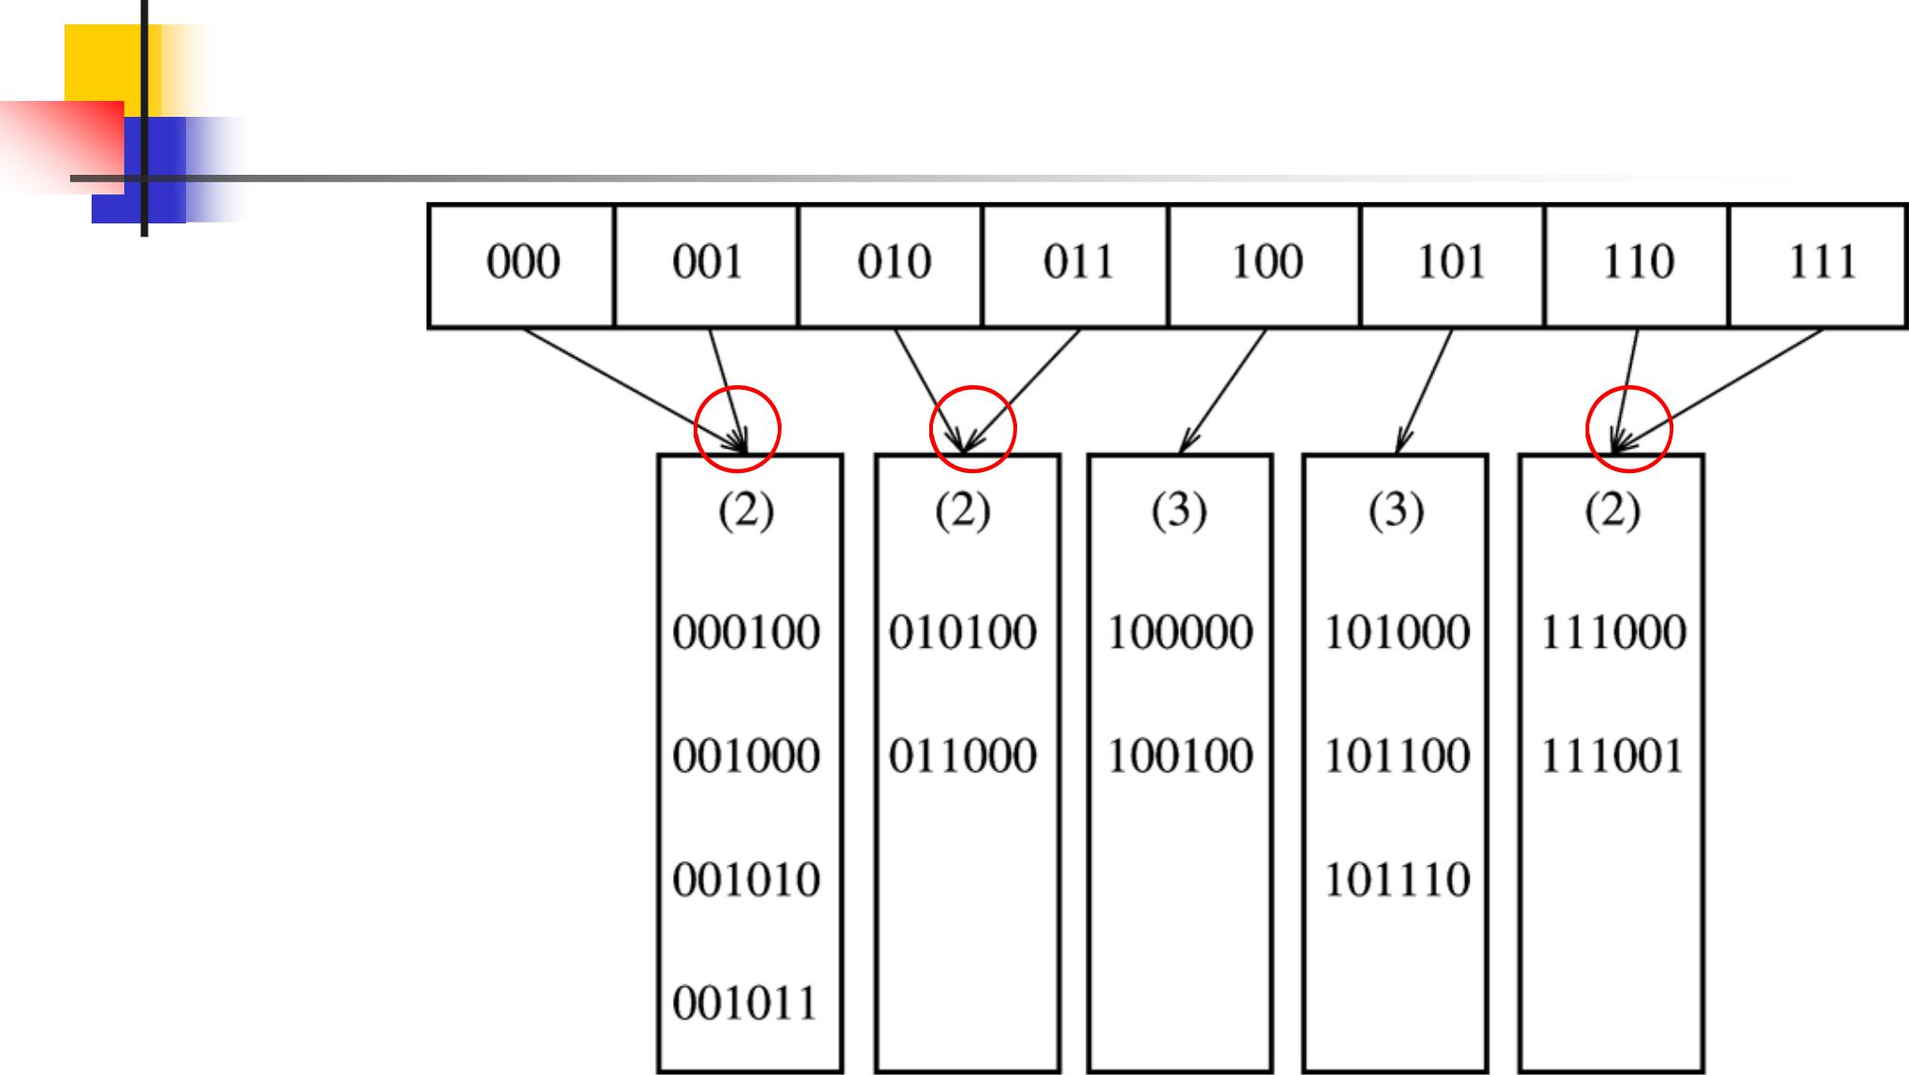

After inserting 100100

Directory split and rewritten

Leaves not involved in split now pointed to by two adjacent directory entries.

These leaves are not accessed.

49

Extendible Hashing Example
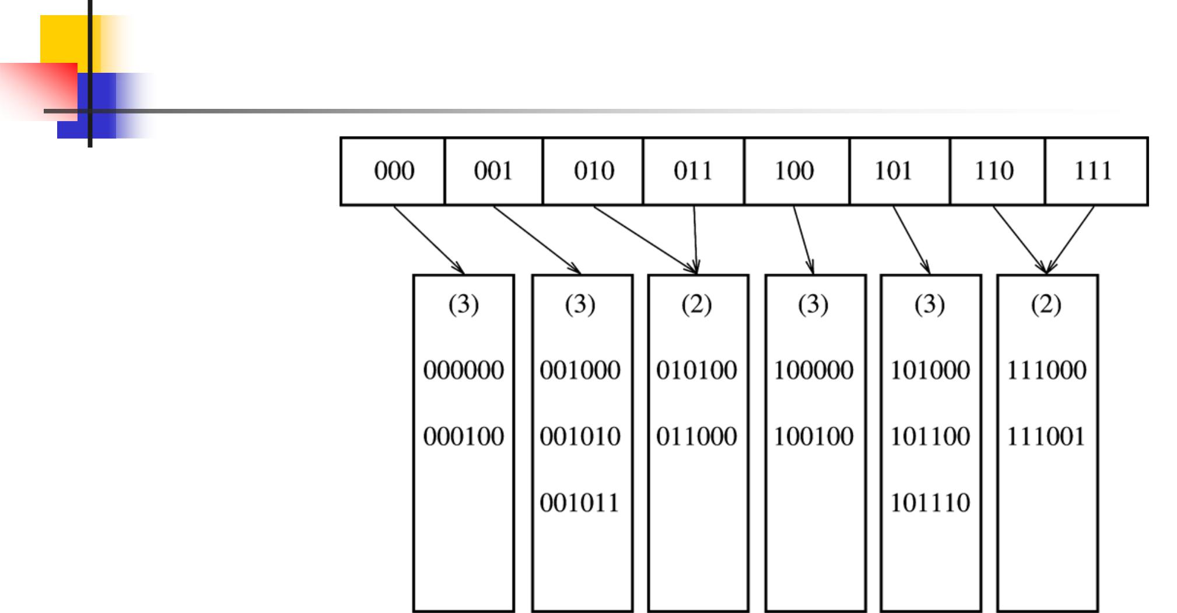

After inserting 000000

One leaf splits

Only two pointer

changes in directory

50

Extendible Hashing Analysis

- Expected number of leaves is (N/M)*log₂ e = (N/M)*1.44

- Average leaf is (ln 2) = 0.69 full

  - Same as for B-trees

- Expected size of directory is

_{O(N}(1+1/M)_{/M)}

  - O(N/M) for large M (elements per leaf)

51

Hash Table Applications

- Maintaining symbol table in compilers

- Accessing tree or graph nodes by name

  - E.g., city names in Google maps

- Maintaining a transposition table in games

  - Remember previous game situations and the move taken (avoid re-computation)

- Dictionary lookups

  - Spelling checkers

  - Natural language understanding (word sense)

52

Summary

- Hash tables support fast insert and search

  - O(1) average case performance

  - Deletion possible, but degrades performance

- Not good if need to maintain ordering over elements

- Many applications

53

